August 2001
Prepared by Customer Service Training and Development
Compaq Computer Corporation
Contents
Product Description 3
Differences 3
Models 3
Option Kits 3
Operating Systems/Drivers 4
Installation Procedure: 4
Service Considerations 6
Reference 6

Compaq ProLiant DL360 1.13GHz and 1.26GHz Processor Upgrade
Service Overview
Abstract: This white paper describes the Intel Pentium III 1.13GHz and 1.26GHz processor upgrade for Compaq ProLiant DL360 servers. Information provided includes model, option and spare part numbers as well as installation procedures and service considerations for the product.

Compaq ProLiant DL360 Processor Upgrade Service Overview© 2001 Compaq Computer Corporation
Compaq and the Compaq logo Registered in U.S. Patent and Trademark Office. Microsoft and Windows are trademarks of Microsoft Corporation in the United States and other countries. All other product names mentioned herein may be trademarks of their respective companies.
Compaq shall not be liable for technical or editorial errors or omissions contained herein. The information in this document is provided “as is” without warranty of any kind and is subject to change without notice. The warranties for Compaq products are set forth in the express limited warranty statements accompanying such products. Nothing herein should be construed as constituting an additional warranty.

Product Description
This upgrade to the Compaq ProLiant DL360 features an Intel Pentium III 1.13GHz or 1.26GHz processor. In addition to the new processor this release of the server contains a new 512KB level 2 ECC cache. The server is upgradeable to dual processing and ships with 128MB of PC133MHz registered ECC SDRAM memory standard (expandable to 4GB). There are two embedded Compaq NC3163 Fast Ethernet PCI 10/100 controllers and two expansion slots: one 64-bit, PCI/33 MHz and one 32-bit, PCI/33MHz. The system also has an embedded integrated SmartArray controller to support optional internal drives which can provide a maximum storage capacity of 145.6GB using two 72.8GB one-inch drives. This rack model server has a 1U form factor.

Differences
The ProLiant DL360 1.26/1.13GHz servers use a different system board than the 1GHz and below. The new system board is NOT backwards compatible with the 1GHz and below processors. This is because the 1.26 and 1.13GHz processors have 512K of level-2 cache and require a new VRM (PPM) and socket. Customers who choose to upgrade 550 MHz, 800 MHz, 866 MHz, 933 MHz or 1.0GHz to1.13GHz or 1.26GHz may do so with an upgrade kit in addition to the processor option kit. Processor speed mixing is not supported.

Models
Table 1: System Models
Model | Part Number | Notes
DL360R01 P1130-512KB 128MB | 229600-xx1 | Not available in North America
DL360R01 P1130-512KB 128MB, RILO | 229643-421 | Available in EMEA only
DL360R01 P1266-512KB, 128MB | 236084-xx1
DL360R01 P1266-512KB, 128MB, 3-Pack | 247273-001 | Available in North America only
DL360R01 P1266-512KB, 128MB, RILO | 236086-421 | Available in EMEA only

Option Kits

ProLiant DL360 1.13GHz or 1.26GHz Processor Upgrade
Customers who are adding a second processor to a Compaq ProLiant DL360 already configured with one 1.13GHz processor will need to order the Pentium III P1130-512KB Processor Option Kit, Part Number 232545-B21.
Customers who are adding a second processor to a Compaq ProLiant DL360 already configured with one 1.26GHz processor will need to order the Pentium III P1266-512KB Processor Option Kit, Part Number 236121-B21.
Customers wishing to upgrade their Compaq ProLiant DL360 servers from 550MHz, 800MHz, 866MHz, 933MHz or 1.0GHz would order the Compaq ProLiant DL360 P1133/P1266 Upgrade Kit (236122-B21) in addition to the processor option kit. This kit includes the new system board with a socket that accommodates the different pin connections required by the new Tualatin processor.

Table 2: Processor Option/Upgrade Kits
Kit | Part Number
Pentium III P1130-512KB Processor Option Kit | 232545-B21
Pentium III P1266-512KB Processor Option Kit | 236121-B21
ProLiant DL360 P1133/P1266 Upgrade Kit | 236122-B21

Spare Parts
Ordering information for individual spare processors, heatsinks and system boards is shown below:

Table 3: Spare Part Numbers

Description | Spare Part Number
SPS-PROC, 1.13GHz, W/HEATSINK | 238905-001
SPS-PROC, 1.26GHz, W/HEATSINK | 249095-001
SPS-BD, SYSTEM I/O, 1.13 GHz or 1.26GHz | 239120-001
SPS-HEATSINK, 1.13GHz or 1.26GHz | 249096-001

Operating Systems/Drivers
The 1.133GHz and 1.266GHz Compaq ProLiant DL360 are supported by the same operating systems as their predecessors with the exception of SCO UnixWare 7.1.0. A timing issue related to the processor speed increase has been confirmed by SCO. This problem will not be fixed for version 7.10 but is not seen in version 7.1.1 and beyond.

Installation Procedure:

Identify contents of upgrade kit | 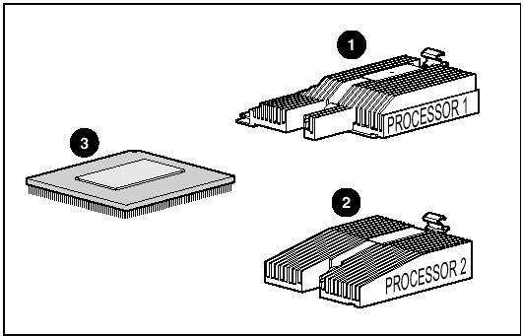
Locate the processor and DIMM sockets  - Processor socket 2 (1)  - Processor socket 1 (2)  - DIMM socket 1 (3) | 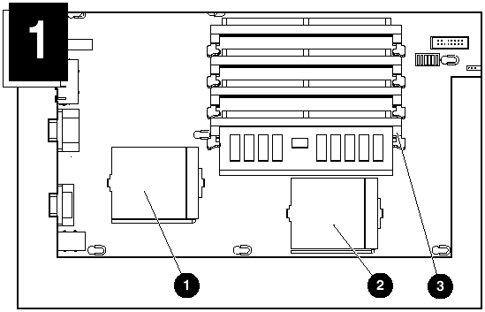
 | 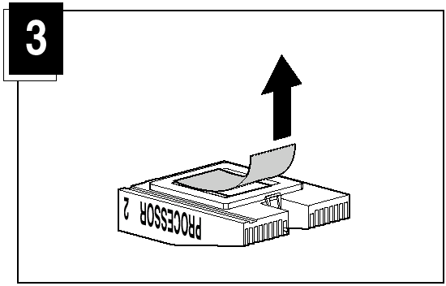
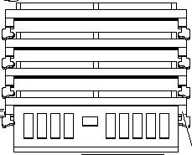
 | 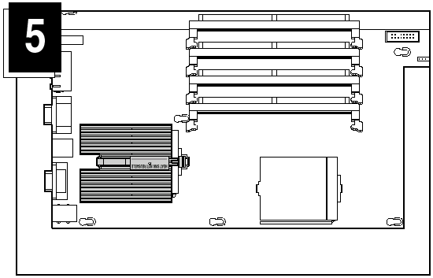
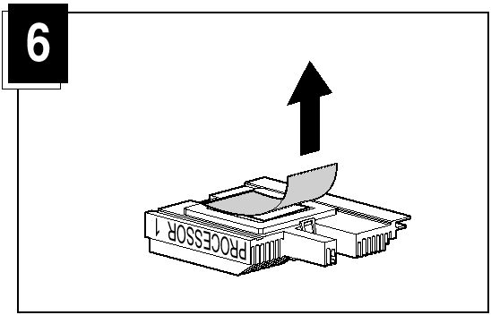
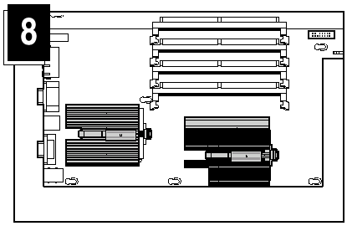 | Notes:  - Replace the DIMM in DIMM socket 1.  - Processor socket 1 must always be populated to ensure proper system operation.  - The system automatically detects and configures processor settings.

Service Considerations
- Failing to flash the ROM before installing a new processor results in system failure. The most recent Compaq ROMpaq can be downloaded from http://www.compaq.com/support/files.
- Before upgrading from a Compaq ProLiant DL360 server processor operating at 550, 800, 866, 933MHz or 1.0GHz ensure that the following components are installed in the system:
  - System board labeled “replace with Compaq spares P/N 239120-001”
  - Fan assembly labeled “replace with Compaq spares P/N 173826-001”
If either part is not present, order and install the 1.13- or 1.26GHz system upgrade kit P/N 236122-B21 before installing the new processors. The system upgrade kit includes a new fan, new system board and several gaskets.
Note:
Failure to install the upgrade kit may result in damage to the processors and the system.
- Never use or reinstall a used heatsink after removal. The thermal material on the bottom of the heatsink is for one-time use only. Used heatsinks do not provide proper heat dissipation and can cause system failure.

Reference
For information on installing the Pentium III 1.13- or 1.26GHz Processor refer to the Pentium III 1.13- or 1.26GHz Processor Installation Card for Compaq ProLiant DL360 Servers. First Edition (July 2001) Part Number 238968-001.

For information on servicing the Compaq ProLiant DL360 Server refer to the Compaq ProLiant DL360 Server Maintenance and Service Guide Fifth Edition (June 2001) Part Number 169616-005 or spare part number 173840-001.

