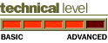[N
.
.
.
.
.
.
.
.
.
.
.
.
.
.
.
.
.
.
.
.
.
.
.
.
.
.
.
.
.
.
.
.
.
.
.
.
.
.
.
.
.
.
.
.
.
.
.
.
.
.
.
.
.
.
.
.
.
.
.
.
.
.
.
.
.
.
.
.
.
.
.
.
.
.
.
.
.
.
.
.
.
.
.
.
.
.
.
.
.
.
.
.
.
.
.
.
.
.
.
.
.
.
.
.
.
.
.
.
.
.
.
.
.
.
.
.
.
.
.
.
.
.
.
.
.
.
.
.
.
.
.
.
.
.
.
.
.
.
.
.
.
.
.
.
.
.
.
.
.
.
.
.
.
.
.
.
.
.
.
.

August, 1999
Prepared by
Micky Balladelli
Senior Consultant
Applied Microsoft Technology Group
Compaq Computer Corporation

Overview of Windows 2000 Active Directory
The Active Directory is one of the most important features of Windows 2000 Server. This White Paper provides a comprehensive overview of the functionality of the Active Directory and reviews its different components.

Notice

.
.
.
.
.
.
.
.
.
.
.
.
.
.
.
.
.
.
.
.
.
.
.
.
.
.
.
.
.
.
.
.
.
.
.
.
.
.
.
.
.
.
.
.
.
.
.
.
.
.
.
.
.
.
.
.
.
.
.
.
.
.
.
.
.
.
.
.
.
.
.
.
.
.
.
.
.
.
.
.
.
.
.
.
.
.
.
.
.
.
.
.
.
.
.
.
.
.
.
.
.
.
.
.
.
.
.
.
.
.
.
.
.
.
.
.
.
.
.
.
.
.
.
.
.
.
.
.
.
.
.
.
.
.
.
.
.
.
.
.
.
.
.
.
.
.
.
.
.
.
.
.
.
.
.
.
.
.
.
.
.

The information in this publication is subject to change without notice.

Compaq Computer Corporation shall not be liable for technical or editorial errors or omissions contained herein, nor for incidental or consequential damages resulting from the furnishing, performance, or use of this material.
This publication does not constitute an endorsement of the product or products that were tested. The configuration or configurations tested or described may or may not be the only available solution. This test is not a determination of product quality or correctness, nor does it ensure compliance with any federal, state or local requirements. Compaq does not warrant products other than its own strictly as stated in Compaq product warranties.
Product names mentioned herein may be trademarks and/or registered trademarks of their respective companies.
Compaq, Contura, Deskpro, Fastart, Compaq Insight Manager, LTE, PageMarq, Systempro, Systempro/LT, ProLiant, TwinTray, LicensePaq, QVision, SLT, ProLinea, SmartStart, NetFlex, DirectPlus, QuickFind, RemotePaq, BackPaq, TechPaq, SpeedPaq, QuickBack, PaqFax, registered United States Patent and Trademark Office.
Aero, Concerto, QuickChoice, ProSignia, Systempro/XL, Net1, SilentCool, LTE Elite, Presario, SmartStation, MiniStation, Vocalyst, PageMate, SoftPaq, FirstPaq, SolutionPaq, EasyPoint, EZ Help, MaxLight, MultiLock, QuickBlank, QuickLock, TriFlex Architecture and UltraView, CompaqCare and the Innovate logo, are trademarks and/or service marks of Compaq Computer Corporation.
Other product names mentioned herein may be trademarks and/or registered trademarks of their respective companies.
©1999 Compaq Computer Corporation. Printed in the U.S.A.
Microsoft, Windows, Windows NT, Windows NT Advanced Server, SQL Server for Windows NT are trademarks and/or registered trademarks of Microsoft Corporation.

August 1999
2nd Revision.
Feedback may be addressed directly to micky.balladelli@compaq.com.

Many thanks to Tony Redmond, Pierre Bijaoui, Don Vickers, Gary Gooding, Dung Hoang Khac and Geoffrey Robb for their comments and inputs to this paper.
Table of contents
Introduction 5
Directory Services 6
Scalability 6
Availability 6
Manageability 6
Security 6
Accessibility 6
What Is The Active Directory 7
Active Directory Namespaces 8
The roles of DNS 8
The role of LDAP 9
Why combine two protocols 9
WINS 10
Domains 10
Organizational Units and Objects 11
Linking Domains To Form Trees And Forests 13
Trust Relationships 13
Trees 14
Forests 15
Floating Single Master Operation roles 15
Schema Master 16
Domain Naming Master 16
PDC Emulator 16
RID Master 16
Infrastructure Master 16
Naming Contexts 17
Global Catalog 17
Groups 17
Universal Groups 18
Global Groups 18
Local Domain Groups 18
Local Group 18
Domain Modes 18
Sites 19
Finding the closest DC 19
Replication 21
Update Sequence Number and Property versions 21
High-Water Mark Vector and Up-to-Date Vector 22
Collisions 22
Replication transports 22
Replication Topology 23
Site Links 23
Site Link Bridges 24
Urgent Replication 24
Naming Conventions 25
Administration Tools 25
Conclusion 26

Figure 1: Objects in the Active Directory 7
Figure 2: Windows NT and Windows 2000 namespaces 8
Figure 3: Windows 2000 Active Directory and a Domain 10
Figure 4: A Domain with Organizational Units 11
Figure 5: Complete Trust Domain Model and Trust transitivity 14
Figure 6: a Tree of domains 14
Figure 7: a Forest of domains 15
Figure 8: Illustrating Sites 19
Figure 9: A Workstation discovering its closest DC 20
Figure 10: Laptop discovering its closest DC 21
Figure 11: Illustrating Inter-Site Replication 24
Figure 12: Microsoft Management Console 26

Introduction
When the Windows NT operating system first shipped in 1993 it was mainly used as a departmental file and print server. Corporations still relied on OpenVMS, UNIX and other operating systems to run their business applications.
The evolution of BackOffice applications and more specifically Microsoft Exchange were the major drivers that made Microsoft enhance Windows NT to meet the requirements of the enterprise. Over the last few years, the Windows NT operating system has evolved from a small workgroup to a large enterprise server. Some limitations remain in Windows NT that prevent true scalability in terms of user accounts.
The Windows NT account database (also known as the Security Account Manager (SAM) database) contains information about users, groups and computers. The SAM database is limited in size to approximately 40MB. This is not an architectural limitation but rather a Microsoft recommendation that it is unwise to exceed this size. In some circumstances, large corporate deployments have encountered the limit. For example, the DIGITAL1 account domain in Compaq contains 33,000 user accounts. The limited size of the SAM database impacts on large deployments that must accommodate tens of thousand accounts. If a single account domain can’t host the required number of accounts, the accounts must be divided across multiple domains. Trust relationships must then be created between the different account domains to allow roaming users to benefit from passthrough authentication and access resources in all the domains. Creating trust relationships is not a difficult task, provided that the number of trusted domains is limited. The number of outgoing trust relationships is restricted to 512 per domain. In addition to account domains, resource domains are often created to delegate resource management. For example, all of the Exchange or SQL servers might be placed in a separate resource domain that can then be managed by a restricted group of administrators. In many cases, the number of resource domains grows to exceed the limit of trust relationships. Inside Compaq, over a thousand resource domains are deployed to support different applications, but trust relationships are seldom granted between resource domains (unless required by a specific application) because it is easy to reach the limit. Many of the resource domains were not created by design and have come about as a result of deploying many different applications that operate at the level of the workgroup within enterprise Windows NT infrastructures.
Scaling Window NT through the deployment of multiple domains makes it difficult to match the naming scheme of the infrastructure with the business organizational or geographical model of the enterprise. Replication of account information can also pose scalability problems for distributed Windows NT deployments. The Windows NT replication model is based on a single master server, which is the owner and writer of the account database. The single master, also called the Primary Domain Controller or PDC, replicates the content of the database to secondary read only servers called Backup Domain Controllers or BDCs. Replication can be either full or partial. Full replication means that the entire content of the SAM database is replicated from the PDC to the various BDCs. Partial replication means that individual objects are replicated between controllers. For example, when a user changes his or her password, only the specific user object is replicated in its entirety. Except for scheduling when replication takes place, large corporations are limited in the number of steps they can take to control Windows NT SAM replication. Another limitation of Windows NT is the lack of a common Directory Service (DS). For example, Windows NT has its SAM database and Exchange Server has its directory. Both store information about NT accounts, but neither leverages the other. Not having a common DS for the enterprise forces applications to deploy their own, resulting in independent islands of information that are difficult to manage and keep up to date.
Windows 2000 is a complete redesign of the operating system that aims to meet the requirements of enterprise deployments. The Active Directory is a scalable and robust DS that is embedded into the operating system. This paper describes how the Active Directory is integrated into Windows 2000.
Directory Services
A DS is a way to lookup and retrieve information from anywhere within a distributed environment.
A DS provides storage for the data, a schema to define what the data is, methods to access it, and is capable of organizing the data in a hierarchical way.
Enterprise information requires certain characteristics from a DS. These include:
- Scalability
- Availability
- Manageability
- Security
- Accessibility
Scalability
The DS must be scalable before it can be deployed in large enterprises. A DS in a large enterprise may contain multiple GB of data. In case of mergers or acquisitions, the DS of two or more enterprises may merge to form an even bigger DS.

Availability
A DS must make information available from anywhere in the enterprise. Searching and retrieving information from the DS must be done within acceptable response times, usually determined in a few seconds. Meeting the requirement for fast and available access means that the directory must be distributed or replicated so that it is closer to the users. Distributing information has impacts in terms of manageability.

Manageability
Different companies may require different management structures, some require a centralized management infrastructure with for examples all the administrators physically located at the same site. Some other companies may prefer administrators disseminated to multiple sites. These requirements are mainly due to the organizational or political structure of the company.
In all cases a DS must be flexible enough to accommodate all needs.
Security
The DS holds sensitive information that must be secured. A security model must be implemented to preserve data integrity and control different levels of access. Delegation of management is another aspect of security that must be accommodated in a distributed management model.
Accessibility
A DS must support different protocols allowing various clients based on different operating systems and interfaces to access the information stored in the directory.
What Is the Active Directory
The Active Directory is the Directory Service for Windows 2000 servers. It is deeply embedded into the operating system. Many other components of Windows 2000 depend on data held in the directory. These facts mean that careful thought must be given to the deployment of the Active Directory before any implementation of Windows 2000 can begin.
The Active Directory provides the storage, the access methods and the security for both the OS and applications that use its services. It is extensible and shareable and it provides the scalability and manageability required by large enterprises. These aspects of the directory are described in later sections.
Many different objects can be stored in the Active Directory, including:
- All the objects necessary for running a Windows 2000 based infrastructure such as:
- Users, Groups
- Security credentials such as Certificates
- System resources such as Computers (or servers) and resources
- Replication components, settings are themselves objects in the Active Directory.
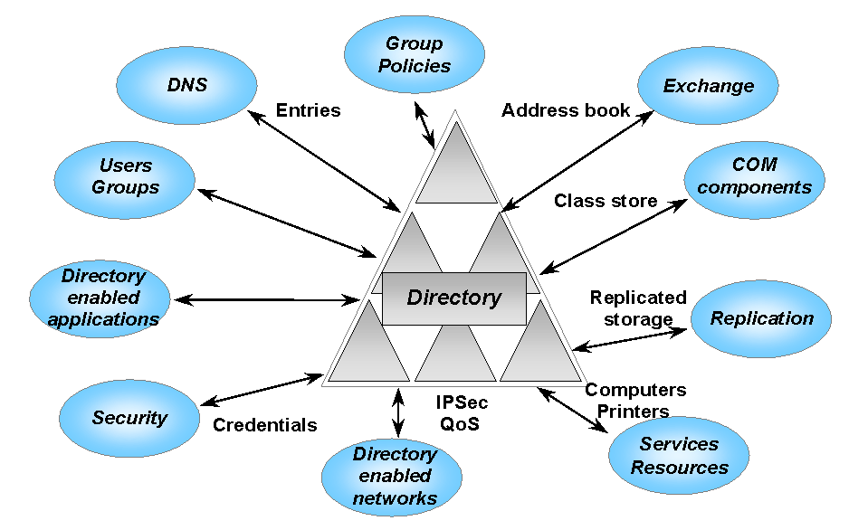
- COM components that required, in previous versions of Windows NT, storing in the registry information about their location are now stored in the Class Store in the Active Directory
- Rules and policies to control the working environment
- Active Directory Enabled Applications can extend the schema of the AD to define their own objects. The next functionality release of Microsoft Exchange Server will be the first AD enabled application. This version of Exchange will use the Active Directory to store information about servers, mailboxes, recipients, and distribution lists in the Active Directory.
- Directory Enabled Networks use the Active Directory to retrieve security rules and user and computer settings to set the networking environment.
- Domain Naming Service (DNS) can store its data in the Active Directory and take advantage of its replication features.
Figure 1: Objects in the Active Directory
Active Directory Namespaces
Windows NT uses a flat namespace, meaning that the name of domains does not reflect a hierarchical naming structure representing the geographical or business organization of the company. The names of domains in Windows NT are based on the NetBIOS convention and can be up to 15 alphanumeric characters. Windows NT uses Windows Naming Service (WINS) to resolve NetBIOS names into IP addresses. NetBIOS names can also be used to refer to services on the network such as directory shares or printer shares.
Figure 2: Windows NT and Windows 2000 namespaces

While WINS is the primary name resolution service in Windows NT, DNS is used to resolve IP based host names for applications such as FTP or Telnet.
DNS today is configured via static files, which contain information about server or host computers. Administrators are required to manually create or update details about the hosts in the domain that they manage. On the other hand, WINS is configured automatically at system boot. The only requirement imposed by WINS is that the NetBIOS name requested by the system is unique on the network.
The Windows 2000 namespace is hierarchical. This fact has a tremendous impact on the roles of services such as DNS and WINS. DNS becomes the primary name service for Windows 2000, which implements a new version called Dynamic DNS to overcome the management limitations of classic DNS. Dynamic DNS also takes advantage of a new feature (SRV records – see section later on in this paper) that allows Windows 2000 to resolve the names of services and locate computers that provide those services.
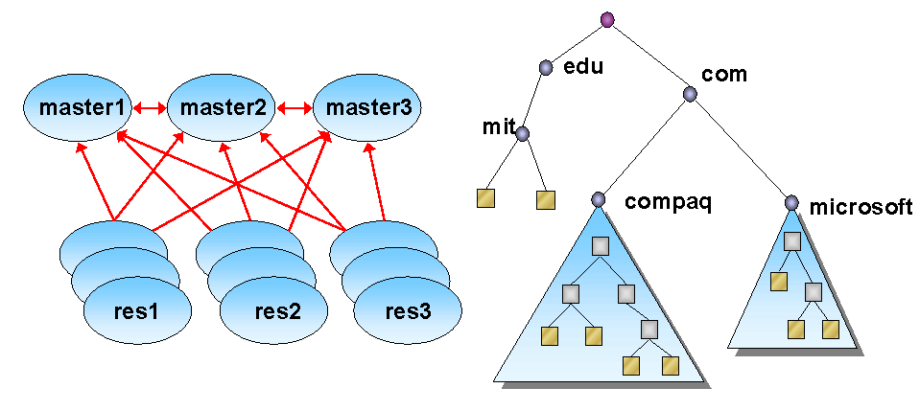
While DNS is used to find servers and services in the Active Directory, the Lightweight Directory Access Protocol (LDAP) is also used to reference objects in the Directory. On first sight, the roles of DNS and LDAP seem overlapping but are instead complementary.

The role of DNS
Today, largely because of its role as the naming service used by the Internet, DNS is the largest naming service in general use. In addition to the Internet, any company that uses an IP based network, depends on DNS to resolve “friendly” names (those given to computers) into 32 bit IP addresses (and vice-versa).
DNS overcomes the limitations of the static host table (HOST.TXT), a file mapping host names and IP addresses. The most notable limitations imposed by the static host table are:
- Scalability. Due to its inherent distributed nature, DNS is very scalable. A simple list of server to IP address translations maintained in a text file scales with difficulty.
- Dissemination of updated information. Every host is required to regularly retrieve updated information about other host computers in the network. DNS servers receive updates about other servers via an automated replication mechanism, which ensures that each server maintains a fully synchronized database containing information about the computers in the network.
DNS has two roles in Windows 2000:
- Windows 2000 uses DNS domain names as its basic naming scheme. This means that the same name can used to find computers across the Internet and within a Windows 2000 infrastructure. For example, compaq.com is the DNS domain name registered by Compaq with the Internet’s Network Information Center (NIC). The NIC manages the names of all the registered systems on the Internet to ensure that computers from different companies can be easily located. After Compaq has completed its Windows 2000 deployment, compaq.com will also be a Windows 2000 domain name. Using the same name for different purposes can bring some confusion as to what a domain is. In this document the term domain is used to refer to Windows 2000 domains, and the term DNS domain is used to refer to DNS domains. We will come back to Windows 2000 domains in a later section.
- Dynamic DNS, an updated version of DNS, supports records that point to network services. The new records are called SRV records and are specified in the Internet Engineering Task Force (IETF) Request For Comments (RFC) number RFC2052.
Windows 2000 implements Dynamic DNS (IETF RFC2136). Dynamic DNS allows servers and workstations to automatically update the DNS database when they boot, removing the administration burden of previous versions that required manual modifications of the database. In addition, dynamic DNS can be configured to control which servers and workstations are allowed to update the database during boot time.

Windows 2000 is not the only system to provide Dynamic DNS support. For example, Berkeley Internet Name Domain (BIND) version 8.1.2 (BIND-8) implements Dynamic DNS. BIND can be used with Windows 2000 since it also supports SRV records.

Microsoft DNS has one major advantage over BIND for Windows 2000 networks in that the Microsoft implementation of DNS can be integrated in the Active Directory. This means that DNS uses the Active Directory for data storage and replication, and no separate effort is required to design and maintain a DNS network.

The role of LDAP
LDAP is an IETF standard described in RFC 1777. The latest version (LDAP V3.0) is described in RFC 2251.
In essence, LDAP is a lightweight version of DAP, the X.500 Directory Access Protocol. Over the past few years, LDAP has become the most commonly accepted directory access protocol and is supported in implementations of X.500, the NetWare DS, and the Microsoft Exchange (5.0 and 5.5) directories. DSLDAP V3 is implemented in Windows 2000 and is used by applications to access the hierarchically organized objects in the Active Directory.
Why combine two protocols
As we’ve seen, two separate protocols (DNS and LDAP) are used by Windows 2000 to access data in the Active Directory. Some explanation is required to outline why two protocols are required and when they are used.
DNS is a very effective and well-proven protocol for locating hosts computers. Windows 2000 uses DNS to find LDAP servers within its network. In fact, the LDAP Servers are Domain Controllers (DCs), and once they are located, Windows 2000 then uses LDAP to access the data managed by the DCs. LDAP is most efficient at retrieving information organized in finely-grained attributes, such as the properties maintained for objects in the Active Directory. DNS is therefore used to locate the LDAP servers, and all further access to directory information is accomplished with LDAP.
WINS
WINS provides the primary naming service in Windows NT V4.0 networks. Due to the adoption of DNS and LDAP, Windows 2000 does not use WINS as a naming service. However, an improved version of WINS is still supported for backward compatibility. WINS is required during the migration phase to ensure that servers and clients which depend on WINS can continue to access Windows NT resources even though these resources are being migrated to Windows 2000.
The improved version of WINS incorporates the following changes:
- Manual Tombstoning (indicating records marked for deletion)
- Improved Management Tool (MMC, Multi-Thread support)
- Enhanced Filtering and Record Searching
- Dynamic Record Deletion and Multi-Select
- Record Verification, Version Number Validation
- Consistency checking (intensive with bandwidth!)
- Export Function (use Excel to produce reports)
- Increased Fault Tolerance (clients to define 12 servers)
- Dynamic Re-registration

Domains
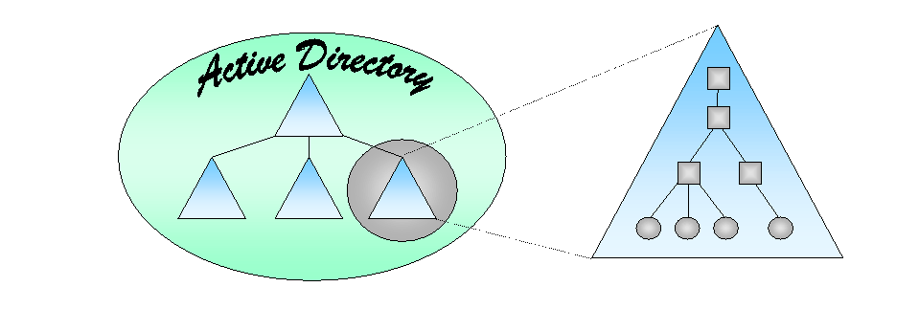
Similar to Windows NT, a Windows 2000 domain is a security boundary. What this means is that a domain boundary limits the scope of access control and policy rules implemented within the domain.
Figure 3: Windows 2000 Active Directory and a Domain

A domain is also a partition of the Active Directory. In this respect, a domain is a partition of the data and the namespace held in the Active Directory. In fact, the Active Directory is the sum of all domains within an enterprise. In other words, the Active Directory is composed of one or more domains linked together. As the namespace within the Active Directory is hierarchical, the domain structure in Windows 2000 is made up of a series of parent/child relationships between the different domains. This is very different to the trust relationships that connected domains in earlier versions of Windows NT.
Windows NT uses a single master replication model. In this model, all changes are made at a single primary domain controller and then replicated out to the backup domain controllers. The Active Directory allows Windows 2000 to use a multi-master replication model. This means that an administrator can use any Domain Controller in a Windows 2000 domain to manage resources. The need to connect to the primary domain controller is therefore eliminated. As previously noted, the Windows NT SAM database is limited to a size of approximately 40 MB, in turn limiting the size of a domain to the number of accounts that can be stored in the SAM. By comparison, the Active Directory can grow to store millions of objects, so Windows 2000 domains can contain millions of accounts. Tests performed by Compaq demonstrated that a Windows 2000 domain with 16 million accounts can be created and used without obvious performance degradation.
Organizational Units and Objects
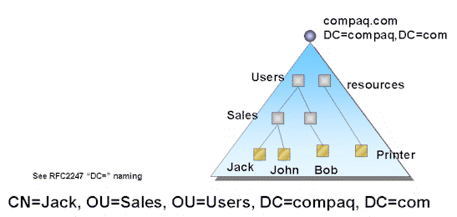
The Active Directory is built from a collection of organizational units (or OU), which form the base of the hierarchical representation of objects within a domain. An OU is a general object container. It can contain any object in the domain including other OUs.
Figure 4: A Domain with Organizational Units

OUs can be used to delegate Administration control to a particular group of users without allowing them to have administrative permissions for other objects in the Domain. Delegation of administration must not however be confused with access control. OUs are not groups and must not be used to control access to resources within the domain. We will discuss groups in a later section.

Active Directory objects include users, groups, computers and printers to name but a few. Objects can be organized hierarchically using organizational units.
Every object in the Active Directory has a unique name referenced by a LDAP Distinguished name (DN). Distinguished Names are the fully qualified LDAP representation of an object and are composed of a sequence of Relative Distinguished Names (RDN). RDNs are a portion of a DN identifying all the ancestors or containers of the object and the object itself.
Figure 4 illustrates a domain composed of a number of organizational units. The user Jack is referenced by the RDN CN=Jack. User Jack belongs to a number of Organizational Units. Each OU is identified by its own RDN and in the hierarchical order in which they were created. The OUs belong to the compaq.com domain, which is referenced by the Domain DC RDN. The full representation of the distinguished name is the sum of all the RDN composing it, which results in:
CN=JACK; OU=SALES; OU=USERS; DC=COMPAQ; DC=COM
To retrieve the full description of Distinguished Names refer to RFC2247.

Active Directory Schema
The Schema contains the definition of all the objects in the Active Directory. Every object has its own class and a set of Attributes (also called Properties) associated to it. A class is the unit of storage in the Active Directory. This means that for an object to be stored in the Active Directory it must first have a class that defines how it is stored and what attributes it may have.
Attributes hold the value of a particular property in the object. Attributes are typed, that means that their value is stored as a string, or octet or numeric, etc. Attributes may be multi-valued, this means that an attribute may be stored using multiple values. For example a user may have multiple telephone numbers.
The internal structure of the Active Directory can be compared to a relational database. Objects are stored in a large table. Each object is stored in a row within the table, and the different attributes for objects are stored in the columns in the table.
When an attribute is not used, it doesn’t occupy any space within the database. For example, if the telephone number attribute for a user object is not filled, the column will be empty and no space will be allocated to store the attribute inside the database. This feature is necessary since the number of attributes associated to an object may be considerable. For example the class user went from a few attributes in Windows NT 4.0 to a more than a hundred in Windows 2000.
Attributes may be associated to multiple classes, which means that they are created independently from classes. Attributes have their own id (described below) and their own characteristics.
The Active Directory Schema is object-oriented. This means that classes can derive from other classes to inherit their characteristics.
Let us take for example the class user, which as its name implies describes the user object. The class user is associated with a number of attributes related to the user account such as principalName, logonHours, groupMembership and many more.
The class user derives from the class organizationalPerson. The class organizationalPerson defines a person with attributes such as homePostalAddress, homeNumber, mobile, EmployeeID, and more.
Now, organizationalPerson derives from person, which simply defines 4 attributes: cn, seeAlso, sn, userPassword and telephoneNumber.
The class user also inherits from the characteristics of both organizationalPerson and person, its parent classes (super-classes in object oriented terms), which means that the instance of a user may also have any of the attributes associated with organizationalPerson and person. Looking carefully at the person class, we can see that cn, which stands for common name, is a mandatory attribute.
There are two types of attributes, Mandatory and Optional. Mandatory attributes must be provided with a value to allow the object to be created. Given that cn is the only mandatory attribute of class user and its parents, to create an object of class user we must define its common name or cn. Optional attributes may be filled after the object has been created and are not required to create the object.
Please note that the names of the attributes referenced above may change in the final release and were used as an example to show class inheritance.
Classes and attributes have a unique ID and mentioned above. This ID is called, wrongly, the Object ID (OID). I say wrongly because in object-oriented terms an object is the instance of a class, so the term should really have been Class ID. Given that OID comes from the X.500 world and can be found in other DS implementations such as Exchange, Microsoft decided to use the same term in the Active Directory.
There may be multiple instances of the class user: users Joe and Jack may be those instances. The OID identifies the class user while the Globally Unique Identifier (GUID) identifies the instances of the objects. GUIDs are generated by the operating system when the object is created. They are 128 bit numbers computed to be unique. Various “Issuing Authorities” such as the ISO issue OIDs, enterprises can then extend them to add their own class extensions.
Objects are identified by their GUID, not by their name. This allows objects to be always referenced when they are moved or are renamed. This behavior is an improvement over how Exchange references the objects it manages. Exchange uses a DN for every object and not the object GUID. This implies that when an object has to be moved in Exchange, it must first be deleted and then be recreated. Using GUIDs, objects can be moved anywhere in the domain but also within the forest.
The schema itself is stored in the Active Directory. This is very important because it allows Active Directory enabled applications to programmatically browse the directory, learn how objects (or classes) are defined and adapt a User Interface accordingly. These schema-driven applications automatically adapt to meet the requirements of different companies. These applications are able to view and manage Active Directory objects that have been implemented in different ways at different companies. For example, a company may require a particular set of attributes to identify the organization in which users belong. In Compaq, we use user badge numbers and cost centers. Another company may have a totally different identification system based on some other business rules. A schema-driven application could browse the directory for the definition of a user. When the application needs to display a UI for a user, it does it following the schema definition, and in our example, the cost-center and badge number would be part of the list of displayed attributes.
Applications can extend the Active Directory with their own class definitions or extend the definition of an existing class. For example, Microsoft Exchange Server extends the user object to allow it store information about mailboxes on an Exchange server. One of the most important features introduced in Windows 2000 is that different levels of access control can be defined to allow users to view different portions of an object. For example, we might want to have different levels of administrative access to user objects. We can define a set of administrators that are allowed to modify user passwords and modify logon hours. We can then define a different set of administrators, which might come from the HR department that can manage sensitive user information such as home addresses, personal telephone numbers and so on. The goal is to permit different views of information held in a common directory, allowing administrators to access the information they need to do their job while restricting access to data that shouldn’t be generally available.
Linking Domains To Form Trees And Forests
Windows NT links domains together through trust relationships. The collection of Windows NT domains that are linked together form the enterprise Windows NT infrastructure. Domains can also be linked together in Windows 2000, in this case to form the enterprise namespace. However, the link set by a trust relationship in Windows NT establishes a very loose connection between the participating domains. Connecting Windows 2000 domains together within an enterprise namespace forms a far more coherent and well-connected infrastructure..
Trust Relationships
As illustrated in the left-hand picture in Figure 5, trust relationships link Windows NT domains together. Trusts allow users in trusted domains to access resources in the trusting domain.
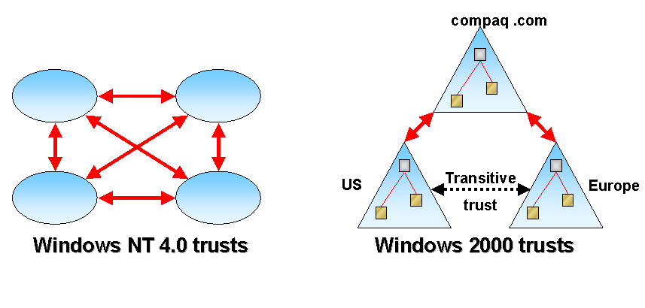
Trust relationships must be explicitly defined. As we’ve already seen, there are a number of limitations that must be considered when setting up trust relationships in large enterprise deployments. Trust relationships also exist in Windows 2000, but the trusts take on a very different nature because they are based on Kerberos and can be transitive. The right hand picture in Figure 5 illustrates how Windows 2000 trusts might be used to connect Windows 2000 domains together. In this instance, the US domain trusts the Compaq domain, which in turn trusts the Europe domain. In Windows NT, no trust would exist between the US and Europe domains because no formal trust relationship has been established to connect the two. However, in Windows 2000, the Kerberos-based trust means that the US and Europe domains trust each other through the transitive trust relationship established through the Compaq domain.
Figure 5: Complete Trust Model and Trust transitivity

Figure 5: a Complete Trust domain model and Trust transitivity

Trees
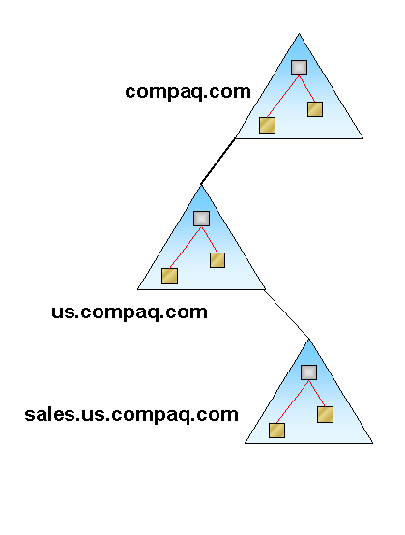
Trees are hierarchies of domains linked by trust relationships. Each tree shares a a contiguous namespace. Figure 6 illustrates a tree formed by the Compaq, US, and Sales domains. The names of the three domains are compaq, us.compaq and sales.us.compaq. The names are contiguous as the child domains inherit from the names of the parent domains. Hence, the US domain inherits part of its name from its parent Compaq domain and in turn provides the root of the name for its child Sales domain.
New sub-trees can be created within a tree. So for example we could create a new sub-tree under the compaq domain, europe. This new sub-tree would then be called europe.compaq. The europe portion of the name is contiguous is the compaq name, but is disjointed from the us name. This is why we have two separate sub-trees, the europe sub-tree and the us sub-tree.
Figure 6: a Tree of domains

Forests
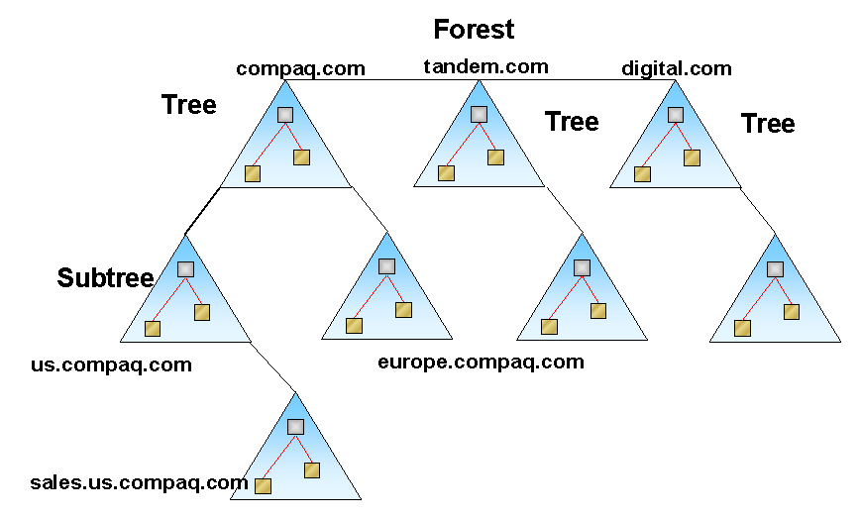
A forest is a set of trees linked together via trust relationships. The trees that are joined together at the top level of the forest do not necessarily have to share the same namespace.
Figure 7: a Forest of domains

Figure 7 illustrates a forest formed by three trees. The trees are formed from domains called Compaq, Digital, and Tandem. After the forest is formed each domain remains unchanged, and each domain remains at the head of its own tree. A forest is sometimes referred to as the Active Directory. Earlier we defined a domain to be a portion of the Active Directory and we defined the Active Directory as the sum of all the domains that are connected together. A forest is exactly this: the sum of all trees, which are composed of domains connected together via Kerberos trusts. A forest and the Active Directory is the same thing.

The trees within the same forest share the following:
- A common configuration. The topology of the domains within the forest is known by all domains and is replicated immediately whenever a new domain joins the forest.
- A common schema. The schema defines all the objects in the forest.
- A common Global Catalog (GC). Global Catalogs are discussed later on in this paper.

Flexible Single Master Operation roles
Windows 2000 supports multi-master replication of Directory data. This means that any DC in the domain can be used to modify the values of an object. Replication then occurs between DCs to update all the DCs with the latest data for the object. Inevitably, some potential for update conflicts exists in a multi-master replication model. The replication process is covered in more detail later on but for now it is enough to say that when a replication conflict occurs the time stamps of each modification are evaluated, and the last writer wins.
Some objects in the Directory, such as the schema itself, cannot be resolved with such methods because two versions of the schema may generate instances of objects using different properties. It would be hard to resolve such conflicts without losing data. To avoid schema conflicts, a single-master replication mechanism is performed by a special DC called the Schema Master. This is one of 5 Flexible Single Master Operation (FSMO, pronounce Fizmo) roles implemented in a single-master replication model.

Schema Master
The Schema Master is unique in the entire forest. New Classes or Attributes can only be created by the Schema Master. Updates are then replicated to all domains in the forest.

Domain Naming Master
The Domain Naming Master manages the names of every domain in the forest. It is unique in the forest. Only the Domain Naming Master can add and remove domains in the tree or forest to avoid that naming conflicts occur. In future releases, the Domain Naming Master will allow domain moves within the forest.

PDC Emulator
The PDC Emulator is unique in the Domain and provides backward compatibility to downlevel clients and servers in the following ways:
- Provides downlevel clients support for password updates
- Performs replication to downlevel BDCs
- It acts as the Master Domain Browser, if the Windows NT Browser service is enabled
Windows 2000 DCs replicate password changes to the PDC first. Each time a DC fails to authenticate a password it contacts the PDC to see whether the password can be authenticated there, perhaps as a result of a change that has not yet been replicated down to the particular DC.

RID Master
The RID Master is unique in the Domain.
When a Security Principal (e.g. User, Group) is created, it receives a domain wide Security ID (SID), and a domain-wide unique Relative ID (RID).
Every Windows 2000 DC receives a pool of RIDs it can use. The RID Master ensures that these ID remain unique on every DC by assigning different pools.

Infrastructure Master
The Infrastructure Master is unique in the Domain.
When an object from another domain is referenced, this reference contains the GUID, the SID and the DN of that object. If the referenced object moves the following happens:
- The object GUID does not change (issued when the object is created and never changes)
- The object SID changes if the move is cross-domain (to receive a SID from the new domain)
- The object DN always changes
A DC holding the infrastructure master role in a domain is responsible for updating the SIDs and DNs in cross-domain object references in that domain.

Naming Contexts
Naming contexts (NC) are portions of the Active Directory that follow different replication rules, they are boundaries for Active Directory replication.

The Domain NC (also called the User NC) contains all the data within a domain. It is replicated only within the domain.
The Schema NC contains all the classes and attributes and is replicated throughout the forest.
The Configuration NC contains the topology of the forest and is replicated throughout the forest.
The three naming contexts are replicated in the Global Catalog either entirely or partially. The next section describes why in more details.
All naming contexts have a location in the directory. The root of a domain namespace is its DNS name and all objects within the domain are children of this root.
When the first domain is created, it contains the configuration NC. The Configuration NC is the parent of the Schema NC.
Global Catalog
The Global Catalog (GC) contains a subset of the attributes of all Domain NC objects in the forest as well as the Schema NC and the Configuration NC. The role of the GC is to provide the Active Directory with a search engine. By containing a partial replica of all the objects in the forest, GCs become extremely fast search engines.
The subset of the attributes is defined and modifiable in the schema and is by default the attributes most commonly searched, such as name, e-mail address and phone number for a user.
Any DC can be configured to become a GC. A GC incurs more overhead than a DC because it performs more replication and requires more disk space for its database. However, because users and applications connect to the GC to search for objects in the Active Directory, it is recommended to deploy enough GCs to ensure that clients can make a high-quality connection. Normally, this implies a LAN-quality connection established by locating a GC close to each major user community.
In order to understand how a search works against a GC, let’s imagine that we are looking for a color printer that is located in the same floor in a building. We only know a subset of the characteristics of the printer we wish to use. . We know that it supports color and we have a rough idea of its location, but we don’t know its network name, so we can’t connect to it and print our documents. We can use LDAP to search the indexes maintained by the GC for all matching printer objects using the known characteristics. The search will return all matching objects, hopefully including the printer we want to use.
Without the GC, we would have to conduct a search against a domain controller and drill-down through the entire forest. Such a search would take too much time and the response time would be unacceptable.
Groups
Windows NT supports groups, literally a convenient way to bring one or more users together under a common heading. Windows 2000 introduces two types of general-purpose groups: Security and Distribution list.
Security groups contain security principals and are used for access control. Conceptually, security groups are similar in use and function to Windows NT groups. Distribution lists are similar to the distribution lists currently in use by Exchange Server. Both security groups and distribution lists can be used to address messages sent via Exchange. Windows 2000 also introduces four group types with special behavior:

Universal Groups
Universal groups are available throughout the Forest. They may contain other Universal, Global groups or users. Because this type of group may contain objects located anywhere in the forest they are expensive to use in terms of performance when used in ACLs. Authorization still requires authentication performed by the domain in which the user belongs.
Universal groups are published in GCs. This does not mean that a GC provides authentication features. However when used as Distribution lists, replicating them locally to users via GCs provides applications such as Exchange with a convenient, powerful and simple way to implement Global Address List.
The implication of publishing Universal Groups in GCs affects the authentication process. During the authentication process a DC will contact a GC to verify the membership of the user in the Universal groups.

Global Groups
Global groups are available throughout the Forest. They can contain other Global groups and users from the same domain.

Local Domain Groups
Local domain groups are available only in their own domain. Local Domain groups may contain references to Universal groups, Global groups from any domain and Local Domain groups and users from its own domain.

Local Group
Local groups are available only on the local computer, but may contain objects from anywhere in the forest.
Figure 8: Illustrating Sites

Domain Modes
There are two domain modes: Mixed Mode and Native Mode.
Mixed mode is the default mode and is used when a new domain is created or when a Windows NT PDC is upgraded to Windows 2000. Mixed mode implies that there are downlevel servers or domain controllers in the domain. One of the Windows 2000 DCs takes the FSMO role of PDC emulator and acts as a Windows 2000 PDC to the eyes of the downlevel clients and BDCs. This is quite important because it allows Windows NT operations to be maintained while the domain is migrated to Windows 2000.
The groups in the domain use Windows NT behavior when operating in mixed mode, This means that groups cannot be nested. In addition, Universal groups are not available in Mixed mode.
When all the downlevel clients and BDCs have been upgraded to Windows 2000, the domain can be switched over to Native mode. This is a one shot operation that cannot be undone.
Once in Native mode the groups can be nested.
Sites
A site is a collection of IP subnets that share LAN (Local Area Network) type connectivity. In fact, the best way to think of a site is to compare it to a LAN. Sites reflect locality, all the systems belonging to the same site are close to each other and benefit from good bandwidth.
When a Windows 2000 server creates a new domain, the Active Directory creates the site Default-First-Site-Name and stores the DC there. All the DCs joining the domain are added to the default site. Systems continue to be added to the default site until a new site is explicitly created.
The Active Directory will evaluate the IP subnet of the systems joining the domain and will place them accordingly to their appropriate site, if a matching IP subnet is found.
A domain may span multiple sites, as seen in Figure 8, however multiple domains may belong to the same site. Sites are independent from the domains they belong to.
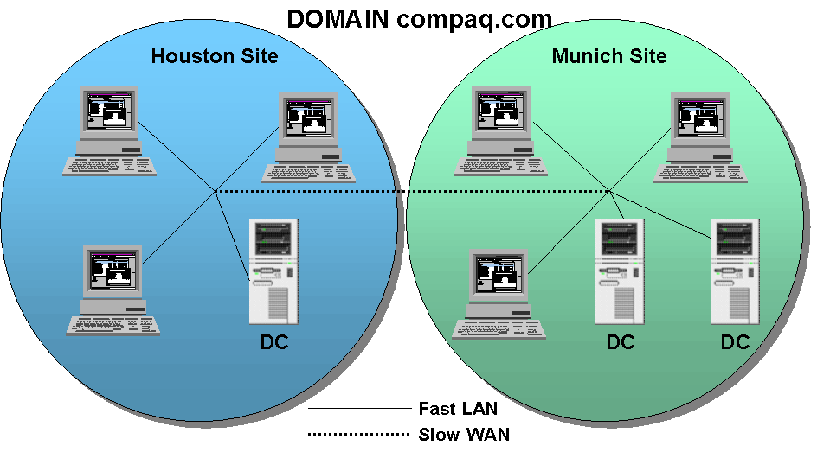
Sites are used for two roles:
Figure 8: Illustrating Sites

- During Workstation logon to determine the closest DC. We will get into how workstations discover their closest DC in the next section
- During Active Directory data replication to optimize the route and transport of replicated data depending on the DCs sites. We will also get deeper into this.
In order to achieve these two roles, all DCs in a domain know about all the sites.

Finding the closest DC
When DCs boot, they publish information about the domain and site they belong to in DNS using SRV records. As previously mentioned they cache information about all sites locally.
When a workstation boots, it either receives its IP address from a DHCP server or the network administrator statically assigned this address to it. DHCP may also provide the DNS server address unless this information was entered manually.
During the logon, the workstation is attempting to locate the closest DC to improve logon performance. The workstation does not have information about sites so it must perform a few steps to receive it.
Figure 9: A Workstation discovering its closest DC
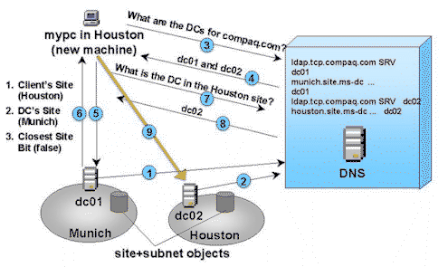
- The workstation asks DNS for DCs in the domain it is trying to logon to. In our example, for the domain compaq.com, DNS returns two names, DC01 and DC02.
- The workstation then performs the logon on the DC01 DC. DC01 accepts the logon and returns information about the site the workstation belongs to. This is possible since the workstation provided its own IP address and the DC was capable to match that IP address with one of the IP subnets forming a site.
- DC01 returns the fact that the workstation does not belong to the Munich site, but it belongs to the Houston site, and that it is not the closest DC available.
- With information about the site it belongs to, the workstation can make a much more specific request to DNS and asks for the DC in the domain that belongs to the Houston site. DNS returns DC02.
- The workstation can then logon to DC02, which is in the same site, and can store site information in its own registry.

Let’s now imagine that the workstation isn’t really one, but it’s a laptop instead, and this laptop travels to Munich, let’s assume that the Munich DHCP provides a new IP address. As shown in figure 10, the following steps now occur:

- The laptop retrieves the site information that it previously stored in the registry and very naturally attempts to retrieve from DNS information about the DC in that site.
- The laptop goes back to DNS simply because the DC that it used previously may have been shutdown or have been replaced with a different one, and if that would have been the case the SRV records in DNS would have been updated. The laptop asks DNS for a DC in the Houston site. DNS returns DC02.
- Upon logon, the DC02 updates the laptop about the new site it belongs to, it mentions that it is no longer the closest site and that it now must logon on a DC in the Munich site.
- The workstation goes back to DNS asks for the DC in the Munich site and DNS return DC01. Now the laptop performs logons on DC01.
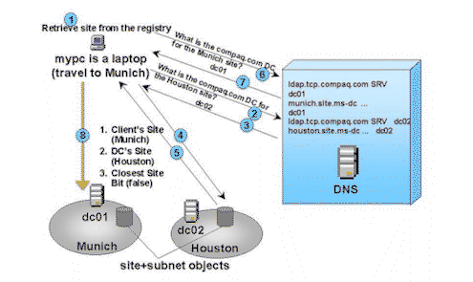
- What is important to see in this example is that the discovery of the closest site was done automatically without Administrator intervention.

Figure 10: Laptop discovering its closest DC

Workstations can be set to contact the DCs that match their own IP subnet first. This can reduce considerably the time required by contacting remote DCs. However a site can be composed of a number of IP subnets and even if a DC and a client are in the same site they could still belong to different subnets. In this case the above scenario would still apply.

Sites play a major role in replication of data. The next section covers replication in more detail.
Replication
Replication of Active Directory information is highly optimized and fairly complex. This section discusses how replication is performed.
Like most directories, the Active Directory is a read-mostly, write-infrequently store. When an object is created, modified, moved or deleted from the directory, the operation is replicated to all DCs within the domain or the forest depending on the Naming Context the object belongs to.
Windows 2000 introduces a multi-master replication model, which means that all DCs in the domain have write access to the replica of the database that they own. A DC can therefore make a change to any object in the domain. When a change is made it is replicated to other controllers to ensure that the Active Directory is kept up to date everywhere.
Update Sequence Number and Property versions
The Update Sequence Number (USN) is a 64 bit number associated with an operation performed on an object or an attribute.
When an attribute is modified the USN is increased atomically, which means that both operations must be valid for any of them to complete. Every object and every attribute in the Active Directory possesses two USNs. The first USN refers to the creation of the attribute. The second refers to the modifications made to the attribute.
In addition to the USN, every attribute has a version number also called property version. This version number is used to differentiate between modifications made through replication and modifications made locally. A write performed by a system and not through replication is called an originating write.
A write operation originated through replication updates the object but does not advance the version number. However, all updates (replication and direct write) cause the USN for the object and the USN for the modified attributes to be updated
High-Watermark Vector and Up-to-Date Vector

The high-water mark vector is a table containing the list of all the replication partners and their highest USN values. Every domain controller in a domain is a replication partner. The high-water mark vector is used to detect changes performed at other DCs that are replication partners.
In an enterprise Windows 2000 network, there may be a large number of DCs. Replication of directory data may follow multiple paths, in turn incurring the risk that attempts might be made to update an object multiple times.
In order to avoid unnecessary replication, the Active Directory uses a table of up-to-date vectors. This table contains the list of replication partners and the highest originating write USN on each partner. Each DC has its own up-to-date vector table, which is sent to the replication partners to filter out unwanted data that is up-to-data. The replication partner matches the USN in the up-to-date vector table with its high-water mark vector table to identify which attributes require to be updated. This operation allows replication dampening since all DCs know which replication partners are up to date and avoid unnecessary replication.
Collisions
In a multi-master replication model, there is a possibility that a concurrent attempt might be made to update the same attribute at two different DCs. Such an update will result in the USN advancing on both DCs. When replication occurs, the changed data is sent to replication partners, which then have to deal with a replication collision. The attribute has been updated multiple times, but which update is most valid and should represent the value of the attribute after the collision is resolved? The Active Directory resolves the conflict by comparing the timestamp of each update. The latest timestamp found is used to determine the update that will be applied, and any update with an earlier timestamp is discarded.
Another possible collision is the creation of an object in a particular OU on one DC. On a different DC an administrator could delete the very same object. In this case the object is created under a deleted OU. How is the object handled? The delete operation on the OU is replicated throughout the domain and the object is moved the Lost & Found container.
Replication transports
Replication occurs both intra-site and inter-site. Intra-site replication is performed through standard Windows NT RPCs. However, different transports can be used to exchange data between domain controllers in different sites. Information is held in the Active Directory about all the domain controllers in each site, the connectivity that exists between each site, and the best route to take to replicate information. Network links between sites vary greatly. To support varying types of connections the Active Directory supports two major replication transports:
- DS-RPC (Directory Services RPC)
- ISM- SMTP (Inter-Site Messaging - Simple Mail Transport Protocol)
A general assumption is made that replication must occur quickly within a site and that there is a low tolerance for inconsistencies within the directory across all controllers in a site. For this reason, intra-site replication is always RPC-based. Inter-site replication can be performed through RPCs or via special forms of SMTP messages exchanged between domain controllers. RPC replication is always synchronous whereas message-based replication is asynchronous. Intra-site replication cannot be scheduled. Each domain controller sends update notifications to its replication partners after updates have occurred. Normally this happens every 5 minutes. This interval is configurable through the system registry. Even if no changes have occurred and replication has not taken place, domain controllers “ping” each other every six hours by broadcasting details of the latest USN held on the controller to ensure that an update has not been missed. After a DC receives a notification that an update is available, it makes a connection to the DC where the change has occurred to initiate replication. Data is not compressed when RPCs are used.
Inter-site replication uses compressed data when it is performed through messaging. The data is compressed to between 10-15% of its original volume before it is sent. CPU cycles are required to compress and expand the replication data, but the overhead required in CPU cycles is more than compensated by the reduction in data that passes across the network. Unlike Exchange Server, which replicates complete objects whenever an attribute is changed, the Active Directory is able to replicate on an attribute level, which greatly reduces the amount of data involved in all replication activities. Inter-site replication can also be scheduled to occur at a particular time.
Between sites connectivity may not be as good, and replication may take advantage of compression and scheduling. Scheduling and compression may be specifically defined, however a replication topology can be automatically generated. Let’s see how.
Replication Topology
When a new Windows 2000 domain is created and there is only one DC in the domain, no replication is necessary and none occurs. When, however a second DC joins the network, let’s say in the same site, a service called the Knowledge Consistency Checker (KCC) generates the replication topology between the two DCs. The KCC has a very important role to play because it generates and optimizes replication paths used by the various DCs.
The two controllers are in the same site, so two uni-directional connections are created. These DS Connection Objects are authenticated channels between the two DCs that allow them to exchange replication information. The replicated data depends on the Naming Context to be replicated. When the two DCs connect for the first time, all NCs are replicated: the configuration, the schema and the domain to which the first DC belongs. Between DCs of different domains, only the configuration and schema NCs are replicated. In the case of a DC that is also a global catalog, the three NCs will be replicated with an exception to the domain NC, of which only a subset will be replicated.
When additional DCs join the domain in the same site, the KCC will automatically create all the required connection objects and avoid duplicates. In order to optimize the number of connections created, the KCC on each DC will attempt to compute the required number of connections required for every DC in the site so that the number of hops between itself and any other DC in the site is three at the most.
Site Links
Inter-site replication requires an explicit Site link to be created. As the name indicates a site link, links two sites together. A site link represents a network between two sites.
A site link has a cost associated to it. The cost is used to determine how easily data can be replicated between sites. When multiple sites are linked together using site links the KCC will use the cost and the site link availability schedule to determine which connection objects must be created between DCs to enable replication.
The KCC will create a spanning tree of connection objects between DC at different sites. Spanning trees avoid a loop to be created between the sites and the replication is based on a store and forward model. This is contrary to intra-site replication where a pull replication model is in place. This is very much like Exchange Server replication is performed.
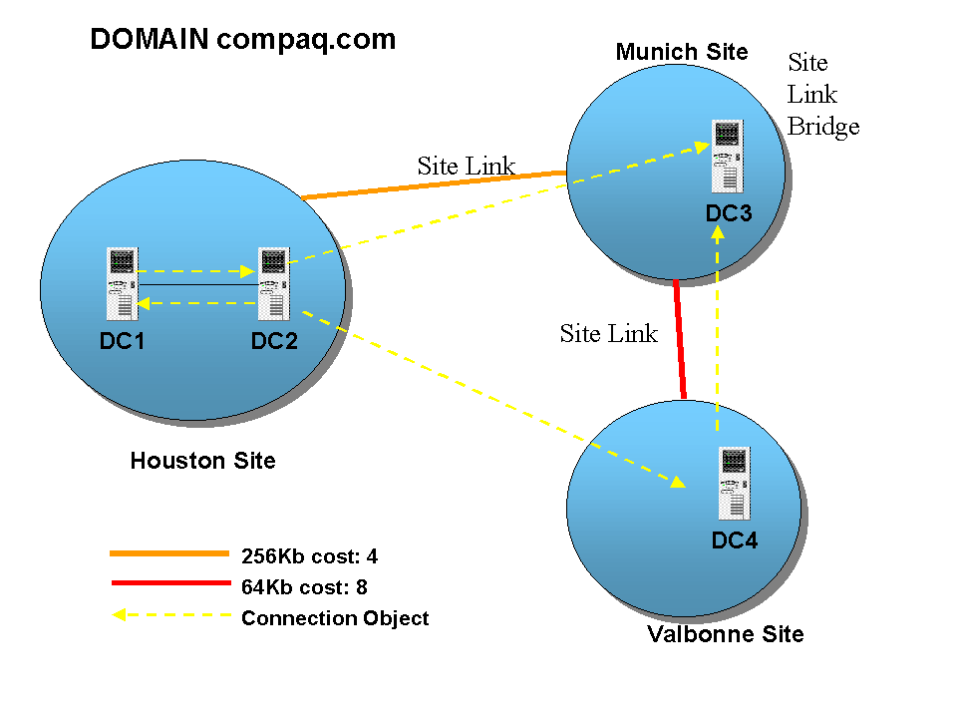Site Link Bridges
A Site Link Bridge connects two site links to form a bridge. Think of Site Link Bridges as routers that connect two networks together. In replication terms, these networks are Site Links.
In our example illustrated in figure 11, we a Site Link Bridge connecting the Site Link from Houston to Munich and from Munich to Valbonne. Without the Site Link Bridge the DCs in Houston and the DCs in Valbonne wouldn’t be able to exchange information.
To Replicate from DC2 to DC4 it costs: 4+8 =12. If the KCC could find an alternative path with less cost to replicate, it would generate the Connection Objects using that path.
Figure 11: Illustrating Inter-Site Replication

Urgent Replication
Even though priority cannot be assigned to the replication of different Active Directory Objects, some objects replicate faster than others. For example, when an account is disabled or locked out, this change must be replicated as quickly as possible to all DCs for obvious security reasons.
Another case of Urgent Replication is the assignment of RID pools without which a DC cannot assign a SID when a Security Principal is created.

Supported Protocols and APIs
The Active Directory supports both LDAP V2 and LDAP V3 protocols (RFC 1777 and 2251) and HTTP. LDAP is essential for interoperability reasons, as most of the DS implementations are supporting it.
The supported APIs are:
- Active Directory Service Interface (ADSI), a set of COM interfaces for searching and managing various directories services.
- LDAP API, a low-level C interface (RFC 1823). However, access to the Active Directory via this interface is not recommended as ADSI is available.
- MAPI, the Windows Open Services Architecture (WOSA) Messaging API. MAPI is supported for backward compatibility, largely to support access from MAPI clients like Outlook 98 and Outlook 2000. Other messaging clients (like Outlook Express) use LDAP.
Naming Conventions
The Active Directory supports a number of naming conventions that are already widely spread either in the Internet or in various DS implementations. These are:
- RFC822 names are in the form of JohnS@compaq.com. Anyone using the Internet or an IP based network are familiar with these names as they serve as e-mail addresses.
In Windows 2000, these names can be used to logon as they allow concatenating the username and the logon domain.
- HTTP URL names allow accessing Active Directory data using Web browsers.
HTTP://SomeServer.compaq.com/Product/Sales/JohnS
- LDAP URLs
The Active Directory supports access via the LDAP protocol from any LDAP-enabled client.
LDAP://SomeServer.compaq.com/CN=JohnS, OU=Sales, OU=Product, DC=compaq, DC=com
- Universal Naming Convention (UNC) Names were the norm in Windows NT and are still supported in Windows 2000.
\\compaq.com\product\sales\john\public\budget.xls
Administration Tools
Windows 2000 uses the Microsoft Management Console (MMC) as the common infrastructure for management tools. The management tools designed for the MMC are snap-ins or COM based applications that snap into the MMC. Snap-ins are easy to use as they are based on a graphical user interface.
All the Windows NT management tools from have been migrated to snap-ins. The MMC allows a customization of the snap-ins that are loaded and allows saving the console with the snap-ins loaded. This way, administrators can create custom management consoles dedicated to particular tasks. The console in the figure shows 4 snap-in loaded:
- Active Directory Domains and Trusts, managing the trust relationships between domains
- Active Directory Schema Manager, which is the snap-in used to modify the content of the schema
- Active Directory Sites and Services, used to manage the replication topology and connectivity between DCs and Sites
- Active Directory Users and Groups, the replacement of User Manager for Domains, managing users, groups and the hierarchical organization of a domain.
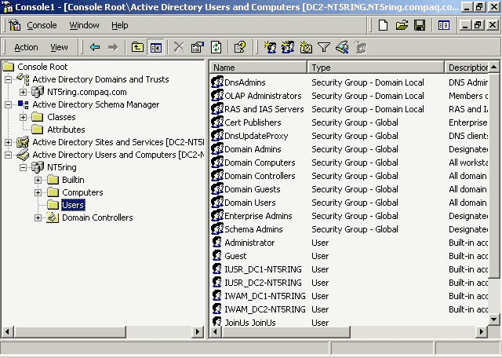
Figure 12: Microsoft Management Console

Many more snap-ins exist and applications will provide add-ins to manage objects that they add to the Active Directory. Tools provided in Visual Studio V6.0 allow programmers to write additional add-ins, if required.
Conclusion
Windows 2000 is a lot more than a major upgrade, it’s a whole new operating system that was designed with clearly the enterprise in mind. The Active Directory is the most important technology introduced in Windows 2000. It provides the foundation for the enterprise infrastructure.
Before attempting to design a Windows 2000 based infrastructure one should carefully understand the replication topology required for effectively disseminate data throughout the enterprise so that it remains available at a reasonable cost. Understanding how the schema must evolve, what objects should be published in the directory and understanding who need to have access to what are prerequisites for a successful Windows 2000 design. Always keep in mind that designing a Windows 2000 infrastructure involves designing the DNS namespace, the domain and organizational unit structure and possibly the Exchange Server and other Active Directory Enabled applications infrastructures.

