September 1999
PS-99-23
Prepared by Compaq Professional Services Technology Group
Compaq Computer Corporation

Contents
Introduction 3
Knowledge Management:
An Integral Part of an
E-Business Strategy 4
Why Are Businesses Interested in Knowledge Management? 5
Knowledge Management: More Than Technology 9
Technical Solution Domains 10
Emerging Best Practices and Applications in Knowledge Management 16
Conclusion 41
Readings and References 41
Acknowledgments 42

Knowledge Management: Approaching Solutions
Abstract: Knowledge Management (KM) is a churning topic in the information technology and business management consulting industries. The term is applied in such an inconsistent variety of contexts that there is not — and cannot be — a common model for a “KM solution” that is accepted and understood in the market.
The purpose of this paper is to provide the Compaq community, including our partners and customers, with a common language and conceptual framework to use in exploring, designing, planning, implementing, and managing Knowledge Management solutions. It addresses the questions:
- How does Knowledge Management fit into a company’s
e-business strategy?
- What are some of the key business problems for which a Knowledge Management approach is appropriate?
- What are the key infrastructure technologies that are used in supporting Knowledge Management solutions?
- What are the emerging best practices in Knowledge Management applications and programs?
- What are the critical success factors in the design and implementation of Knowledge Management programs and systems?
This document draws extensively from examples of Compaq’s internal expertise in developing its intranet applications to support knowledge workers, and from the experience of the Compaq Professional Services Knowledge Management programs and initiatives.

Notice
The information in this publication is subject to change without notice and is provided “AS IS” WITHOUT WARRANTY OF ANY KIND. THE ENTIRE RISK ARISING OUT OF THE USE OF THIS INFORMATION REMAINS WITH RECIPIENT. IN NO EVENT SHALL COMPAQ BE LIABLE FOR ANY DIRECT, CONSEQUENTIAL, INCIDENTAL, SPECIAL, PUNITIVE OR OTHER DAMAGES WHATSOEVER (INCLUDING WITHOUT LIMITATION, DAMAGES FOR LOSS OF BUSINESS PROFITS, BUSINESS INTERRUPTION OR LOSS OF BUSINESS INFORMATION), EVEN IF COMPAQ HAS BEEN ADVISED OF THE POSSIBILITY OF SUCH DAMAGES.
The limited warranties for Compaq products are exclusively set forth in the documentation accompanying such products. Nothing herein should be construed as constituting a further or additional warranty.
This publication does not constitute an endorsement of the product or products that were tested. The configuration or configurations tested or described may or may not be the only available solution. This test is not a determination of product quality or correctness, nor does it ensure compliance with any federal, state or local requirements.
Product names mentioned herein may be trademarks and/or registered trademarks of their respective companies.
Compaq, Contura, Deskpro, Fastart, Compaq Insight Manager, LTE, PageMarq, Systempro, Systempro/LT, ProLiant, TwinTray, ROMPaq, LicensePaq, QVision, SLT, ProLinea, SmartStart, NetFlex, DirectPlus, QuickFind, RemotePaq, BackPaq, TechPaq, SpeedPaq, QuickBack, PaqFax, Presario, SilentCool, CompaqCare (design), Aero, SmartStation, MiniStation, and PaqRap registered in United States Patent and Trademark Office.
Netelligent, Armada, Cruiser, Concerto, QuickChoice, ProSignia, Systempro/XL, Net1, LTE Elite, Vocalyst, PageMate, SoftPaq, FirstPaq, SolutionPaq, EasyPoint, EZ Help, MaxLight, MultiLock, QuickBlank, QuickLock, UltraView, Innovate logo, Wonder Tools logo in black/white and color, and Compaq PC Card Solution logo are trademarks and/or service marks of Compaq Computer Corporation.
Microsoft, Windows, Windows NT, Windows NT Server and Workstation, and Microsoft SQL Server for Windows NT are trademarks and/or registered trademarks of Microsoft Corporation.
NetWare and Novell are registered trademarks and intraNetWare, NDS, and Novell Directory Services are trademarks of Novell, Inc.
Pentium is a registered trademark of Intel Corporation.
NonStop registered in U.S. Patent and Trademark Office.
Copyright ©1999 Compaq Computer Corporation. All rights reserved. Printed in the U.S.A.
Knowledge Management: Approaching Solutions
White Paper prepared by Compaq Professional Services Technology Group
Second Edition (September 1999)
Document Number PS-99-23

Introduction
Price Waterhouse Coopers defines Knowledge Management as “…the art of transforming information and intellectual assets into enduring value for an organization’s clients and its people.” A growing number of companies today are pursuing Knowledge Management because of its promise to let them better leverage their collective knowledge through the use of intranets, groupware, relational databases, search engines, and other software tools.
The number of companies that have Knowledge Management initiatives in place jumped from 28% in May of 1997 to 51% in April of 1998.According to a 1999 survey of 200 IT managers by InformationWeek Research, 94% of companies consider Knowledge Management strategic to their business processes. But implementing Knowledge Management is difficult because it involves managing the interaction among people, experience, and problems — and then systematically capturing the results of those interactions and sharing them across global boundaries via technology.
As an emerging business practice, Knowledge Management has wide applicability across industries, markets, and professions. It is not a new application or solution domain: it provides an engaging conceptual model and language for positioning IT and organizational change initiatives. Many companies are feeling increased pressure during the current shift to a knowledge-based economy to better manage:
“
“The productivity of knowledge and knowledge workers will not be the only competitive factor in the world economy. It is, however, likely to become the decisive factor…”
— Peter Drucker
- Intangible assets: dynamic human expertise
- Information assets: the captured documents, designs, physical or electronic, and other fruits of that expertise
- Innovation: corporate strategies that leverage these assets for competitive advantage

Knowledge Management as a strategic activity consists of the systematic management of the intellectual capabilities of people within enabling business, organizational, and technical infrastructures. The most concrete way to provide accessibility to those capabilities is by understanding how to discover, organize, share, and synthesize the fruits of the intellectual activity.
The first step to understanding a Knowledge Management framework is to be clear about the distinctions among data, information, and knowledge. Figure 1 shows a common model with definitions that are widely accepted.

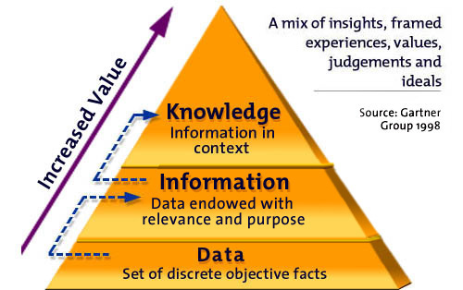
Figure 1: Data to Knowledge

We know how to manage data, and we know how to manage information, but why are we even trying to manage “insights, framed experiences, values, judgments, and ideals?” This paper puts this question into context, linking business goals to both organizational practices and enabling technologies for Knowledge Management, and offering an approach for adopting a Knowledge Management perspective on existing and new corporate initiatives.

Knowledge Management: An Integral Part of an E-Business Strategy
As companies increasingly rely on Internet technologies to stay connected with suppliers, partners, and customers, they find they must adapt their business models to the paradigm of electronic business. Internet-enabled enterprises are reaping the rewards of operational efficiency, business agility, and customer intimacy.
Compaq believes that those enterprises that most rapidly embrace and exploit the Internet will be the market leaders of the future. Our goal is to enable our customers’ success in this new global Internet economy. With our strategic focus on eBusiness solutions and services, we can help them leverage their networked systems to increase revenue, improve productivity, and enhance customer satisfaction with faster response time.
Knowledge Management is one of the three customer need focal points for the Compaq NonStopTM framework of eBusiness solutions, services, products, and technologies that enable customers to compete effectively in a global 24 x 365 marketplace. As you can see in Figure 2, Knowledge Management is one of three — overlapping — perspectives from which to approach an e-business strategy. All three are supported by an e-commerce infrastructure and underlying applications, systems, and networks.

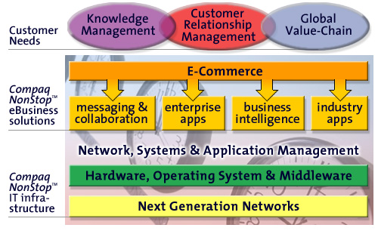
Figure 2: Compaq NonStopTM eBusiness Solutions Framework
A complete eBusiness strategy will account for almost all the elements in this framework. Sound business and IT management practices are required to ensure that corporate programs and initiatives are suitably positioned, prioritized, and planned in accordance with an overall business vision and mission.

Why Are Businesses Interested in Knowledge Management?
Knowledge Management is neither a panacea nor a complete solution to any one specific business problem. It can provide perspective and focus for an integrated approach to an identifiable number of specific business needs that intersect and complement corporate e-business initiatives in customer relationship management, global value chain, and e-commerce. Specific business drivers that prompt companies to look at Knowledge Management solutions are shown in
Figure 3.

Figure 3: Knowledge Management Business Drivers
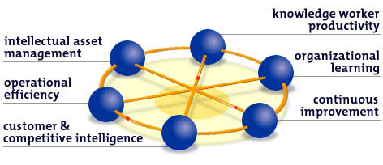
In the following sections, we summarize each of these business drivers and related common business problems that are referenced consistently in the context of Knowledge Management. Note that none of these application areas is new, but in thinking about them in the context of Knowledge Management, the problems are “re-framed.” That is, Knowledge Management offers a new frame of reference that provides fresh insights into ways to solve problems.

Intellectual Asset Management
There are several specific aspects to intellectual asset management, including the following two key business drivers: innovation and protection.
Innovation: Businesses grow by expanding into new markets, developing new products and services, and by constantly discovering new ways to add value to and please their customers. Ideas are precious, but they are also fleeting, dispersed, and difficult to capture and act on. The capability to support human creativity and the cycle of innovation — embodied in appropriately integrated processes and technologies — is a primary focus of Knowledge Management. Knowledge Management systems designed to support innovation emphasize a communications infrastructure that supports:
- Rapid interchange of ideas and documents in real-time
- Enterprise-wide accessibility of online discussion forums, research notes, and product and project information
- Disciplined capture and sharing of best practices, methods, and processes
A primary theme in the literature of Knowledge Management is of communities, including communities of practice, communities of interest, communities of purpose. Community — shared understanding and access to the work and minds of others — is a principal element in an innovation strategy.
Asset Protection: What people know walks out the door with them every night. In many companies, a key element of a Knowledge Management program is to guard against a recurrence of the widespread “organizational memory loss” that often occurred in the early 1990s. A company cannot protect against the loss of the human creative energy that leaves the company, but it can develop a well-managed, verifiable repository of the artifacts of results of that energy: patents, research, analysis, and project experience. Such artifacts, and the expertise required to manage them, provide a necessary hedge against what might otherwise be unsustainable loss through ill-planned downsizing or catastrophic events. Focused attention to the development and documentation of methodologies that embody the work is also an integral part of the repository creation process.
Naturally, effective Knowledge Management programs may also encompass systemic and proactive programs to retain — through systems of tangible and intangible reward — the people who provide the intellect, knowledge, wisdom, and experience that sustain corporate advantage.

Operational Efficiency
Increasing speed and cutting cost are not business problems unique to the domain of Knowledge Management, but there are some elements of Knowledge Management practices that put a new perspective on these classic business problems.
Responsiveness: Time-to-market, time-to-profit, time-to-solution, and time-to-delivery are all critical business drivers that hinge on a company’s ability to respond rapidly and effectively. Companies must be able to respond to customers and partners with a vital piece of information, a project proposal or bid, or the name and availability of a person with a particular skill set. Responsiveness has two key ingredients:
- The availability of carefully filtered and delivered external information about partners, customers, markets, industry and geo-political news events delivered in a timely fashion
- The ability of knowledge workers to reuse and re-purpose existing documents and other knowledge artifacts rapidly without sacrificing quality or information integrity
For a knowledge worker in a time-compressed environment, “How fast can you turn that around?” is a question that continually begs a better answer. In a customer services or call center environment, the ability of a service representative to respond to a customer — in the moment and in the context of all of the customer’s previous interactions of all sorts — is a critical
success factor.
Reuse: Good ideas deserve reuse. Effective Knowledge Management includes methods and systemic rewards for sharing and reusing work ideas and artifacts, and storing them in a form that makes them accessible and usable for others. In a professional services company, the practice of capturing both work artifacts (proposals, design documents, software programs, user guides) and methods (questionnaires, checklists, procedures) used during the course of work are the essential knowledge-building activities. In the Compaq Professional Services group, the Knowledge Management program is focused on the disciplined capture of such artifacts. Reusability is a cornerstone of quality improvement, productivity gains, and increasing profitability.

Customer and Competitor Intelligence
Customer Knowledge: No one disputes the value of maintaining a rich set of current information about customers. Thomas Stewart cites “customer capital” as one of the three
legs — human capital and structural capital (information systems and infrastructure) are the other two — of an enterprise’s overall intellectual capital assets. In an Ernst & Young survey of
431 executives, 97% of the respondents listed customer knowledge as one of the most strategically important issues.
Today, most customer knowledge is dispersed among:
- Sales and financial reporting systems in the IT infrastructure
- Captured responses, patterns, and “clicks” from Internet Web sites
- Marketing information accumulated from focus groups and research
- Usage information compiled from product support databases
- Acquired knowledge from sales and customer support representatives, as well as consultants who interact with customers on a regular basis.
While this last type of knowledge is the most difficult to collect and manage, it is probably the most valuable. The collection of products and technologies that supports this type of capture and
analysis is called Customer Relationship Management (CRM) systems. An enterprise Knowledge Management strategy needs to address the linkages among the types of customer information collected and the opportunities for transforming that knowledge into better relationships and improved value to the customer.
Competitive Intelligence: Competitive intelligence is about being aware of, sharing knowledge about, and creating intelligence with regard to companies, regulators, special interest groups, and other external forces in your industry. The collection and interpretation of data and information about these forces lead to the insights needed for establishing a new value proposition, deciding on which businesses to enter or exit, identifying and evaluating merger and acquisition candidates, and creating more value to customers than competitors. In the context of an overall Knowledge Management strategy, previously independent competitive intelligence (CI) departments are building ties to corporate strategic planning groups, integrating the CI databases and data warehouses with the customer databases and support systems, and tapping enterprise-wide knowledge.

Knowledge Worker Productivity
Productivity for today’s knowledge workers involves:
- Acquiring useful, relevant information about their environment in a timely fashion.
Employees in a global, distributed workforce must have equal access to timely information and personalized delivery of the information. Employees sometimes learn new information about their company from the press before they hear about it from their own management. If the news is about new product offerings or strategic initiatives, the result can be merely embarrassing or it may be actually costly.
- Ready access to the tools, information, and people they need to perform in their work.
Users must have access to the information they need to effectively perform their jobs, but it is not easy to ensure that employees receive what is relevant and useful in their context. A key trend in intranet design is to create personal portals: customized interfaces tailored to the needs and requirements of a specific class of knowledge worker. Intranet portals are an updated version of Electronic Performance Support Systems, also called “workbenches,” which have been evolving over the past decade. Sales Force Automation (SFA) systems are a specific application of workbenches that include workflow and contact management.
- Access to information in a reusable form.
The electronic publishing revolution brought the ability to create, modify, store, and exchange documents to the desktop. Document management systems can capture, categorize, and control revisions and access to product and research data, client information systems, and other vital structured business documents. Internet technologies unleashed an explosion of internal publishing and information sharing. Companies are increasingly recognizing that a key to understanding all of what they “know” is bringing this information — ranging in form from highly structured to completely unstructured — into a cohesive, accessible, and manageable base of corporate knowledge.
In a knowledge-based economy, these elements must be supported by easy-to-use tools that enable tacit (unarticulated) knowledge to be represented explicitly. Word processors, spreadsheets, graphics, and presentation editors are the standard toolkit for knowledge
workers to capture what is in their heads and put it into a form where it can be transferred
to others electronically.

Organizational Learning
People engaged in Knowledge Management initiatives quickly realize potential synergies with programs in human resource departments — especially those that have been focused on organizational development and learning. The development of skill inventories and capability planning tools dovetails with efforts to map corporate intellectual assets and identify knowledge clusters as well as gaps. Organizations need to identify competencies needed for new programs, and put training and development initiatives in place quickly to respond to new market requirements. Frequently, the IT applications that record and track competency development and manage the acquisition of skills are in HR departments, thus making HR representatives key partners in Knowledge Management programs.
Training departments are increasingly looking to distance learning solutions to provide focused training solutions to employees worldwide at the point at which the training is needed. Such systems, integrated into business processes and knowledge worker “portals” support strategic and rapid capability deployment when a business is entering a new product area, new market, or new geography. These systems must be designed to ensure the appropriate mode of learning with the appropriate elements of real-time, online, face-to-face, self-led and instructor-led training to ensure maximum impact.

Continuous Improvement
Continuous improvement of core business processes is a staple ingredient of many quality programs, as it must also be of Knowledge Management programs. In particular, enabling technologies offer solutions for improved responsiveness and for creating and sharing “best practices.”
Product Development: Many document management systems have been developed specifically to support product development processes. These programs enable the capture of information about product specifications, schedules, vendors, customers, problems reported by customers, and the many details that must be managed to support new product development. The information in these systems can provide an essential knowledge base for action when the information is structured and managed in such a way as to provide a perspective that enables product or process improvement.
Best Practices: In many enterprises, the sharing of best practices has evolved from origins in the TQM (Total Quality Management) initiatives of the early 1990s to the realm of Knowledge Management. Many companies use a variety of forums to ensure that departments and groups cooperatively share their experiences in streamlining processes, nurturing innovation, improving quality and capturing learnings.

Knowledge Management: More Than Technology
Although IT is critical for capturing and sharing intellectual capital, successful Knowledge Management also involves changing business practices and corporate culture. With a Knowledge Management program in place in its professional services organization since 1997, Compaq understands that Knowledge Management encompasses more than technology. We acknowledge that less than one third of Knowledge Management involves technology; two thirds is about people and involves culture change and behavior modification. If you look at Knowledge Management from a technology viewpoint only, implementation and organizational institutionalization are likely to fail.
Yet it is technology that is the enabler of Knowledge Management. Knowledge Management is interesting today because the technologies that emerged to support networked businesses and communities are now globally available and pervasive. It is important to understand those technologies as the underpinnings of a Knowledge Management strategy. The choice of Knowledge Management platform — departmental or enterprise — plays a pivotal role in the design and acceptance of the organizational processes that ensue.

Technical Solution Domains
Successful Knowledge Management is also more than simply repositioning existing products or technologies. The best solutions start with an analysis of the actual business problem that needs to be solved. The business problem areas described earlier are all good starting points. However, it is also useful when talking about solutions to have an understanding of the technologies that may provide the platforms on which to develop a solution.
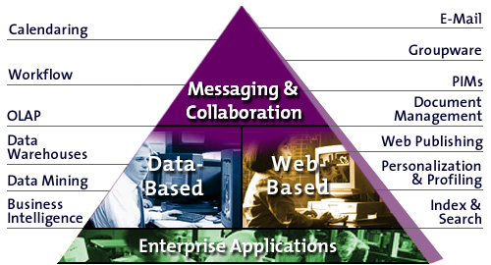
Each of the information technology domains in this section provides a valid and useful starting point for Knowledge Management solutions. These are summarized in Figure 4.

Figure 4: Technical Domains for Knowledge Management
A complete enterprise Knowledge Management strategy potentially encompasses elements of all the domains and application areas shown in Figure 4. The starting point for a solutions approach, however, normally begins with a focus on one of the four key areas shown in the triangle, or document management.

Messaging and Collaboration Solutions
High-quality knowledge transfer is a human-to-human activity. The past 15 years have seen the growth and evolution of technologies to support collaboration and communication. It is, therefore, not surprising that collaboration technologies are being positioned as Knowledge Management “solutions.”
For simplicity’s sake, we can look at the collaboration solution areas in two distinct (but connected) domains: messaging-based and Internet-based.

Messaging-Based Solutions
Until the advent of intranets, the locus of discussion about technologies for collaboration was on messaging-based electronic mail and discussions systems such as Lotus Notes®, Microsoft® Exchange, or Novell Groupwise® and the Internet mail, newsgroups, and related technologies. In the era of Knowledge Management, such messaging products are easily repositioned to support common Knowledge Management activities, as summarized in Table 1.
Table 1: Knowledge Management Activities Supported by Capabilities in Mail and Messaging Technologies
Mail and Messaging Capabilities | Knowledge Management Benefits
Electronic mail coupled with private, ad hoc, or global distribution lists | Exchange ideas and requests for information on an individual or workgroup basis
Global directory services | Locate people worldwide with particular expertise
Subscription-based electronic mail distribution | Distribute internal news and communications to selected sets of employees worldwide
Workflow-enabled messaging | Route and manage project documents
Public folders and discussion (news) groups | Participate in shared discussion groups or electronic bulletin boards
Integration of Internet search engines with mail and messaging products | Archive, index, and search personal or shared mail folders

Internet-Enabled Collaboration
The growing interconnection of the world, increasing capacity of personal computers and personal computing appliances, and the broadening capabilities of communications networks are enabling more real-time and near-time distance collaboration. The specific technologies that are becoming more popular worldwide include:
- Community bulletin boards and online chat services, integrated with messaging-based tools such as newsgroups and electronic mailing lists
- Desktop conferencing that enables one-to-one or many-to-many interactions, including (with appropriately designed networks) audio and video
- Document sharing and electronic whiteboard sharing
Such real-time knowledge exchange capabilities are a fundamental element of enterprise Knowledge Management. Companies with superior network bandwidth are already taking advantage of many of these techniques, though the market has not yet completely
adopted them.

Web-Based Solutions
The transformative impact of the Internet and the World Wide Web has not yet been felt in all enterprises, but the implications are becoming clearer. The lightning speed at which intranets became a primary source of internal knowledge exchange has forever changed the nature of both information technology and organizational systems. It is not coincidental that “Knowledge Management” emerged as a business problem at the same time that increasing amounts of information became more readily accessible to employees via Web browsers. The IT problem shifted from making information available to making meaningful information available. The simple difference is that meaningful information leads to action and hence business advantage.
The primary requirements for an actionable intranet-based knowledge repository are:
- Easy to find. There must be an easy-to-use search engine or portal appropriately configured to index and retrieve enterprise information.
- Easy to share. The collection of documents and other artifacts that represents knowledge work must be manageable; users must be able to easily post, distribute, and update their own intellectual contributions and work products.
- Easy to use. The information artifacts that are shared within the enterprise must be created in standard ways that encourage effective reuse, consistent branding, and
quality content.
- Easy to maintain. Currency of information is important in motivating users to seek information and to trust its value.
The key practices that promote an effective intranet are:
- A clear understanding of the purpose of the intranet and what success looks like for both the intranet sponsor and the end user
- The development of an information architecture, including appropriate portals for specific users, targeted to support business goals
- Selection of a Web server and associated tools that provides flexible content management
- A disciplined categorization and search implementation strategy
- Mechanisms for monitoring the ongoing contribution and use of the information it stores
- Services and support for end users (the knowledge workers) to ensure that they can find, share, and use the intranet site
Web servers and software applications from most vendors are evolving rapidly to provide the foundational support required for these key practices.

Document Management Solutions
Not surprisingly, the document management industry’s biweekly publication ImagingWorld was recast and renamed as KMWorld in 1997. A few Knowledge Management experts dismissed this change because it misses the point about the distinction between information management and Knowledge Management. The name change does exemplify the changing language and positioning of business requirements for Knowledge Management in the workflow, imaging, and document management market.
Key advantages of mature and robust document management systems include:
- Web-based search and access
- Versioning, archiving, and workflow
- Mail-based event notification
- Support for multiple file formats and conversion of formats to standard display formats
A document management system is particularly powerful when it is integrated within an enterprise intranet. For example, Compaq’s Integrated Repository of sales and marketing information evolved from an internal database application to a VTX (Videotex) application to a Web-based application over many years. This repository provides rapid access to product specifications, customer references, white papers, brochures, and many other types of documents in a consistent structured format — which employees can readily access and reuse in creating value-added material for customers and partners.
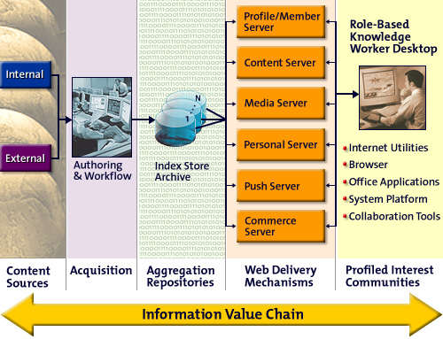
As part of Compaq’s ongoing intranet deployment strategy, it became apparent that this application should be replaced by a formal document management solution — one that would be integrated with and support the heterogeneous intranet environment within Compaq. Figure 5 illustrates how an aggregate of document management repositories would be integrated in an intranet environment.

Figure 5: Document Management System in an Intranet
In this model, content is acquired and aggregated into both indexes and archived storage. Different applications, implemented as Web servers with specific purposes, provide two-way interaction with knowledge workers using a set of common desktop applications. The breakthrough in the use of Web technologies that was a primary enabler of Knowledge Management is the universality of the desktop: the Web browser makes it possible to have the same user interface to all applications and data.

Data Warehouse Solutions
The purpose of a data warehouse is to collect information from multiple databases and put it in a common format (scrubbed and sanitized) for use in decision-support systems, while shielding the actual operational systems from ad hoc queries. The use of data has evolved from accounting for resource tracking to overall operational efficiency, to optimization of the business model. Data warehouses provide a starting point for mining information because they can:
- Provide snapshots and summarized data for trend analysis
- Provide modeled enterprise-wide information in a common format
- Support multiple levels of granularity
- Hold integrated subject-oriented horizontal views across business lines
A key difference between data warehouses and operational systems is that operational systems are designed to answer close-ended questions like how many, what color, how much. Data warehouses are designed to answer open-ended questions such as why and where, offer insights into future trends, and collect and organize massive amounts of customer and competitive intelligence. Typical examples include customer relationship management in banking and insurance, inventory modeling for retail, and target marketing. When data warehouses make information meaningful and actionable, they can be viewed as key elements in Knowledge Management systems. Figure 6 illustrates the transformation of data to knowledge for consumption by an end user.

Figure 6: Data Warehouse/Datamart View of Knowledge Management
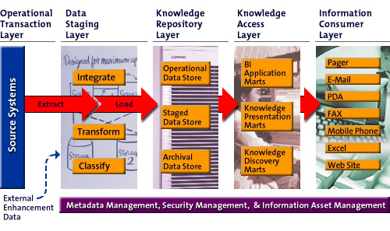
In this model, data is extracted from source systems, and integrated (in data warehouses) using established metadata, security schema and rules for asset management. The “staged” data is stored in a knowledge repository layer, from which it is accessed by data “marts” established for specific purposes: BI (business intelligence) applications, and presentation and discovery (data mining) tools. In decision-support systems, information is obtained from data warehouses by data mining, OLAP (online analytical processing), content-based searches, or ad hoc queries against a database for presentation to information consumers.

Enterprise Information Solutions
The corporate information systems manager, or CIO perspective, provides yet another approach to Knowledge Management. To the keepers of the corporate information systems, Knowledge Management provides another way for users to access corporate data. The types of data and applications include operations data, repositories, information collection, case-based reasoning, use of metadata, taxonomies, thesauri construction, integration of structured and unstructured data, and integration of the variations in delivery of external information.
Knowledge Management systems that evolve from business information systems are most
likely to be focused on either decision support or on enhancing the global value chain. Key
steps to create a Knowledge Management infrastructure beginning with enterprise information systems include:
- Determining the key imperatives for managing corporate information
- Creating a high-level knowledge map of the enterprise
- Identifying and distinguishing transaction-based systems information from content collection and information management systems
- Designing the enterprise information systems architecture for integration
- Looking for integration opportunities
A principal opportunity for enabling integration of transaction-based or corporate-held data into a Knowledge Management solution is to establish baseline reference data for the corporation. In this activity, experts would remap the data fields in enterprise applications to ensure that all systems use the same taxonomies and data fields for core information such as customer IDs, part numbers, employee numbers, and so on.
A supply chain is the network that includes planning, design, and producing and delivering products and services. The global value chain optimizes the business’s ability to efficiently move its business assets (products, transactions, and information) from their source of origin to their point of delivery.
Figure 7 shows a model of the components in the global value chain. In this model, “Knowledge Management” is a component that offers the opportunity to provide added value through point-of-transaction information capture in various supply chain components linked through the enterprise application. These component applications are data sources then available for data mining within the data management systems.

Figure 7: Knowledge Management in the Supply Chain
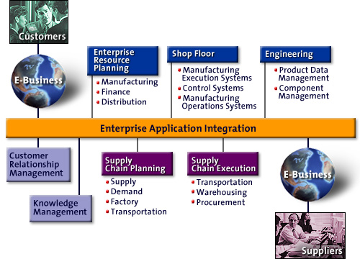

Summary
This section has provided a review and overview of the principal technology platforms on which Knowledge Management solutions are built: messaging, Web, document management, data warehouse, and enterprise infrastructure. Within any company, specific programs and initiatives using Knowledge Management approaches are most likely underway in a variety of these. Almost all can benefit from the application of best practices as they are currently understood — and many of which provide organizational and business perspectives to complement the technical approaches.

Emerging Best Practices and Applications
in Knowledge Management
A review of trends and best practices shows what others have done, and most importantly provides success models and examples on which to build. This section summarizes what Compaq’s senior solution architects and designers judge to be the emerging best practices that support Knowledge Management initiatives:
- Intranet information architecture
- Indexing and searching
- Web content management
- Expertise location
- Customer relationship management systems
- Personalized information delivery services
- Collaboration facilities for communities of practice
- Extranets
- Distance learning
- Portals
This set of practices has evolved from working with customers on intranet design and planning, research on best practices, and the extensive experience of the teams responsible for the wealth of applications and services available on Compaq’s own intranet.

Intranet Information Architecture
The role of information architecture in the design of an intranet for Knowledge Management cannot be over-emphasized. It is foundational work that supports the content creation, indexing, management, and searching — and ensures that an organization’s information types and document formats support the work of the organization.
Architecture, in the IT context, describes the principles, models, and standards that provide a unifying coherence to a complex system project. In information architecture, the key domains that need to be addressed are:
- The Intent or big picture: the role of an information architecture is to provide the overall “structure or map of information that allows others to find their path to knowledge.” Within this picture, each type of knowledge artifact should have a specific purpose or intent and a design with respect to that intent. For example, in a consulting unit key artifacts are documents such as proposals, statements of work, structured checklists, and so on. Each artifact also has a creator, a consumer, and normally a workflow associated with it.
- The Integrity, or technical implementation: the architecture needs to specify for each information type its physical format, location, accessibility, attributes, ownership, standards associated with it, and other system-dependent details. For example, it should specify which tools (and versions thereof) are used to create and modify files, the file attributes that must be specified, and so on. In the example of the consulting unit, the architecture would specify a location for proposals to be kept, a hierarchy for storing them, a taxonomy of keywords to be associated with them for searching, and a range of security attributes. Such attributes, when encoded with the information artifact itself, are usually referred to as metadata.
- The Identity, or the form the artifact takes: critical elements of identity in the information architecture include the presentation (look and feel, branding, and so on), consistency of the artifact with respect to other artifacts in the system, and templates available to help users create new artifacts. This aspect of information architecture is particularly important to making information easy-to-use both for the creator (who needs not worry about details of formatting and design) and reviewers or consumers of the document (who can concentrate on the content).
Figure 8 illustrates the structural design model for an intranet information architecture tool that a Compaq consultant would use to identify and categorize information types that represent key organizational knowledge to be managed.

Figure 8: Enterprise Intranet Information Architecture
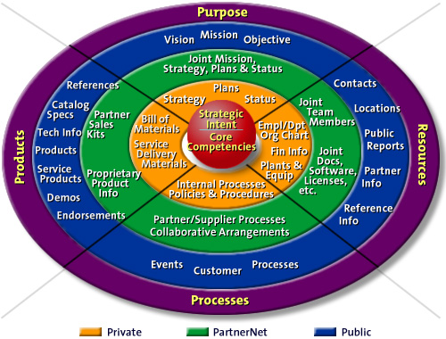
The overarching goal of this architectural model is to aid the design of an intranet so that qualified employees, customers, and partners find the information they need, in a form that
is useful to them.

Indexing and Searching
Structuring and labeling knowledge artifacts so that they can be easily retrieved is a major problem for Knowledge Management. Each technical domain — enterprise applications, document management, mail and messaging, and Web — provides search capabilities. However, as the volume of information sources increases, the ability to search across document and data types in a context-specific way becomes more and more important.
Current technologies for searching are based on the technology platform:
- Enterprise data and document management systems offer database-style queries
- Intranet and groupware technologies offer either full-text search or hierarchical navigation, generally by category.
Examples of intranet options that illustrate the differences are AltaVista™ and Yahoo!™ AltaVista creates an index by “crawling” Web pages. It begins with a root Web page, indexes all the text on that page, follows all the hypertext links, indexes the text on those pages, follows those links, and so on until it reaches all the pages in the Web that have no further links. When a user submits a query at the AltaVista portal, AltaVista searches the index. In a hierarchical system such as Yahoo!, all the information is classified and categorized so that a user begins with a particular topic and moves through subtopics to find the desired object. Figure 9 illustrates the difference between the two approaches.

Figure 9: Search Differences
The search of the AltaVista index lets you specify a set of conditions that must be satisfied to find “a place for ballroom dancing instruction in the Chelmsford area that is in New England.”
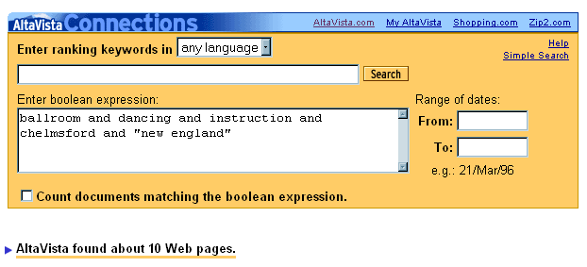
Yahoo!’s category search lets you step through: “Arts, Performing Arts, Dance, Ballroom, Regional Information,…”
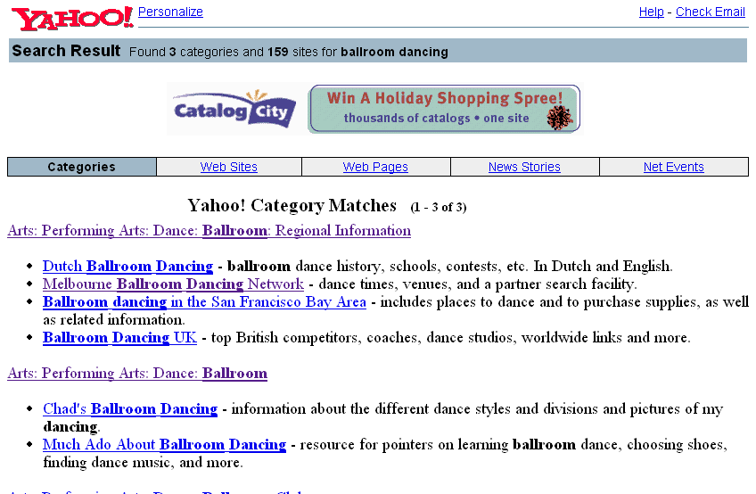
The full-text search can return too many “hits” for simple requests, and requires a user to construct a Boolean query in order to narrow the scope of the request. (Note we had to include “new england” in the AltaVista search so that references in Chelmsford in the UK would be discarded.) Yahoo!’s hierarchical category search technique assumes that the classification system and terms are familiar to users — for instance it assumes that users will find “ballroom dancing” under “performing arts” — and that sites are actually registered within the search
portal’s hierarchy.
In reality, most intranets and public Web portals that have implemented enterprise-wide search and navigation use both forms. This ensures that users with different cognitive styles and needs will be able to find what they need. An enterprise intranet portal provides access in a hierarchical manner and a search index provides full-text access, as illustrated in Figure 10. Notice that in
addition to the organizational tabs for company-wide, regional, divisions and business knowledge, access to the search capability is provided at the top of the page, preceding the list of categories of information available.
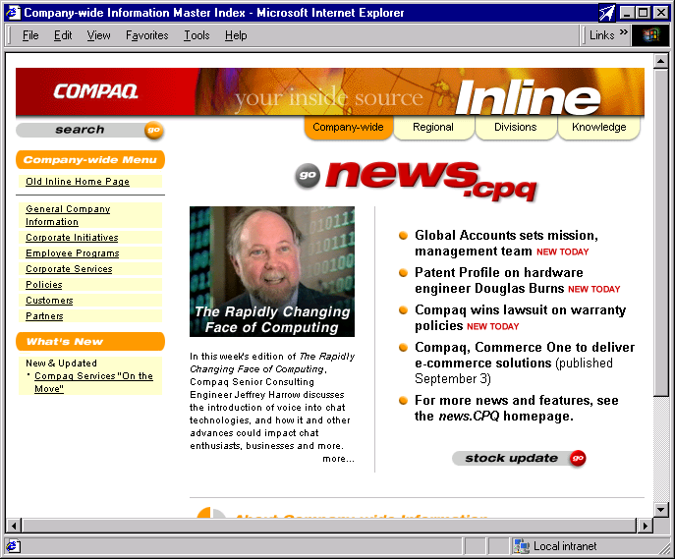
Figure 10: An Enterprise Intranet Portal
Search capabilities are vital for ensuring that “easy to find” is “easy to find the right information” at the time that it is needed. Intranet search products continue to evolve to meet an expanding list of requirements:
- Ability to search all types of documents and databases, including documents residing on user file shares, in mail folders, and so on.
- Adopting the XML (eXtensible Markup Language) standard for indexing and categorization. XML supports the inclusion of metadata, including user-specified keywords, author information, creation date, expiration, and other information that provides context about documents on the intranet and that is specified in the information architecture.
- Performance enhancements that enable the indexing to take place more frequently without degrading overall system performance, thus ensuring that the index is always up-to-date with the information on the intranet.
- Ability to search multimedia content. For companies with a large investment in videotapes, audiotapes, and images, there is no question about the intellectual value contained in these artifacts and the difficulties to date in indexing and finding specific information in them.
- Incorporation of intelligent search agents.
Today’s enhanced Web server applications provide Knowledge Management tools that let users help one another search. That is, an individual user can create an index of a specified set of Web sites that are known to provide useful information — by category or topic — and make this index available to others. Thus, a user who has been designated the resident expert or knowledge coordinator in a particular topic will be able to provide a search index on that topic.
Emerging technologies and products are advancing the sophistication and usability of enterprise-wide searching. Some of the work includes:
- Automatic taxonomy creation and tagging of documents
- Automatic profiling of users based on preference ratings and previous searches
- Simpler query interfaces
- Visualization of the resulting hits and their contextual relationships
- Improving the range and flexibility of the types of questions that can be asked.
Because of the newness of the technologies and the choices currently available, the selection of the most appropriate search product is one of the most difficult for an enterprise — and it is one of the most critically important to ensure discovery, access, and surfacing of vital information sources.

Web Content Management
The World Wide Web is an environment where anyone with access to a Web server can publish anything. In intranets, the spread of ad hoc publishing quickly raises problems associated with the integrity and security of information. How can you ensure that the information posted on the intranet, and accessible by a full-text search engine, is to be trusted when you cannot be sure of the source? How do you ensure quality? How do you ensure that only authorized people have access to sensitive information? How are Web pages created? How do you establish policies, processes, and practices for submitting, editing, posting, and refreshing information?
These questions must be addressed in the context of developing an intranet as a Knowledge Management system or knowledge base. A typical pattern for publishing live content is shown in Figure 11.

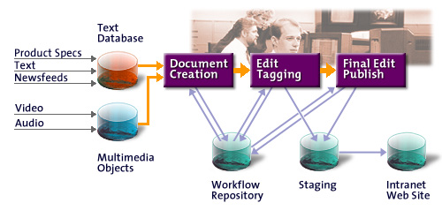
Figure 11: Publishing Workflow in Intranets
Some of the key content management capabilities available in Web server products include:
- A tagging capability to enable authors and editors — or professional librarians or indexers — to add keywords and other metadata to categorize documents.
- Publishing workflow features that let multiple users submit documents or pages for posting — while giving the site owner, webmaster, or designated editor-in-chief the ability to specify editorial reviewers and content approvers.
- Personalization and membership services which are linked to the indexing capabilities and the corporate network security infrastructure — so that when a user searches for information, the only files that are found are those that the user is authorized to access.
These features are critical in an environment where information content needs to be trusted and reliable. One emerging practice in the intranet management is the requirement to “certify” Web pages — that is, to specify that content on a particular page is verifiable, that it has a responsible owner, and that it is subject to regular review and update. Note that in Figure 11 there is no pruning or removal activity, which is a vital part of managing the life cycle of content.

Expertise Location
To work effectively, people need to work together. Businesses spend a lot of time organizing and reorganizing to make this happen. The recent trend toward leaner, flatter, and more distributed organizations has introduced the challenge of getting the right people focused on a task. The bar is raised even higher when people need to work across companies to develop and manage large projects. Inside and across enterprises, access to expertise can mean either finding the right person to talk to or finding the right place to ask a question.
To support rapid access to the right source of knowledge, employee and resource directories as well as adaptive knowledge hubs are key Knowledge Management tools. These can take many forms:
- Individual or group Web pages. Intranet policy may dictate or support the creation, indexing, and maintenance of Web pages that can be tagged and indexed to ensure that employees do not waste time finding internal resources or help.
- “Ask-anything” discussion groups. These corporate electronic “water coolers” can be built using any-discussion technology. Anyone can ask a question and anyone can answer. These groups become more powerful if they are moderated to validate answers, prune out-of-date material, and provide closure for open-ended questions.
- Corporate electronic mail directories, yellow pages, and employee locators. These tools help employees find one another in different contexts and can be particularly effective when linked to employee or group Web sites.
- Skills databases. Team leaders and project leaders often need to assemble groups of people based on a required set of capabilities. Employee databases that maintain current sets of skills and training certifications are usually protected from universal access, but when appropriately managed can position a company to respond rapidly to changing market conditions or customer problems.
- Adaptive question-and-answer forums. New software products are available that support interpretation and routing of questions to appropriate experts inside and outside
a company.

The emphasis in a company on the use of technologies to support expertise location should be based on the style of the company and the nature of its business. For example, a recent Harvard Business Review article distinguished consulting companies based on whether they should use a codification (document-management based) approach or a personalization (expert) approach.

Customer Relationship Management
Any company that is defined and driven by information is actively seeking new ways to
collect, analyze, manage, and act on customer data. The ability to identify individual
customers and analyze their current and potential value to the institution is fundamental in
turning data into knowledge.
Customer relationship management (CRM) systems typically assemble customer information from various sources and provide ways to extract and aggregate the information. For example, a CRM system can give decision-makers knowledge of each customer’s entire relationship with the company so that an individualized plan can be developed for each targeted customer. New business processes can be implemented to ensure that resources are used more effectively and more efficiently, producing better yield.
Call centers, many of which use a technique called case-based reasoning, provide a key collection point for customer data. As customers call for support or to find out about products, the questions and answers are stored for future aggregation and analysis. The sum of the information about the customers collected in such applications provides a tremendous amount of knowledge both about individual customers — enabling one-to-one marketing programs — and about market and customer trends.

Personalized Information Delivery Services
While much of the focus on Knowledge Management is on the collection and accessibility of internal information, there is an increasing recognition that business innovation and responsiveness require information about events and conditions outside the organization. Components of external information management include:
- Electronic publications, including trade publications, conference proceedings, and market research
- Government files for artifacts such as patents and SEC filings
- Real-time news feeds from satellite systems
The challenge in providing access to external information and events is as great, if not greater, than in managing internal information:
- Ensuring that each knowledge community, or cohort, has access to the appropriate information, packaged for groups or individuals, or available for self-service
- Integration of information that may arrive in different file formats or media
- Authentication or certification of the material’s source
- Categorization scheme for tagging information (the corporate taxonomy)
- Licensing agreements for redistributing copyrighted material
Many news services are available for subscription based on topical interest areas. Individual, Inc. was an early adopter of Internet technology for customized news delivery. (This project was implemented by Compaq Professional Services in 1996.) There is also a trend for corporate library organizations to take the lead in bringing individualized news services to knowledge workers. Compaq’s WebLibrary is an example of a service that provides customized, integrated, Web-based access to:
- Daily news articles and abstracts
- Analysts’ reports and competitive analyses
- Research and technology reports
Figure 12 shows a customized information page, designed for focused access to daily news information on specific market and technology topics. This type of customized interface provides an interpretation of content relevant to a business problem.

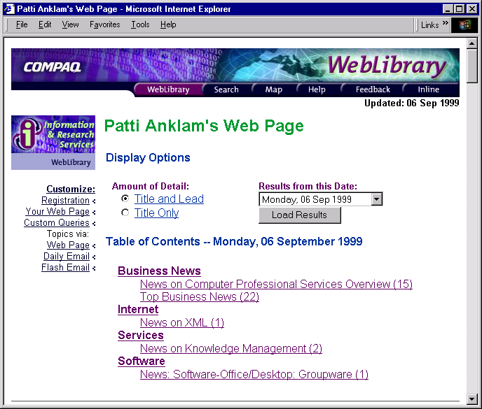
Figure 12: Web Page Customized for Daily News
The WebLibrary won the Innovation in Technology Award from the Special Libraries Association in 1998.

Collaboration Facilities for Communities of Practice
A collaboration focus is particularly important in the domain of sharing tacit knowledge. Tacit knowledge is knowledge that is not articulated: how to do things, why to do them in a particular way, how to interpret events, and how processes operate. Such knowledge is not easily captured or written down, and often the people who have it are not aware that they have it. Yet, in terms of intellectual capital and organizational capability, it is as important if not more important than the capturing and management of explicit knowledge. Explicit knowledge is embodied in artifacts such as documents and reports, as well as in documented processes and procedures.
The groupware (also called computer-supported collaborative work, or CSCW) field has also been invigorated by the interest in Knowledge Management.
Figure 13 shows the classic collaboration matrix with a summary of the technologies that support knowledge-sharing activities.

Figure 13: Collaboration Activities in Time and Place
• Team Portal or Activity “Room”
• Electronic Mail
• Intranets
• Messaging
• Workflow
• File Servers
• Events
• Meeting Rooms
• Collaborative Work Spaces
• Group Decision Support
• Chart Pads & Whiteboards
• Intelligent Projectors
• Situational (“war”) Rooms
• Calendar
• Shift Logs
Same Time,

Same Place
Different Time,

Same Place
Different Time,

Different Place
• Teleconferencing
• Screen Sharing
• Electronic Whiteboards
• Desktop Videoconferencing
• Document Sharing
Same Time,

Different Place
“Same Time” Knowledge Management activities received an incredible boost from inexpensive (or free) technologies such as CU-See-Me® and Microsoft NetMeeting®. The low cost of setup for these technologies has made real-time videoconferencing widely accessible to individual desktops, enabling real-time interaction with peers and colleagues dispersed worldwide.
For many workers in research-driven businesses such as pharmaceuticals, this real-time collaboration is vital to innovation and time-to-market. That’s why it is important in the design of a knowledge base to incorporate opportunities for one-to-one interaction, either live via video/teleconferencing or at a minimum by asynchronous discussion groups. The newest addition to this classic framework is the notion of a team portal. Products and platforms are now available that integrate team members’ calendars, discussions, project schedules, contacts, and documents into a common “electronic room” that is a shared collaboration space for teams.
The collaboration framework shown in Figure 13 is an excellent starting point for designing an overall strategy to incorporate collaborative technologies into an enterprise Knowledge Management system. Collaboration systems — particularly those with a high real-time content —place new requirements on an enterprise’s networking infrastructure to support the bandwidth requirements of video, voice, and multimedia documents. For this reason, many Knowledge Management programs begin with an assessment of the current and necessary networking requirements.

Extranets
A Knowledge Management system should be designed to provide companies the ability to communicate and share resources with customers and partners. In particular, the information and security architectures should reflect the need to share knowledge bases and support interactive collaboration.
Many companies have discovered that Internet technologies provide an increasing number of opportunities for exchange of business information as well as data. An extranet is an extended intranet that gives selected customers, suppliers, and partners Web access to applications and
data inside a company firewall. Figure 14 shows a simple illustration of services available on extranets.

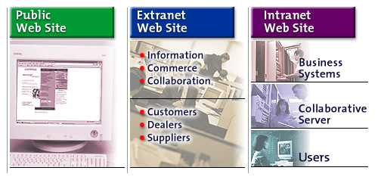
Figure 14: Extranet System Model
Some typical examples of collaboration and Knowledge Management applications you can place on Extranets include:
- Product research, document reviews, presentations, and white papers
- Real-time idea sharing, using, and information gathering
- Problem reporting and quality assurance for products in field test
- Training, either in real-time using collaborative technologies, or self-paced
In 1997, Compaq Professional Services helped Kvaerner, a multinational ship-building conglomerate, develop an extranet that linked its hundreds of partner companies worldwide. The collaborative forums and document sharing capabilities made it possible for the companies to share their learning experiences and best practices as each designed their intranets and linked them with their partner companies.
Today, this is a common activity. Also, many Internet service providers (ISPs) offer “extranet” services for companies that want to rapidly set up a shared “space” to share project documents, collaborate in discussion forums, and so on.

Distance Learning
Intranets, extranets, and the World Wide Web provide the technology platform for the integration of multiple modes of learning. In particular, they provide a number of ways to support distance learning. Distance learning enables employees worldwide to access course materials, self-paced instruction, training schedules, live events, and so on. A Knowledge Management strategy should include an integrated design for employee development based on the reuse and packaging of intellectual content.
Learning strategies should aim to integrate multiple modes of instruction, including:
- Instructor-led, event-based training (lectures, seminars)
- Structured self-paced instruction (computer-based)
- Ad hoc self-paced learning
- Mentoring and cognitive apprenticeship
The last of these is, of course, the richest mode for transferring tacit knowledge. Working side-by-side with an expert in a particular area is the best way to learn how to see, hear, feel, model, and interpret events as the expert does. However, as organizations adopt the Knowledge Management perspective and learn to identify the requirements for transferring both tacit and explicit knowledge, their Knowledge Management systems will evolve to include more opportunities for distance-enabled, real-time collaboration and communication.
Figure 15 shows a sample screen from Compaq’s intranet. Virtual Presenter is a Web-based tool that enables one-to-many sharing of presentations over the intranet. At the same time the presentation is broadcast, attendees listen via teleconference. The calls are recorded so that people who cannot attend at the time of broadcast can see and hear a synchronized audio and video version at their convenience.
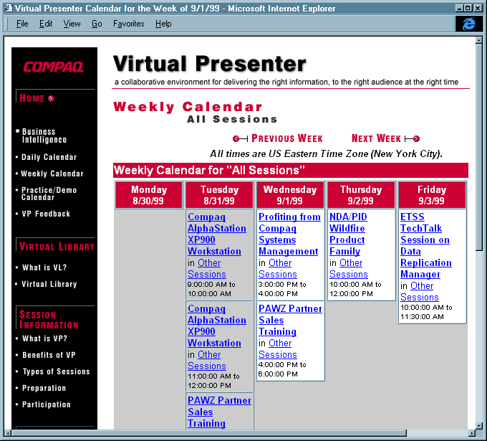
Figure 15: Access to Real-Time and Archived Web-Based Training Sessions

Portals
The most promising — though possibly most expensive — approach to support knowledge worker creativity and productivity is the design and implementation of role-specific desktop user interfaces, traditionally called workbenches and now often referred to as portals. It is important to distinguish among such types of pages:
- InfoCenters
- Workbenches
- Portals
An InfoCenter is typically “static,” that is, it does not change dynamically and it is essentially the same for everyone who accesses it. The static content on such pages is normally augmented by automatic news feeds or other dynamic content that may be based on an individual user’s preference. Compaq’s enterprise intranet portal illustrated in Figure 10 on page 20 in “Indexing and Searching,” is an example of an InfoCenter.
By definition, a workbench is an interface that is tailored to a specific worker’s set of tasks. In one workbench model, called a Sales Force Automation (SFA) system, access to all the user’s business programs and tools, as well as reliable information sources, are integrated into a single user interface. Workbenches are often referred to as Electronic Performance Support Systems.
The concept of portals has been greatly enriched over the past year, and there is an emerging consensus that there are three types of portals: the individual, the group (or team), and the enterprise. The immediate challenge in the design of individual portals is to present a user- or role-specific search interface for all accessible data, information, contact managers, and knowledge bases, as well as collaboration, workflow, and business process servers. A role-specific user interface for a knowledge worker provides specific views or overlays to common information, but it is presented in the context of the user’s work tasks and context. The model for such a knowledge worker interface is shown in Figure 16.

Figure 16: A Knowledge Worker’s Portal
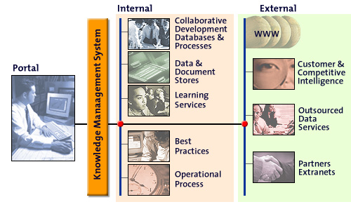
Next-generation portal technologies enable integration of the user’s business and productivity applications into the customized and customizable interface, along with the context of the user’s current projects — personal and team calendar, contact manager, project schedules and milestones — and tailored news and communications feeds from inside and outside the enterprise.

Critical Success Factors
What we have said about Knowledge Management is that it is not a turnkey solution to a specific business problem, but that it is a perspective from which to view, or to “reframe” a variety of business problems. One of the useful attributes of this reframing is that you can make a decision about how to approach a Knowledge Management program or initiative. The approach you choose may be based on:
Critical Success Factors
- Link to economic performance or industry value
- Technical and organizational infrastructure
- Knowledge-friendly culture
- Clear purpose and language
- Change in motivational practices
- Multiple channels for knowledge transfer
- Senior management support
- Some level of knowledge structure
- Modicum of process orientation
— Tom Davenport and
Laurence Prusak
- The organization’s most clearly articulated business problem, which can be derived from a needs assessment
- The existing technology infrastructure and its maturity
- End user or departmental demand, or interest in adopting a best practice
In the preceding sections, we have reviewed the common business problems for which Knowledge Management provides insight, the key technical domains from which to build enabling infrastructure, and conventional wisdom about organizational practices that provide starting points for Knowledge Management activities.
This section uses examples from the implementation of Knowledge Management in Compaq Professional Services to illustrate critical success factors in Knowledge Management solutions design and implementation. The next section provides a review of the technical implementation considerations underlying the system design.

Tie Knowledge Management to Business Process and Organizational Goals
A Knowledge Management solution or technology must be tied to a business goal, and within that it must take into account organizational and personal goals.
In Compaq Professional Services, a consulting organization, support for a Knowledge Management program was immediate and unqualified based on the following compelling business goals:
- To be able to rapidly generate quality proposals, which are vital for winning successful business
- To have the ability to rapidly acquire, assimilate, package, and reuse knowledge of new technologies, products, and processes
- To have access to work-in-progress in areas of emerging technology so consultants can provide customers with credible trusteeship
Most successful Knowledge Management activities similarly begin with a clear understanding of the business goals, coupled with clear and continuous management support. When Teltech Resource Network Corporation, a knowledge services company, set out to research successful knowledge programs, it did not qualify for inclusion any project that was not linked to a strategically important activity.

Identify and Leverage Existing Repositories, Processes, and People
Once a focus for Knowledge Management activity is identified, it’s important to understand the existing repositories (whether structured, ad hoc, or unstructured) and how they will be used to support the Knowledge Management initiative. In the case of Compaq Professional Services, there were many existing structures:
- A repository designed for capturing program management methodology and reusable project artifacts.
- An extensive corporate intranet Web and messaging infrastructure that included the WebLibrary, a global information repository called WEBIR, and worldwide access to communities of practice.
- A centralized, static InfoCenter for Professional Services that provided structured links to local geography Web sites, services development and methodology sites, and sites for the headquarters functions including sales and marketing, technology, and human resources.
- A community of knowledge workers who were committed to evangelizing and facilitating the adoption of Knowledge Management practices.
The focus for getting the program underway was to understand and put in place processes to feed these knowledge bases with the distributed, local information contained on local file shares and Web servers located worldwide.

Focus on the End Users
“Culture Trumps Everything,” says Thomas Davenport. If the culture and organizational reward systems do not support and encourage sharing and reuse of information, Knowledge Management systems will fail. Extensive research in the design and deployment of Knowledge Management systems supports this conclusion. The system design must include the people who will be the primary users of the system and must address some sensitive issues regarding reward systems:
- How the system tracks contribution, access, and reuse of information artifacts. It is not enough that people contribute many things to a system; it is important to understand how useful those artifacts are to others.
- The ability to reward and/or acknowledge users who freely share, exchange, and transfer knowledge that is not artifact-based.
Organizational strategies to stimulate and reward knowledge sharing include:
- Evaluation of contributions to the knowledge base as part of the standard performance review template.

- Creation of job roles and responsibilities for knowledge managers who are measured and rewarded on soliciting and editing contributions to the knowledge base. When the individuals selected for these roles are senior people with local credibility, they can serve as champions for the organizational and cultural shift that needs to occur.
- Withholding project bonuses until the completion of the project review and assessment.
Whatever the organizational strategies are, they must be accompanied by a commitment to evolve the technical system, tools, and processes with a focus on ease of use.

Be Committed to Ease of Use
We have useful lessons from the experience of introducing groupware applications a decade ago: “A factor contributing to the application’s failure is the disparity between those who benefit from an application and those who must do additional work to support it.” One model for the evolution of Knowledge Management systems sees “organic” systems as the end point, as shown in Table 2.

Table 2: Stages in Knowledge Management System Evolution
Assisted | Knowledge managers work with employees and teams to codify and retrieve important information. IT implements stand-alone Knowledge Management applications to support storage and access.
Self-Service | Workgroups do their own codifying, IT develops links between core business applications and Knowledge Management tools to deliver information.
Organic | Codification and dissemination happen as a matter of course while employees and teams do their work. Knowledge Management functionality is embedded in core business applications and employee productivity tools.
At the organic stage of work, the reward for sharing and reusing is intrinsically reflected in the tools used to create, edit, access, and share information. Some of the key design strategies for the development of user interfaces at this stage include:
- Usability. Successful interfaces are designed by usability experts, many of whom have expertise in cognitive psychology. In a customer project in Australia, Compaq Professional Services designed a workbench for a training group. The initial project team comprised a usability engineer and an instructional designer. The engineering work did not begin until the cognitive design was complete.
- Presenting information in the context of the user. It is vital that interfaces be designed by working with users in the context of their work. To develop an interface to support Compaq Global Account Managers, the team used a contextual inquiry process of observing the work of managers through the course of several days to develop the insights required to design a useful system.

Work in the Context of Models
Models provide a visual way to present complex information and to ensure common understanding. What are the knowledge activities in the organization? Is there agreement on how to categorize them? How they relate? This paper provides a number of models, both for technology and organizational design considerations. At the heart of a Knowledge Management program is the organization’s view of the core activities. Figure 17 shows the model we have adopted as part of our reference framework in Compaq Professional Services.

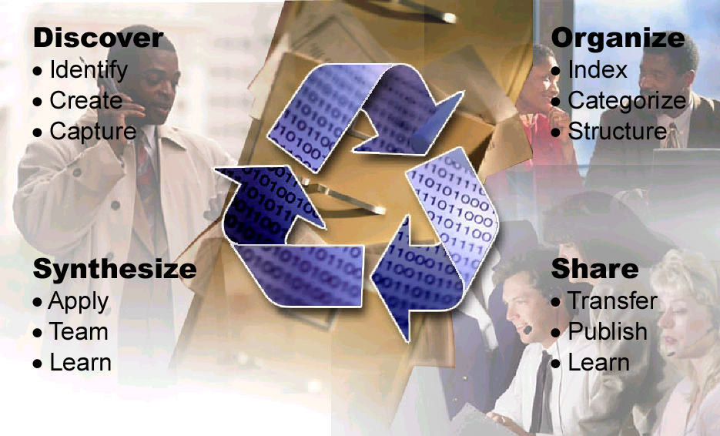
Figure 17: Knowledge Management Activities Model

Technical Implementation Considerations
Once the overall business problems and user functions are well understood, it is important to look at the key technical considerations and requirements. The next few sections highlight some of the evolving technologies that support Knowledge Management. These are areas where technical planning and product selection are important.

Categorization
The only way to deal with information overload is to work within an agreed taxonomy of information and to give users control over which categories of content they want to receive. Web servers support these capabilities by:
- Providing the ability to categorize and tag Web pages, documents, and other artifacts that are stored on a Web server
- Enabling selection lists in the search user interface that let a user select the categories of information within which to perform a search
To develop a good categorization scheme, there are four mutually reinforcing implementation considerations:
- The information architecture work must include a relatively complete information taxonomy and model
- The information creation and editing tools must facilitate tagging artifacts with keywords and categories, as users create, edit, and use them
- The taxonomy must be flexible; that is, it must allow users to add keywords and categories, and to specify and add synonyms for terms.
- The infrastructure must support the tagging scheme across all document types, databases, and repositories.
However it is implemented, the taxonomy is the fundamental basis of the technical infrastructure for Knowledge Management solutions.

Personalization
Personalization services make it possible for an Internet or intranet site to present unique content automatically to specified users through a variety of delivery mechanisms. Using the taxonomy developed for the site, users can specify content areas of interest. The Knowledge Management system uses the user’s profile containing a personalized preference list to select information to send or display to users:
- Selection of information to display as the result of a search.
- Selection of information to display on personalized Web pages.
- Distribution of broadcast electronic mail on particular topics or information to “push” to users’ desktops.
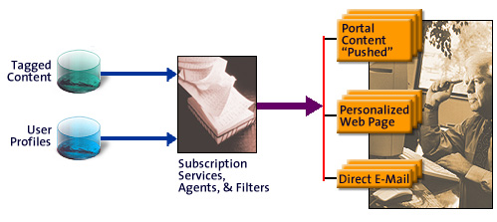
Figure 18 shows a model for the implementation of personalization.
Figure 18: Personalization

Security Model
The basic security of a Knowledge Management system comes from ensuring that only authorized users have access to information. To be authorized to access or place information in a system, users must first be authenticated. That is, users identify themselves and supply passwords or personal identification numbers (PINs). Once users are correctly identified, they have the capabilities to do their own work — and only those capabilities. If a user is not authorized to see a certain type of information, access will be denied. Conversely, an effective security mechanism ensures that users will always have rights to use certain information or applications.
At the highest level, access rights are determined by corporate security policy. That policy defines access rights for individual users or groups of users, information or classes of information, application functions or classes, as well as the actions that are allowed by a user with respect to each. For example, anonymous users might be allowed to view abstracts of an information artifact, but not to download an entire document. The policy governs activities that take place: any permitted activity is allowed but nothing more, and any precluded activity is stopped but nothing more.

Content Administration
The administrative and management tasks of the information artifacts in a Knowledge Management system are best distinguished in the context of the lifecycle of information, as shown in Figure 19.

Figure 19: Lifecycle of Information to Be Managed
System tasks related to the administration of the information include:
- Those pertaining to the operation and security of the infrastructure, such as the network, servers, and applications.
- Those pertaining to information organization, users, and their access rights.
It requires a good deal of planning to ensure that the security domains and services are set up correctly, that the system will perform adequately, and that information is reliable and secure. The detailed work of defining the exact administrative details in the life cycle must be complementary to the agreed-upon knowledge activities model and must plan for the integration of changes in organizational design and work processes.

An Integrated Implementation Approach
Once the business problem has been identified and the critical solution requirements are identified, the next task of the Knowledge Management architect is to develop an architecture that integrates the business, user, and technology views. For example, if a customer has made a significant commitment to a particular view of its knowledge assets — intranet-based, messaging-based, document, business intelligence, or enterprise application — then it makes sense to approach the Knowledge Management solution from this domain.

Compaq’s Approach
Creating a Knowledge Management solution is a highly contextual endeavor. Wherever you start, you will soon see that you are working with a very large problem set and you will want to scope the problem. Compaq’s approach to integrating and designing a custom Knowledge Management system is based on its experience in designing complex solutions that require the integration of new technology with legacy information systems.

Figure 20: Knowledge Management Services for Integrated Knowledge Management
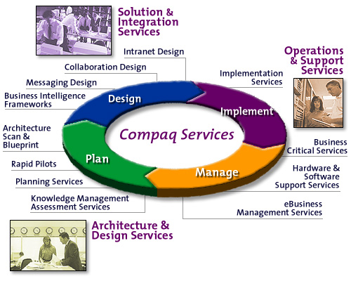
To create a Knowledge Management solution, Compaq employs the following services:
- Exploration workshops, which provide an opportunity to map possibilities for organizational growth and development, and envision strategic directional changes that require IT infrastructure changes.
- Assessment services, which may be specific to Knowledge Management practices and business issues, or to the networking infrastructure or enterprise architecture. These services provide a baseline for the architecture, planning, and design of focused Knowledge Management solutions. They also provide a critical starting point for scoping the project, ensuring that the organization doesn’t try to take on too much, too quickly.
- Planning services, which identify and prioritize the key business drivers for specific projects as well as the key operational (technical and organizational) principles to guide the design of a system. The service typically includes all the stakeholders involved in the design and use of a Knowledge Management system. The result may be a preliminary architecture document and/or a set of recommendations for the appropriate first steps.
- Design services, which include the development of an enterprise information model, and knowledge creation and process models. The models focus on the information architecture and knowledge flow of the workgroup, department, or enterprise for which the service is performed. The knowledge process model focuses on understanding the organization’s overall strategy and the role that knowledge plays in the context of a map of the overall knowledge bases and organizational relationships that support knowledge generation and exchange. (An example of a knowledge model is shown in Figure 21.)
- The workshop, architecture, and modeling processes result in overall designs and recommendations for projects based on specific technologies, products, and tools. An overall program plan provides a Project Manager with a management tool and communications vehicle. A Solution Architect uses the architecture developed as a continuing source against which to validate the completed system elements against the agreed principles, models and standards.
- Implementation areas, which include Intranet Planning, Assessment, Messaging and Collaborations Services, Data Warehousing or Business Intelligence Services, or any combination of these or additional project-specific technologies. Specific implementation projects include pilots or prototypes of the system functional areas, models for information content, user interfaces for workbenches, and organizational and management process changes required. Where no specific product exists, the plan may include a proposal for custom development or integration.
- Management services figure into an overall long-term plan for the successful rollout of new technology, adoption within the enterprise, and end user support. In some instances, a company may outsource the complete Knowledge Management infrastructure, including the systems, applications, end user support, and technology management of the solutions.

Creating a Knowledge Model
The most appropriate starting point for customers who have some experience with intranets, and who want to integrate various Knowledge Management practices, is either a workshop or a needs assessment. A workshop provides a highly interactive participatory process from which both the customer and the consultants achieve a shared model of what’s needed and how to get started. Some organizations prefer an interview-based needs assessment process, which may be more time-consuming in terms of elapsed time, but is less demanding of large chunks of scheduled time for the group of stakeholders. In either case, the first milestone is an understanding of the business requirements, priorities, scope, and clearest opportunity for a pilot or planning session.
A knowledge model provides an organization-spanning view of the knowledge processes in an organization. The knowledge model for the Compaq Professional Services organization is shown in Figure 21.
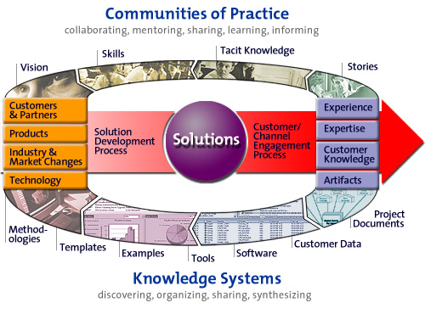
Figure 21: Knowledge Model for Compaq Professional Services
This model summarizes the key business process of knowledge creation: from inputs, insights, and knowledge about the industry and technology as well as directions from customers, partners, and product groups, we use a proprietary process to capture the real-time experience and results of technical projects. This process creates reusable solutions consisting of systems, software applications, and methodologies to deliver to customers. Through our engagement process (also supported by methodology), we create value for the customer while acquiring new knowledge, artifacts, expertise and experience. The upper arm of the model (“Communities of Practice”) shows the exchange and development of tacit knowledge. The lower arm (“Knowledge Systems”) shows the knowledge activities and specific information types. The model proved very useful in determining which areas of our system needed improvement, and in helping to scope specific, measurable projects. It also enabled consultants and developers throughout the company to understand our business and how they relate to its knowledge processes.

Pay Attention to People and Process
As outlined earlier in this document, technology represents less than a third of the problem area. Knowledge creation, transfer, and transformation also involve people and processes. It is very dangerous to think about a Knowledge Management solution without paying attention to the people who will be using the system and the purposes for which the system is to be put in place. Because knowledge entails the discovery and sharing of the elusive knowledge that requires human interpretation and processing, Knowledge Management solutions must describe the new and changed organizational roles of individuals at work in the system.
Knowledge Management presents both an opportunity and a challenge in re-framing current organizational models and processes. To ensure completeness of a solution design, Compaq Professional Services uses the “Fit Model,” as shown in Figure 22, as a benchmark tool.

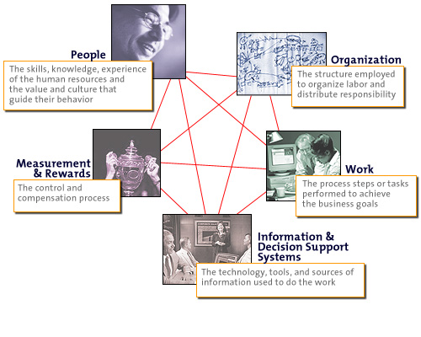
Figure 22: The Fit Model for Whole System Design

Success is in the details, and in the development of Knowledge Management systems there are many details. Some details emerge from using the Fit Model shown in Figure 22. Others may be directly connected to the overall implementation of the Knowledge Management system architecture and tools design. For example, in this paper we have discussed communities of practice and collaboration systems. Technologies to support communities of practice have been available for long enough that research is available on the social and organizational effects. Such research consistently points to the need for facilitated human support to augment the technology investment. Therefore, a program to design and implement a collaboration system should plan for the identification of team facilitators or conference moderators who provide the social and organizational infrastructure required for success.

Establish the Opportunity Scope
You can frame any of the business problems summarized at the beginning of this paper — Innovation, Responsiveness, Efficiency, and so on — in the context of Knowledge Management. None are particularly new problems; all have existing solution approaches, if not out-of-the-box solutions available to help companies solve them. The opportunity for working on Knowledge Management solutions becomes more interesting and complex when you decide how you want to scope the problem:
- Departmental solution, enterprise-wide, or a combination of both?
- Enterprise only, or extended to business partners and customers?
- Manage internal information only, or internal and external information?
- Deal with new content only, or provide systems to integrate legacy content and formats?
As you might imagine, given the range of problems that can be addressed by Knowledge Management solutions, there can be a dramatic increase in complexity when you add customers and partners to the collaboration or knowledge sharing environment. Therefore, it is very important to approach projects in the area of Knowledge Management with an understanding of the overall scope and to map an approach that balances immediate needs (to produce immediate results) with long-term business strategies and goals.
There are a number of approaches to implementing and managing the implementation of an overall Knowledge Management solution:
- Start with a critical business problem.
- Start with the solution domain.
- Start with a strategic assessment of your Knowledge Management goals and develop an overall knowledge model and architecture.
Whatever approach you start with, be sure that you scope the work so that the organization has realistic expectations of when solutions will be in place. One emerging trend is to implement systems organically but systemically. Organizations that are adopting this mode will establish key operating principles and ground rules for workgroups and business functions and let solutions emerge from the bottom up. This approach reflects emerging management practices based on complexity theory. You can establish a guiding body, such as a program office, as a clearinghouse and forum for disparate groups to share emerging best practices, propose standards and process changes, and even offer consulting and production services.

Establish and Communicate Principles
If you begin with a realization that Knowledge Management principles and practices will have an impact across your enterprise, you may want to start with activities that generate a vision and principles. From a set of strategic principles, you can map your organization’s knowledge assets and develop a program and a roadmap for how you will move your people, processes, and technologies toward that vision over time. Principles are agreed-upon goals or values that will guide the design, implementation, and evolution of a Knowledge Management system over time. Some examples of Knowledge Management principles might be:
- All documents must be developed and written as if they are going to be reused.
- Business processes will be designed to ensure that knowledge assets are captured at the point of creation.
- Information is presented to the user based on the user’s stated preference and history.
- Everyone knows how to find the information they need, and the information is readily available to them.
Principles such as these lead to the specifications and standards on which a Knowledge Management system will be built. They will also guide the alignment of the Knowledge Management activities and processes with the organization’s cultural values.

Distinguish Knowledge Management Projects from Information
Management Projects
There are subtle but important differences in the approach to a project when it is a Knowledge Management project, even though to many it might look like just another “information management project.” The following table from the Ernst and Young Center for Business InnovationSM provides some useful distinctions:

Table 3: Knowledge Management vs. Information Management Projects
Knowledge Management | Information Management
Goals emphasize value-added for users | Goals emphasize delivery and accessibility of information
Supports operational improvement and innovation | Supports existing operations
Adds value to content by filtering, synthesizing, interpreting, pruning content | Delivers available content
Usually requires ongoing user contributions and feedback | Emphasizes one-way transfer of information
Balanced focus on technology and culture | Heavy technology focus
Requires ongoing human inputs whose variance precludes automating capture process | Assumes information capture can be standardized and automated

Plan to Evolve the System
One way of looking at how companies approach Knowledge Management is shown in Figure 23, which maps the technology domains and specific technologies to stages in a company’s understanding and adoption of Knowledge Management practices and techniques.
Figure 23: Evolution of Knowledge Management Systems
This model shows an evolution of practices from bottom to top: from focusing on existing knowledge assets and artifacts (data, documents, static Web pages) toward exchanging and reusing artifacts, toward an active focus on making information accessible across the enterprise. Customers who are looking for Knowledge Management solutions may be at different points along this evolutionary path. Within an enterprise, there may be multiple initiatives at different points along this path.
Other organizations prefer a more top-down management approach, and often provide visibility and credibility to Knowledge Management initiatives through the appointment of a Chief Knowledge Officer (CKO).

Align the Strategy with the Infrastructure IT and E-Business Context
A Knowledge Management perspective on the information and intellectual assets of a corporation ultimately impacts the IT infrastructure in profound ways. If a role-based user interface design calls for integrated access to decision support systems, then the Knowledge Management system is reaching into the deepest levels of the corporate IT infrastructure. For example, if this design is being implemented at a time when the company is redesigning its infrastructure or implementing wide-scale renewal projects, then it is possible to impact the overall design and architecture in a way that supports the Knowledge Management program.
E-business initiatives provide a number of entry points into Knowledge Management. For example, in the design of a Web-based e-commerce system, it is important to ensure that the system captures and stores all customer interactions with the system. The information captured will certainly be useful for e-commerce marketing and planning. If properly understood, customer interactions can also provide useful knowledge about patterns that can direct the design of new products and services. Similar opportunities exist in the design and development of customer relationship management systems and in global value chain initiatives.

Manage the Program Knowledge
Managers, designers, and knowledge workers engaged in the implementation of Knowledge Management programs must be proactive about sharing their work and progress. This establishes and models the cultural change that is envisioned for the program. As the tools evolve to meet the needs of the users, and the organization’s knowledge base grows and meets the business needs for which it is designed, communication is essential. Communication models and processes to consider include:
- Establish a program office, knowledge program manager, or core team and give them visibility in all the appropriate organizational vehicles. Many companies have created Chief Knowledge Officers to manage the overall programs.
- Maintain an accessible map of the overall project areas, program plan, and program status and updates on the intranet. Develop and implement an ongoing communication plan about the program. Integrate the communications into the knowledge base.
- Train users in how to use new technologies and introduce the Knowledge Management tools at all possible internal conferences and symposium events.
- Communicate and track metrics.
The Knowledge Management program must work within the context of goals, some of which may be tangible, based on return on investment — and some which may be less tangible, such as employees’ satisfaction with their work environment. Whatever the goals, the program must facilitate, coach, and connect a number of grass-roots Knowledge Management activities and projects.

Conclusion
Knowledge Management is not a solution, but an approach to information and document management and collaboration that supports innovation and the identification and capture of intellectual property. It has become an increasingly important part of the e-business strategy for forward-thinking companies.
Although IT is critical for capturing and sharing intellectual capital, successful Knowledge Management also involves changing business practices and corporate culture. In short, only about one third of Knowledge Management is about technology. The selection and adoption of technology will occur slowly and in the context of how people work. Solution design must occur in the context of the immediate business problems to be solved and the available and acceptable technologies and methods.

Readings and References
Allee, Verna, The Knowledge Evolution: Expanding Organizational Intelligence, Butterworth Heinemann, 1997
Davenport, Thomas H., Information Ecology, Oxford University Press, 1997
Davenport, Thomas, Working Knowledge, Harvard Business School Press, 1998
Davenport, Thomas, “Managing Customer Knowledge,” from CIO Magazine Think Tank, June 1998. http://www.cio.com/archive/060198_think_content.html
David W. DeLong, Tom Davenport, and Mike Beers, “What is a Knowledge Management Project?”, Research Note, Ernst & Young LLP, April 1996
Drucker, Peter, “Looking ahead: Implications of the present,” Harvard Business Review, September-October 1997.
Forrester Research, “Vision: Managing Knowledge,” Forrester Reports, Leadership Strategies, Volume 3 Number 2, November/December 1997. http://weblib.ako.dec.com/Forrester/ldrship/1997/reports/dec97lsr.htm
Forrester Research, “Focus: Searching the Intranet,” The Forrester Report, Software Strategies, Volume 8, Number 12, March 1998.
http://weblib.ako.dec.com/Forrester/software/1998/reports/mar98swr.htm
Grudin, Jonathan, “Why CSCW applications fail: Problems in the design and evaluation of organizational interfaces,” MCC Technical Report Number ACA-HI-211-88.
Hansen, Morten T., and Thomas Tierney, “What’s Your Strategy for Managing Knowledge?”, Harvard Business Review, March-April 1999.
Lawrence, Andrew, “The Searchers,” in Computer Business Review, Volume 5, Number 10, October 1997.
Santosus, Megan, “Simple, Yet Complex,” CIO Enterprise Magazine, April 15, 1998. http://www.cio.com/archive/enterprise/041598_qanda_content.html

Stewart, Thomas A., Intellectual Capital, Currency Doubleday, 1997.
Wenger, Etienne, Communities of Practice: Learning, Meaning, and Identity (Learning in Doing: Social, Cognitive and Computational Perspectives) Cambridge University Press, 1998.
Wurman, Richard Saul, Information Architects, Watson-Guptill Publications, 1997.

Acknowledgments
This document received review, comments, and input from a number of current and former Compaq colleagues, including George Champine, Alex Conn, Merle Conyer, Sudhir Desai, Robert Fleischer, Stan Garfield, Nancy Hintlian, Mary Lee Kennedy, Leo Laverdure, Nasrin Malayery, Chris Marshall, Margaret Meehan, Roger Mizumori, Chris Putur, Dennis Rossi, Howard Williams, Tim Woisin.
I am particularly indebted to David W. DeLong, Boston University School of Management, for a detailed and thoughtful review.

The Delphi Group, ongoing research. Results from a marketplace poll in April 1998, reported in Market Advisory, April 30, 1998.
Etienne Wenger, Communities of Practice: Learning, Meaning, Identity, Cambridge University Press, 1999.
Stewart, Thomas A., Intellectual Capital, Currency Doubleday, 1997.
Cited in “Poor Knowledge Management Practices Threatens Competitive Advantage”, Canada News-Wire via DowVision 11 May 1998. Other high-scoring issues: best practices/effective processes (87%) and their own competencies and capabilities (86%).
Richard Saul Wurman, Information Architects, Watson-Guptill Publications, October 1997
Andrew Lawrence, “The Searchers”, in Computer Business Review, Volume 5, Number 10, October 1997. “The new generation of search tools will need to duplicate the way a human flicks through a bundle of old newspapers, instantly knowing the difference between advertisements, letters, news, stories, and features, processing pictures, graphics, and text, recognizing shifts in tone and style…”
Morten T. Hansen and Thomas Tierney, “What’s Your Strategy for Managing Knowledge?”, Harvard Business Review, March-April 1999.
Peter Drucker, “Looking Ahead: Implications of the Present,” Harvard Business Review, September-October 1997.
Popularized by Robert Johansen, Institute for the Future.
This concept has been well developed and practiced by many companies since its introduction by Gloria Gery in her book, Electronic Performance Support Systems, published by Gery Associates, September 1991.
Hildebrand, Carol, in “Making KM Pay Off,” CIO Enterprise Magazine, February 1999. http://www.cio.com/archive/enterprise/021599_ic_content.html
In lecture at Babson College CIMS conference on Knowledge Management, December 1997.
“Why CSCW applications fail: Problems in the design and evaluation of organizational interfaces,” Jonathan Grudin, MCC Technical Report Number ACA-HI-211-88.
The Contextual Inquiry methodology was developed during the late 1980s at Digital Equipment Corporation. It is one of a number of user-centered design processes that are practiced in the user interface design and usability community.
“Simple, Yet Complex”, Megan Santosus. CIO Enterprise Magazine, April 15, 1998. Megan cites work by Roger Lewin and Birute Regine, including a work-in-progress from Simon & Schuster.
David W. DeLong, Tom Davenport, and Mike Beers, “What is a Knowledge Management Project?”, Research Note, Ernst & Young LLP, April 1996.

