Industry Trend Reports
November 1998

Compaq Brings Industrial Strength Work Management to Exchange

Introduction
When Microsoft made Exchange a key component of its BackOffice suite, it promised more than just E-mail. Exchange in fact has rapidly evolved to become a platform for a wide variety of collaborative work management solutions. The basic reason is simple: Exchange is the software millions of knowledge workers use every day to communicate with colleagues, share data and documents, and look for new action items. It’s where they “live” on the desktop. Exchange not only includes many of the system components users need for collaborative applications and knowledge management, but implements them as low-cost infrastructure, one that is already being deployed enterprise-wide. These include advanced directory services, a rich document/folder object model compatible with ActiveX automation, a powerful but easy-to-use forms designer, and an out-of-the-box groupware client in Outlook.
Today, the pressures of global competition are driving line-of-business executives to demand new tools to let their workgroups collaborate more efficiently, take better control of their business processes, and deliver improved service to customers. These tools, collectively known as work management technology, typically combine workflow, document management, and electronic forms in an integrated framework for building collaborative business solutions. However, IT managers, wary of creating new information islands built on proprietary or boutique vendor technology, are insisting that any work management solution should layer on – not duplicate – enterprise infrastructure standards. As the Microsoft BackOffice component already deployed on desktops across the enterprise for informal collaboration and information sharing, Exchange fits the bill for both parties.
Thus it should be no surprise that several vendors have introduced work management suites built on Exchange. To take maximum advantage of the Exchange infrastructure, virtually all of these leverage its store-and-forward messaging services, internal database, security, and information store, despite the fact that these services were really optimized for E-mail and casual collaboration, not business-critical work management. As a result, these Exchange-based work management solutions have remained focused on informal collaboration, but have not been able to deliver the scalability, transaction integrity, performance, or tight document-level security demanded by the business processes most important to the corporation.
With the introduction of Work Expeditor, Compaq is now offering a better idea. Using Outlook – Microsoft’s principal and strategic client for Exchange – as the familiar, ubiquitously deployed, and richly featured user interface, Expeditor is designed to deliver industrial strength work management services built on a SQL Server back end. Users already conditioned to look for messages in their E-mail Inbox can also check their Expeditor Incoming Work folder without leaving Outlook. Expeditor work items and folders, implemented as MAPI items and folders, show up in Outlook folder views just like ordinary Outlook items. And custom work item properties, like Customer ID or Amount, can be displayed in user-customizable folder views, just like regular Outlook items.
However, the repository of work item data is not the Exchange information store, but Microsoft SQL Server. Extending Exchange’s native folder-level security model, users can define a rich array of access rights and permissions enforced by SQL at the work item or document level. Shared work items are not replicated, with copies delivered to each user’s E-mail inbox – creating the possibility of complex conflict reconciliation downstream – but a single copy of the work item is truly shared, each user seeing the latest changes in real time.
Compaq’s Work Expeditor thus represents a new work management architecture for Exchange users. It takes advantage of the ubiquitous Microsoft infrastructure on the Exchange user’s desktop for work item organization, display, and automation, while enhancing Exchange Server’s capabilities as a mission-critical work management engine.
Expeditor can be used in a wide variety of applications, but Compaq is targeting the general area of case management solutions. In case management, a work folder is a complex container of documents and data that moves through a business process – which may be predefined and structured, freeform, or ad hoc. Documents and data may be added to the work folder along the way, updated, approved, and ultimately finalized, while the work management engine routes and tracks the folder, enforces security, and implements business rules. Typical applications of Expeditor include:
- Case file management
- Project/program management
- Technical documentation
- Bids and proposals
- Correspondence management
- Customer service
- HR employee files

Compaq in the Work Management Marketplace
As a result of acquiring Digital Equipment Corporation earlier this year, Compaq instantly has become the predominant provider of solutions and services for Microsoft Exchange. As the number one systems integrator of Microsoft Exchange, Digital brings to Compaq the world’s largest accumulated experience in deploying Exchange, totaling hundreds of installations around the world, a business growing at 100 percent annually. Compaq is also the number one supplier of server hardware for Exchange, with 77 percent market share. And the company now has more than 800 dedicated messaging and collaboration consultants, and more than 2,000 Microsoft-certified engineers in over 100 countries, providing support and professional services for millions of E-mail users.
These include migration services from legacy mail systems to Exchange, and integration services for an ever-increasing number of third-party products through Compaq’s Business Solutions for Exchange program. Many enterprises rely on Compaq to provide Exchange and Collaborative Computing lifecycle services, including migration assessment workshops, rapid Exchange and business solution pilots, system planning and design, migration and integration services, even ongoing support and outsourcing.
Compaq’s Exchange Utility Service provides complete lifecycle management of customer Exchange installations at a fixed monthly price per seat. Services include installation and configuration, Exchange server management, system monitoring, guaranteed information delivery response, web-based administration tools, help desk, and more. In addition, Compaq’s LDAP Directory Synchronizer Utility provides high-volume directory exchange between LDAP directories and virtually any other directory or database. The net result is that Compaq is a major force in the Exchange marketplace, and the acknowledged leader in enterprise deployment.
At the same time, Digital has also brought to Compaq a strategic partnership with Microsoft chartered to accelerate the adoption of BackOffice and Windows NT in business-critical systems, by applying its experience in meeting glass-house requirements for performance, availability, and networking. In January 1998, Digital was announced as Microsoft’s first Prime Integrator for Windows NT and BackOffice Solutions.
Compaq is thus leveraging significant infrastructure and experience with both Exchange and BackOffice services in bringing Expeditor to market. Expeditor will be used as a work management platform and rapid development toolkit for customized business solutions developed and delivered primarily by Compaq’s own Enterprise Messaging and Collaboration Services unit. This contrasts with the approach taken by other vendors of Exchange-based collaboration software, who are dependent on small third-party Microsoft Solution Providers for solution deployment, but it fits well with the growing demand from customers for enterprise-scale deployment experience with Exchange.
Figure 1. Expeditor architecture integrates with Outlook forms and views, and with Exchange directories and CDO, but provides a separate SQL-based information store.

Expeditor Architecture
The Expeditor architecture is shown in Figure 1. The Expeditor server maintains an information store and method engine separate from Exchange Server, but work items are stored as MAPI messages and folders, so they show up in Outlook as another information service, just like Exchange Mailbox, Personal Folders, and Public Folders. Moreover, Microsoft’s CDO API for manipulating items in the Exchange information store can also be used to manipulate Expeditor work items. Manipulating the work management properties and methods of Expeditor items uses an additional Expeditor API implemented as extensions to CDO.
Expeditor scales by adding tightly coupled servers linked by permanent network connections. This maintains a single “logical community” across multiple servers, with one user list and one security framework. One of the servers, called the Management Cell, contains all the work item and process descriptions and the system-wide organizational hierarchy. The other servers, called User Cells, manage subsets of work items used locally. Workflow and document sharing can occur across User Cell boundaries.
Structured data in the Expeditor servers is stored by Microsoft SQL Server, a scalable, secure, and richly featured database, ideally suited to the needs of business-critical work management. Work item document contents are stored in the NT file system, under the control of the Expeditor information store. Expeditor is integrated with the Exchange directories, so information about users and organizational roles is automatically synchronized.
A notable feature of Expeditor is its tight integration with Outlook. Expeditor integrates directly into Outlook menus and uses Outlook Forms. Just as each type of regular Outlook item – message, calendar item, contact, or bulletin board “post” item – has its own predefined message class that defines its properties and methods, so do Expeditor items. And just like regular Outlook items, Expeditor items can have application-specific custom or user-defined properties that extend the generic standard properties and provide a business context to Outlook views. Expeditor provides out of the box several generic classes of what it calls “business objects” – one for each basic document type – and a Class Editor tool for solution providers to customize these or define new ones without programming.

Work Management Functionality

Work Item Containment
Like other work management products, Expeditor provides a dynamic, programmable container for data and documents.. Although a work item can be a single form or document, in case processing solutions it is typically a folder, containing multiple documents and forms, that is routed and tracked through a business process as a unit. Alternatively, in collaborative authoring or project management solutions, each item in the work folder may follow its own individual workflow. Expeditor is flexible enough to handle any of these scenarios.
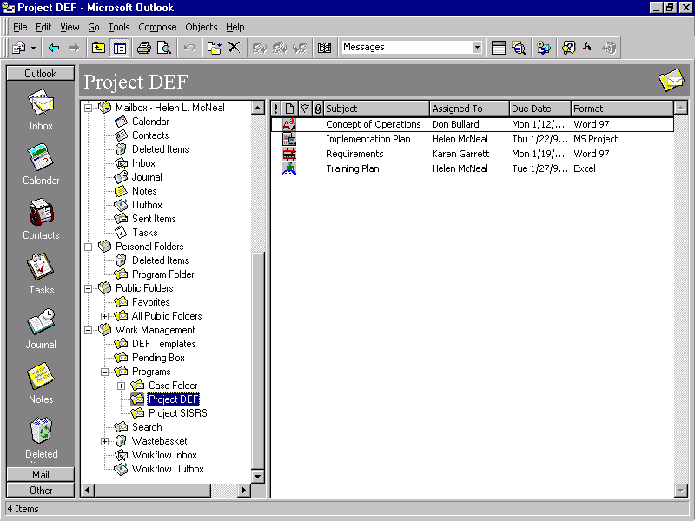
For example, Figure 2, the Expeditor folder Project DEF contains four individual work items. As indicated by the separate icons, each represents a different object class, even though two of them are Word documents. Each object class has its own properties, including default business process flow, access control list, etc. Here all four share the properties Subject, Assigned To, Due Date, and Format, which are displayed in the right Outlook view pane.
Figure 2. Expeditor work items are displayed in Outlook views.
Outlook 2000, due in 1999, will allow Outlook views to list folders, not just individual objects. This better fits the case processing model where multiple documents and forms are routed through the business process as a single complex work item, and a view can represent a queue of cases to be processed. In addition, Outlook 2000 will allow customized work item displays, enabling Compaq to offer out-of-the-box templates tailored to specific industry applications.

User Model and Access Control
While some work management products depend on managing a list of individual users with access to each Exchange folder, Expeditor takes a more practical approach. It implements a rich user model based on roles and organizational units, and controls access at the document or work item level. The entire organization is modeled as a hierarchy of workgroups, with each user assigned to one or more workgroups. An individual’s access rights to any item in the Expeditor store depends upon that user’s workgroup membership, his role with respect to the item, and properties of the item itself. At creation time, each Expeditor item is assigned an individual Owner and Owning Workgroup. Users who are members of the owning workgroup have different permissions than those who are not. Besides Owner, other predefined roles in Expeditor include Administrator, Manager, or Workflow Originator, but each solution may define additional roles.
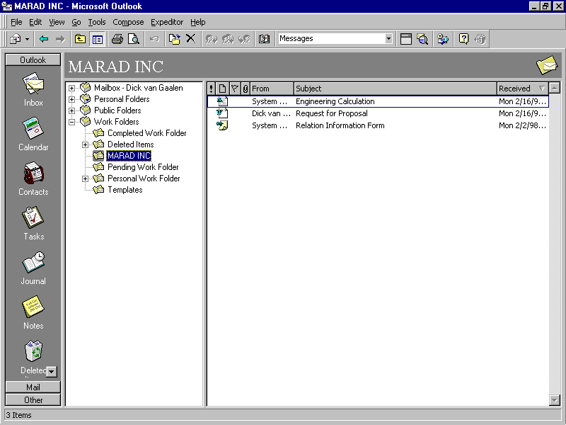
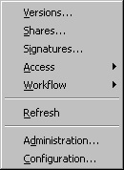
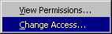
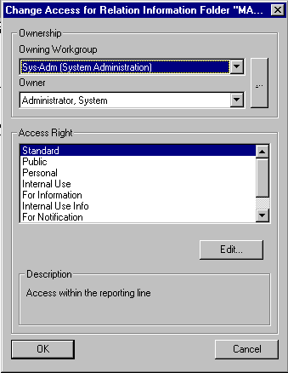
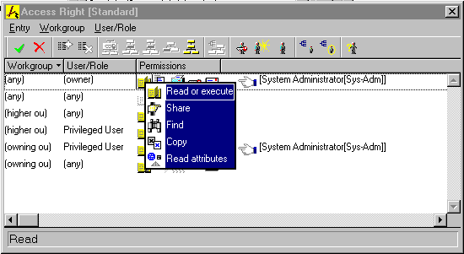
A user’s access right to a work item is the set of permissions assigned to the user individually or by virtue of his membership in a particular workgroup or role. Sixteen specific permissions in five permissions groups are controlled individually for each item, including read/execute, share, find, send, change, sign, archive, and delete. To simplify administration of such a rich security model, Expeditor provides predefined access rights that can be assigned by name. For example, the “Internal Use Info” access right is predefined as unrestricted access for the Owner and Managers in the owning and higher workgroups, Read group and Send group permissions for other users in the owning workgroup, and Send only permission for other users.
Figure 3. Expeditor includes a large number of access control profiles, specifying read, edit, and control permissions at the document level.

Document Management
Expeditor does not bill itself as an enterprise document manager, but focuses on work in process. For example, Outlook views do not list all the items in the Expeditor repository that are accessible to a user, but only the user’s own and shared work folders. Nevertheless, Expeditor includes a wealth of document management functionality including searchable metadata, collaborative authoring and editing, locking and version control, review and approval, and signoff finalization.
A document in Expeditor is not the raw native file, but an Expeditor business object, with specific properties or metadata, access control list, and attached workflow. Expeditor business object classes are registered with Outlook as form types in the Standard Forms Library, alongside regular Outlook item types like Appointment, Contact, and Mail Message. With an Expeditor folder selected in Outlook, a new Expeditor item can be created by using Outlook’s File/New/Choose Form... dialog and selecting the appropriate Expeditor business object. Alternatively, an existing file can be dragged and dropped from the Windows Explorer into an Expeditor folder. In the drag-and-drop method, Expeditor automatically applies the default business object wrapper for the document type.
Searching for Expeditor items makes use of Outlook Find and Advanced Find functions. Find searches the text contents of the selected Expeditor folder and subfolders. Advanced Find allows users to define queries on metadata. Expeditor also allows users to search for items in other users’ work folders by selecting the Expeditor Search folder before invoking Find or Advanced Find. This causes the scope of the search to be the entire Expeditor store.
Shared access to documents for collaborative authoring, editing, and approval is a key feature of Expeditor. When an object is created, by default only the Owner has access to it. Even if granted the appropriate permissions, other users will only be able to access that object via a Search, workflow routing, or direct Sharing. The Owner, or another user with Sharing permission, can elect to Share an item or folder with other selected users. These users are said to have Links to the shared item or folder.
Users see linked folders in their Expeditor folder list, and can access all subfolders and items contained in them. Expeditor supports an implicit form of check-out/check-in functionality, automatically locking any item open for editing by a user, and creating a new version when an object is modified and saved by a new author. A user may also manually create a new version, import an external file as a new version, or make an earlier version the current version.
Expeditor provides password-protected electronic signatures for work items, a feature missing in most other work management products. Signing an item can be used to indicate that the item has been read (“initialed”), approved or disapproved, or finalized (“signed off”). Signing off an item sets its Final Form property in Expeditor, after which it cannot be edited. An item’s signatures can be viewed by users, and can be used to enforce business rules in a workflow.

Workflow
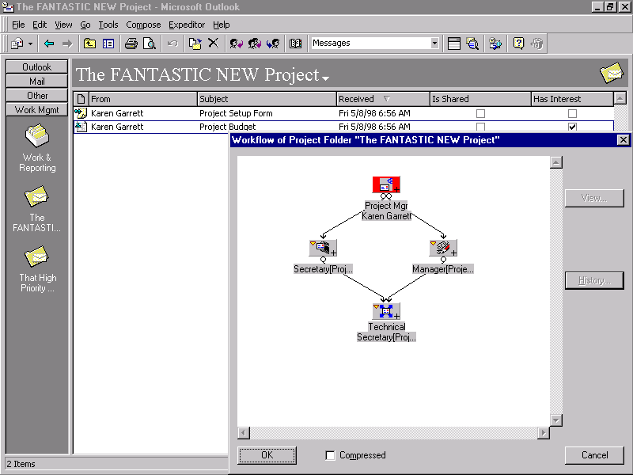
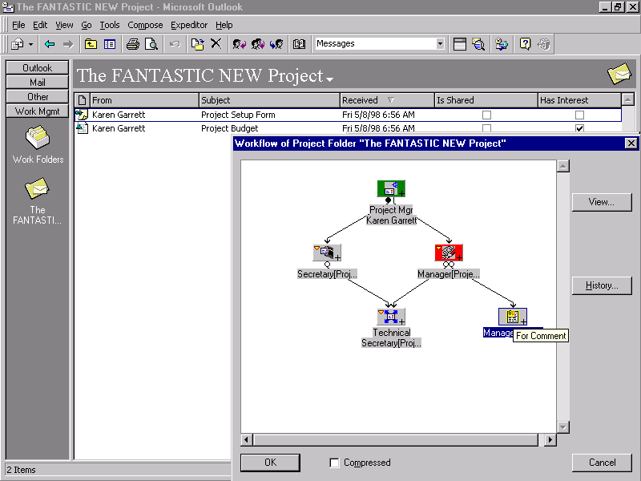
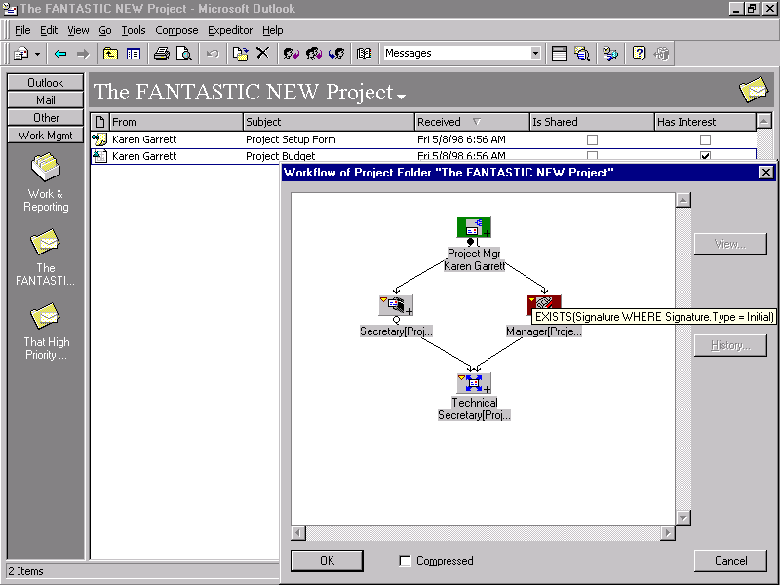
Most work management products are designed either for structured workflows, where the process map is predefined, or ad hoc flows, where users create process maps on the fly for one-time use. Expeditor not only handles both of these, but also freeform workflow, where the next step of the work item is determined manually by each participating user. In many collaborative and case management scenarios, freeform routing is the only viable workflow option, and Expeditor is one of the only work management tools that includes it. Regardless of the type of flow, work items are tracked against specified deadlines, secured against unauthorized access, and tested against predefined business rules.
Figure 4. Tracking past and future workflow steps from the Incoming Work folder. Light gray icon background indicates a future step, and the History button provides an audit trail.
In Expeditor, a workflow is like a graphical routing slip, optionally attached to an object. It depicts a map of iconic worksteps, called stages, and the work item’s processing history. In freeform routing, the map of the item’s processing history is generated by the system it progresses through the business process. Users with required permissions can manually edit the workflow map of future stages, and predefined maps called workflow blueprints can be attached. In fact, elements of structured workflow (blueprints), ad hoc worksteps, and freeform routing can be combined in a single flow.
When a user Forwards an object with a workflow attached, it arrives in the recipient’s Incoming Personal Work or Incoming Group Work folder, along with a notification in the recipient’s Outlook Inbox. Handling instructions to the recipient, such as “For authorization,” “For comment,” or “For processing” are a selectable property of the workflow for each stage, called its workflow mode. Rather than being delivered via e-mail, work items are posted directly to Expeditor incoming work folders. However, users can open and reply to work items directly from the Inbox, preserving the idea of a single place to look for incoming information.
Figure 4 illustrates the workflow attached to a project folder when it arrives in a user’s Incoming Personal Work folder. The triangle in the upper left corner of the icon for the current stage (Manager) indicates a precondition, shown on the map to be WHERE Signature.Type = Initial. Until the user of preceding step signs the work item, it cannot be routed to the Manager stage. Expeditor provides routing rules in the form of both post-conditions, which determine whether a work item can be forwarded at all from a stage, and preconditions, which determine whether a particular stage can be selected. These routing conditions, which can be complex nested expressions involving object properties, are used both to enforce business rules and to provide conditional branching logic.
Expeditor provides a simple graphical tool for defining workflows. Users with the requisite permissions can modify the flow with ad hoc steps, such as the For Comment path in Figure 4, or insert saved workflow blueprints. Note also in Figure 4 that the work item splits into two parallel paths that join at the last stage. Unlike some other workflow products, in Expeditor all parallel paths see the same work item – dynamically updated with the latest changes – as opposed to copies that must be reconciled at the join.
Each stage in a workflow can be assigned a deadline. A work item not forwarded from that stage by the deadline will generate a notification message sent via E-mail to users with a registered interest in the work item. Notifications also can be sent when specified Expeditor objects or folders are modified.

Business Solution Automation
While simple work management can be achieved using Expeditor out of the box, real business solutions typically involve some amount of programming. Like Exchange, Outlook, Office applications, and other Microsoft components, Expeditor is designed to be programmed through ActiveX Automation, using Visual Basic, Visual Basic for Applications, or VBScript. Expeditor provides an automation object that is used in conjunction with Microsoft-supplied automation objects for Exchange (CDO) and Outlook.
While Expeditor can be programmed from an external custom VB front end application, a more self-contained example within the Exchange environment could use Expeditor forms built using the Outlook Form Designer. Outlook provides a flexible and powerful tool for building custom forms with data entry text boxes and list boxes, checkboxes and radio buttons, and scriptable command buttons. Using the Class Editor, an Expeditor form object can be defined and exported to Outlook, so that its custom properties can be used in Outlook Form Designer. Using VBScript, command buttons in the form can manipulate Expeditor properties of the form, its parent folder, or other objects in the folder – e.g. set a deadline, insert an ad hoc workflow stage, or create a version – allowing full automation of the business process.
Currently, Compaq envisions the task of building Expeditor objects and automation scripts to be the job of a solution provider, e.g., Compaq’s own Collaboration Services unit, rather than a customer function. However, Expeditor’s application-building tools facilitate rapid development, and given the increasing number of IS shops able to customize Exchange applications, it would not be a stretch to see Expeditor solutions built entirely by corporate developers in the future.

Analysis
Expeditor represents a new kind of product for work management, a hybrid between infrastructure-based software and a traditional client/server solution. It retains the key advantage of infrastructure-based solutions – heavily leveraging technology already deployed and supported enterprise-wide in the customer site, in this case Exchange and Outlook – while adding a scalable, secure, and bulletproof platform for work management.
Expeditor fits in a fairly wide segment of the work management market, but its sweet spot represents business processes involving:
- A collection of disparate documents and forms that must be managed as a unit, as in case processing or project management. It is NOT designed for high-volume repetitive transaction processing, like health insurance claims, nor for basic groupware functions like meeting scheduling.
- A combination of structured, free form, and ad hoc routing, while maintaining a unified system of tracking and notifications. Competitive products are usually optimized either for structured or ad hoc, and rarely deal with freeform at all.
- Scalability to several hundred or more concurrent users, all within a single “site” or high-speed connected domain.
- Collaborative authoring, editing, and a review-and-approve cycle, with specific user permissions to read, revise, or manage documents tightly secured at the document level. It is not really optimized as an enterprise document library or knowledge repository.
- Users who “live” in Exchange and Outlook, and know how to use their wide array of features. Expeditor gains much of its power from the Microsoft software’s extensive user-customizability features, such as Outlook views and searching.
Expeditor’s feature set compares favorably with other Exchange-based work management software on the market. It includes document management functionality missing in Keyflow and workflow features missing in Eastman WorkFolder for Exchange. The closest product to it functionally is Open Text Livelink, but that product is strictly web/HTML-based, and cannot take advantage of Outlook’s rich client user interface nor user information in the Exchange directory.
That is not to say Compaq has no interest in web access. The next version of Expeditor will work with a web browser, which will allow users who are not on the regular Exchange network, or not directly tied to the workgroup backbone network, to participate in solutions. A thin client version will also streamline company-wide deployment to thousands of seats, and perhaps allow Expeditor to be sold more as an enterprise platform for work management than as the core of a custom business solution.
For now, however, Compaq’s unmatched experience in deploying and customizing large Exchange sites fits well with Expeditor 1.0. Exchange shops with a need for case-oriented work management should definitely consider it.

