proliant dl580 g2 and lotus domino
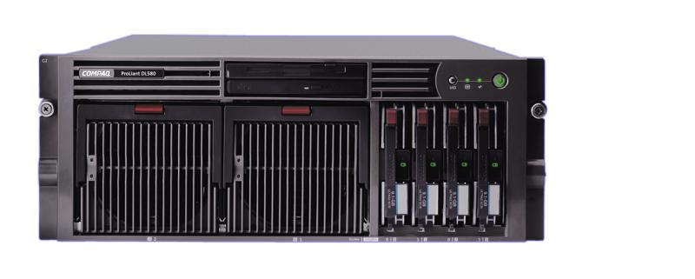

contents
Test Configuration 3
Results 4
NotesNum Output: 4
Conclusions 5
abstract: Based on testing performed in the Nashua, New Hampshire labs during June 2002, hp submits this document as results of performance of the ProLiant DL580 G2, and Lotus Domino. This document is not intended to be used a sizing guideline, but rather as a document that can be used to compare this server with other Lotus Domino Results.
The ProLiant DL580 G2 was configured with four 1.60GHz INTEL XEON processors, 4 Gigabytes of PC1600 RAM, and three SmartArray 5302 controllers, with eighty-four 36.4 Gigabyte 15,000 RPM UltraSCSI-3 disks. Using Windows 2000 Advanced Server, with Service Pack 2, Lotus Domino was installed as 3 partitioned servers
Two workloads were run to simulate 20,500 Notes R5Mail users, and 6,750 WebMail Users, respectively. The R5Mail test ran 8 hours and during which the system under test achieved an average of 28,377 transactions per minute at an average response time of 0.222 seconds. The WebMail test ran 9 hours and during which the system under test achieved an average of 3,456 transactions per minute at an average response time of 0.700 seconds.

notice

The information in this document is subject to change without notice.
september 2002
ese-mca-ldpf-580-01

Test Configuration
Using the Messaging and Collaborative Applications testing lab environment 8 driver systems and one controller system, were setup to create a load of 20,500 R5Mail users against the System Under Test (SUT), the ProLiant DL580 G2. In the case of WebMail, 9 driver systems, and one controller were setup to create a load of 6,750 WebMail users. Each of these driver systems generated between 500 and 2000 simulated Lotus Notes users that performed activities associated with an average Lotus Notes user, such as reading and sending mail, scheduling an appointment, and sending a C&S invitation.
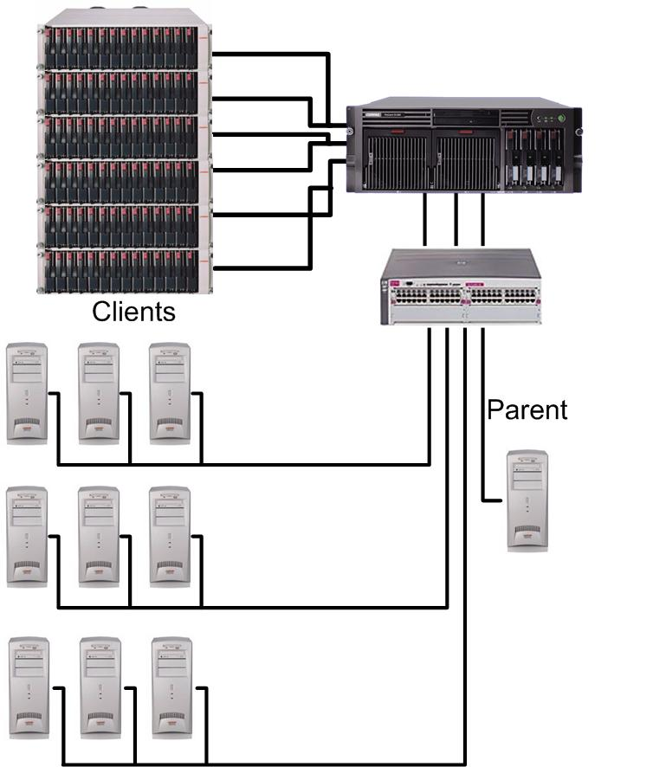
The SUT was configured with four 1.60GHz INTEL XEON processors, 4 Gigabytes of PC1600 RAM, and three SmartArray 5302 controllers, with eighty-four 36.4 Gigabyte 15,000 RPM UltraSCSI-3 disks. Windows 2000 Advanced Server was installed with Service Pack 2 on two mirrored 36.4 Gigabyte drives on the internal SmartArray 5i controller. The Operating System was then updated with the most currently available hardware drivers available from http://www.hp.com.
All the driving systems were connected to the SUT through an hp procurve 5300xl series switch at 100 Mbps, while the SUT was connect to the switch at 1 Gbps. More information on hp’s line of procurve switches is available at http://www.hp.com/rnd/index.htm.
For both the R5mail and WebMail testing, Lotus Domino R5.08 was installed as 3 partitioned servers. 48,000 registered users were created in the Domino Directory for the R5mail testing, while 13,500 registered users were created in the Domino Directory for the WebMail Testing. Each partition was giving a 28 disk RAID0+1 logical array as its data directory.

Results
Price/Performance Ratios:

R5Mail Workload | 20,500 Users | Price/Performance for System Capacity | $6.51/User
 | 28,377 NotesMark (tpm) | Price/Performance for System Throughput: | $4.70/NotesMark
WebMail Workload | 6,750 Users | Price/Performance for System Capacity: | $13.52/User
 | 3,456 NotesMark (tpm) | Price/Performance for System Throughput: | $26.41/NotesMark

NotesNum Output:

- The 20,500 R5Mail Users Test Report
Min Start Time = 06/24/2002 07:36:34 AM Max Stop Time = 06/24/2002 08:54:48 PM
Total Test Errors = 0
Total Test Time = 47880 sec
Test Run: Users = 20500 NotesMark = 28377 Response Time = 222 msec (06/24/2002 12:38:00 PM to 06/24/2002 08:41:00 PM)

- The 6,750 WebMail Users Test Report
Notesnum: Cumulative Web Mail Stats
------------------------------------------------------------------------------
HTTP Stats-----------Min-----Max-----Avg----HTTP Stats------Min-----Max----Avg
ConnectTime : 1 340 11 SendTime : 1 310 3
ReceiveTime : 1 51464 1203 TotalTime : 3 51486 1218
ActionsTime : 0 51036 3429
Byte/Page : 205 21774 525 Object/Page : 1 5 1
Byte/Obj : 205 21508 402
-------------------Bytes---Pages-----Objs---------------TimeOut---Drops---ActF
Totals : 1255687437 2390940 3119287 Totals : 0 0 0
---------------------Act---SErrs---CErrs----------------Hit/ Min----MinRunning
Totals : 64855 0 0 : 496 698

Reading results file - c:\results\results1\res1 ...

Reading results file - c:\results\results1\res2 ...

Reading results file - c:\results\results1\res3 ...

Reading results file - c:\results\results1\res4 ...

Reading results file - c:\results\results1\res5 ...

Reading results file - c:\results\results1\res6 ...

Reading results file - c:\results\results1\res7 ...

Reading results file - c:\results\results1\res8 ...

Reading results file - c:\results\results1\res9 ...

Min Start Time = 06/26/2002 07:35:45 PM Max Stop Time = 06/27/2002 08:49:48 AM
Total Test Errors = 0
Total Test Time = 47640 sec

Test Run: Users = 6750 NotesMark = 3456 Response Time = 700 msec (06/26/2002 11:39:00 PM to 06/27/2002 08:38:00 AM)

Conclusions
 | The ProLiant DL580 G2 demonstrates itself as an excellent platform for companies looking to deploy mid to high end solutions. And proving that whether you’re deploying a single Domino server, or consolidating your enterprise, ProLiant servers are the best performance solutions for price sensitive customers, hands down (based on Notesbench testing results).  Built on the industry standard Intel processor line, HP offers a wide range of end-to-end solutions to fit your all needs. From the DL330 G2, a 2 CPU system that packs enough punch to support
a small to medium business, all the way up to the current performance leader in the Windows space, the DL580, each ProLiant server is engineered to provide maximum reliability and performance.
You might think that since we all use the same CPUs that all Intel servers are pretty much the same, but you’d be wrong. HP engineering is constantly developing new ways to advance the technology of each server. For example, the DL580 G2 is the first server in the industry to offer Hot-Plug Mirrored Memory. Hot-Plug Mirrored Memory eliminates service interruptions caused by multi-bit memory errors and allows you to replace failed memory without ever taking down your server. This feature provides a higher level of advanced memory protection than ECC memory, protecting up to 24GB of memory from unplanned downtime. By basing this on industry standard DIMMS and the ServerWorks Grand Champion-HE chipset, Advanced Memory Protection technology provides the highest levels of memory protection at an exceptional total cost of ownership.
Another good example is the HP Integrated Lights-Out (iLO) feature, an HP innovation that integrates industry-leading Lights-Out functionality and basic system board management capabilities on selected ProLiant platforms. HP Integrated Lights-Out Advanced (iLO Advanced) technology offers sophisticated virtual administration features for full control of servers from across the Datacenter, or across the world.
But our engineering doesn’t stop at the hardware, with Compaq Insight Manager 7 for HP you get pre-failure alerts that provide notification of potential failures before they result in unplanned downtime, e-mail and pager notification to reduce the need for dedicated console watching, remote update of BIOS, drivers and agents across groups of servers to reduce maintenance time, travel expense, and much more.
HP engineering is working hard to build the very best in Industry Standard Server technology to assure that our customers can deploy the very best solutions for their Lotus Domino needs. Once you look at our technology (http://www.hp.com) and our performance records (http://www.notesbench.org), you will understand why HP ProLiant Servers are the most commonly chosen platform for Lotus Domino.

