proliant dl380 g3 and lotus domino

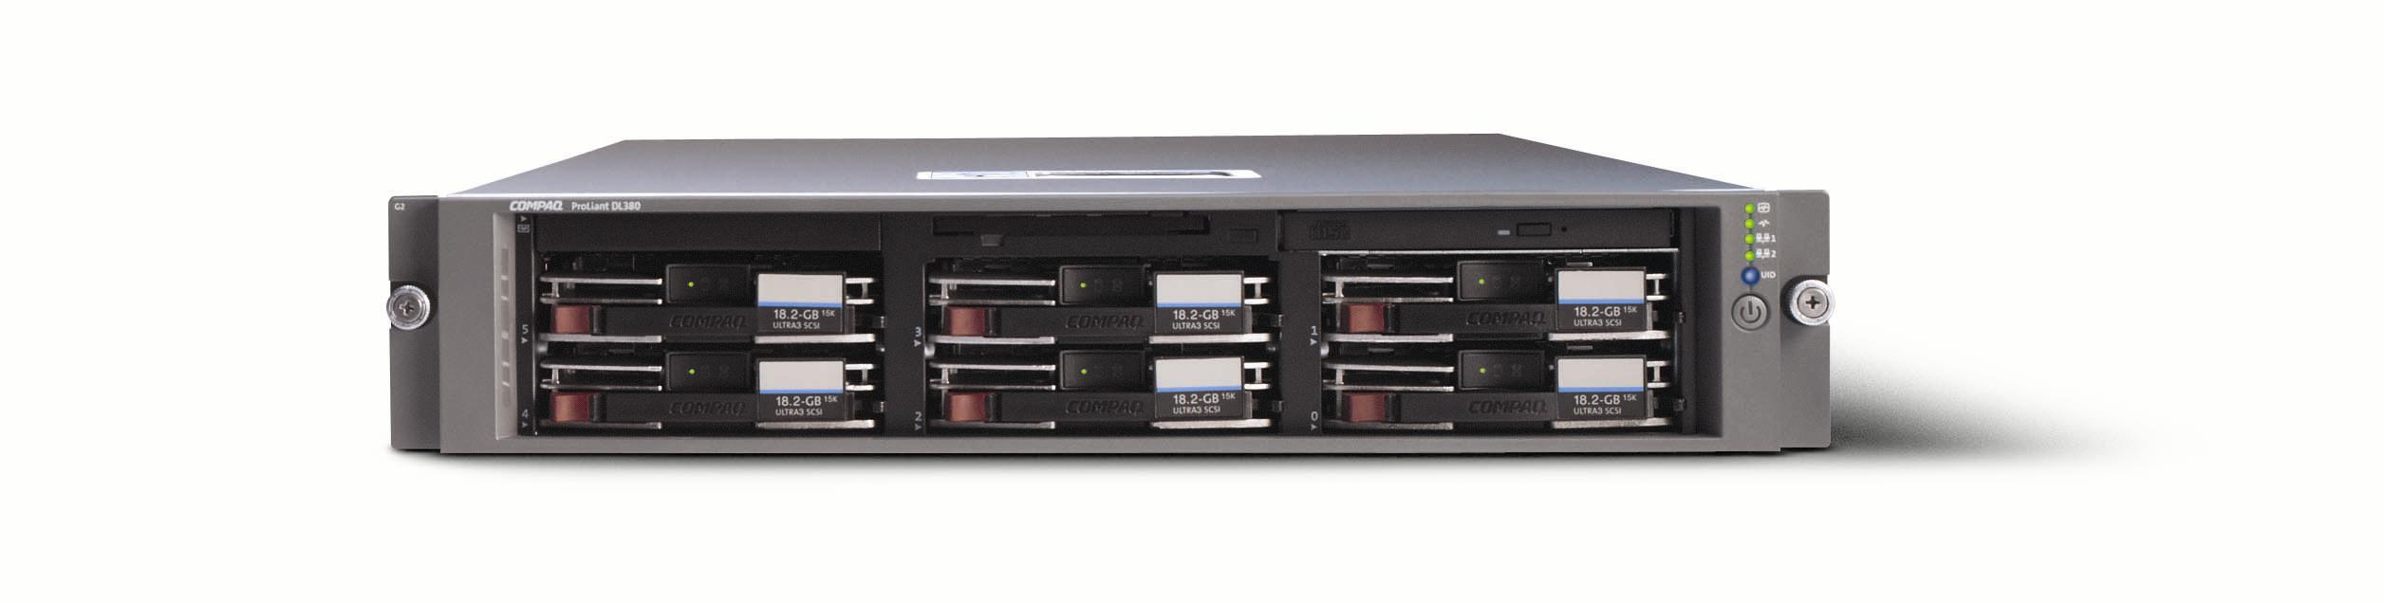
abstract: Based on testing performed in the Nashua, New Hampshire labs during September 2002, hp submits this document as an unofficial, and non-audited results document of performance of the new ProLiant DL380 G3, and Lotus Domino. This document is not intended to be used a sizing guideline, but rather as a document that can be used to compare this server with other Lotus Domino Results.
The ProLiant DL380 was configured with two 2.80GHz INTEL XEON processors, 4 Gigabytes of PC2100 RAM, and a single Smart Array 5304 controller, and fifty-six 18.2 Gigabyte 15,000 RPM UltraSCSI-3 disks. Using Windows 2000 Server, with Service Pack 3, Lotus Domino was installed as 2 partitioned servers, each with 16,000 registered users per partition.
A workload was run to simulate 16,000 Notes Mail users, 8,000 simulated users on each partition. The test ran 7 hours and during which the system under test achieved an average of 22,055transactions per minute at an average response time of 0.076 seconds.

contents
Test Configuration 3
Test Results 4
Conclusions 5

notice

The information in this document is subject to change without notice.
october 2002
ese-mca-ldpf-380-01

Test Configuration
Using the Messaging and Collaborative Applications testing lab environment 8 driver systems and one controller system, were setup to create a load of 16,000 simulated Lotus Notes users against the System Under Test (SUT), the ProLiant DL380 G3. Each of these driver systems generated 2000 simulated Lotus Notes users that performed activities associated with an average Lotus Notes user, such as reading and sending mail, scheduling an appointment, and sending a C&S invitation.
The SUT was configured with two 2.80GHz INTEL XEON processors, 4 Gigabytes of PC2100 RAM, and a single Smart Array 5304 controller, and fifty-seven 18.2 Gigabyte 15,000 RPM UltraSCSI-3 disks. Windows 2000 Server was installed with Service Pack 3 on a single 18.2 Gigabyte drive on the internal dual channel UltraSCSI-3 controller. The Operating System was then updated with the most currently available hardware drivers available from http://www.hp.com.
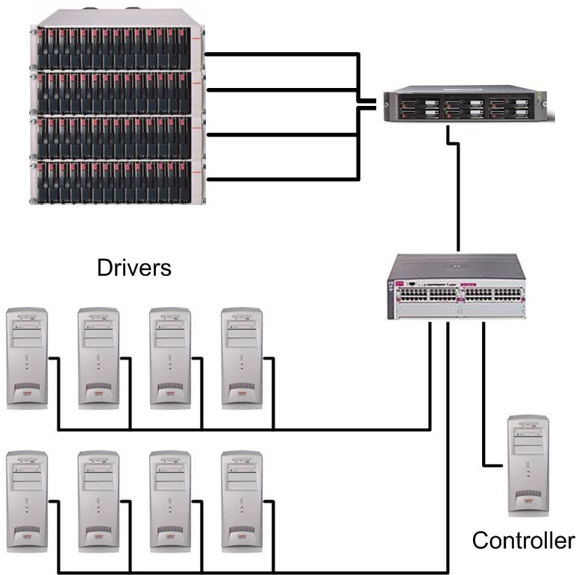
All the driving systems were connected to the SUT through an hp procurve 5300xl series switch at 100 Mbps, while the SUT was connect to the switch at 1 Gbps. More information on hp’s line of procurve switches is available at http://www.hp.com/rnd/index.htm.
Lotus Domino R5.010 was installed as 2 partitioned servers, each with 16,000 registered users per partition. Each partition was giving a 28 disk RAID0+1 logical array as its data directory.
Testing began with the drivers being started incrementally, adding users to the Domino environment at an average rate of one simulated users every .6 seconds. At this rate of load, it took the test just under 3 ½ hours to reach full testing load. The test ran stably for 7 hours after reaching full load.

Test Results
As the performance monitor graph below indicates, the DL380 G3 was able to support 16,000 simulated Lotus Notes Users at an average rate of 90% CPU utilization over the course of the test. The test ran 8 hours and during which the system under test achieved an average of 22,055 transactions per minute at an average response time of 0.076 seconds.

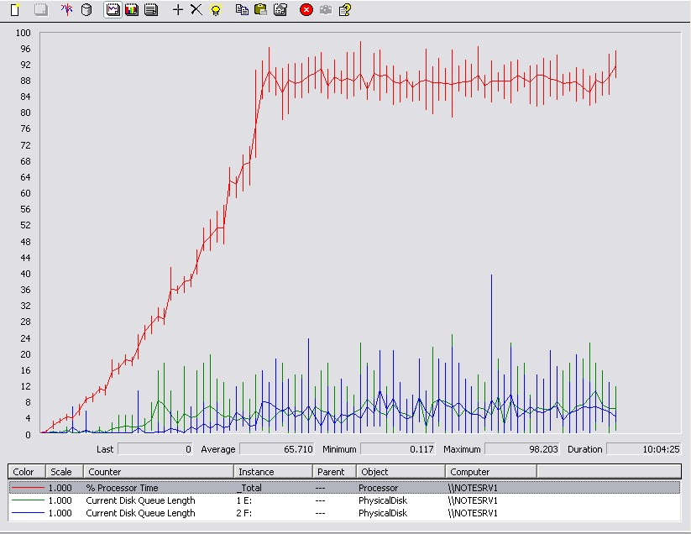

The test ran for more then six hours after all driver threads were connected to the system under test, with over 90% of the mail generated during the run was delivered during the run. Steady state was determined and achieved during each test run by monitoring server output, as well as mail routing, calendar and scheduling activities.

Conclusions
The ProLiant DL380 G3 demonstrates itself as an excellent platform for companies looking to deploy low to middle level Lotus solutions. And whether you are deploying a Lotus Domino server for mail or other functionality such as Sametime, or Domino Enterprise Everyplace, hp will continue to engineer our servers to offer the best possible solutions for whatever your situation calls for.

HP engineering is working hard to build the very best in Industry Standard Server technology to assure that our customers can deploy the very best solutions for their Lotus Domino needs. Once you look at our technology (http://www.hp.com) and our performance records (http://www.notesbench.org), you will understand why HP ProLiant Servers are the most commonly chosen platform for Lotus Domino.

