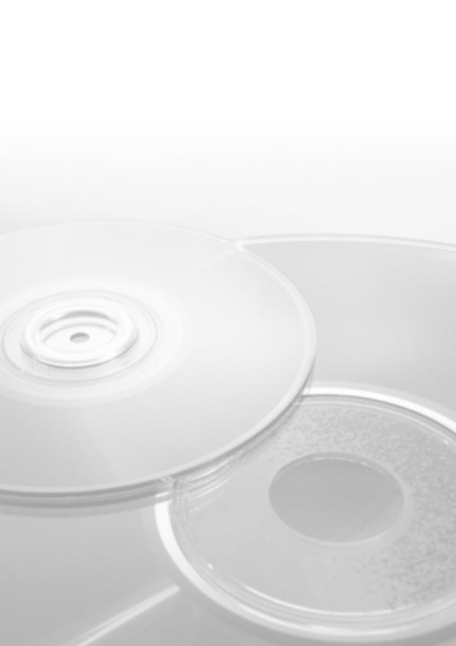
The SAP standard 4.6 C application benchmark performed on October 2, 2001
by Compaq in Nashua, USA was certified on October 16, 2001 with the following data:

Number of benchmark users & comp.: 420 SD (Sales & Distribution)
Average dialog response time: 1.80 seconds
Throughput:
Processed Order Line items / hour: 42,670
Dialog steps / hour: 128,000
SAPS: 2,130
Average DB request time (dia/upd): 0.013 sec / 0.026 sec
CPU utilization central server: 99%
Operating System central: Tru64 Unix V. 5.1A
RDBMS: Oracle 8.1.7
R/3 Release: 4.6 C
Total disk space: 275 GB

Configuration:

1 Central Server: Compaq AlphaServer ES45, 4-processors SMP, Alpha EV6.8CB 1000 MHz, 8 MB L2 cache, 16 GB main memory
Certification Number. 2001040
© 2001 by SAP AG. All rights reserved. SAP and the SAP logo are registered trademarks of SAP AG.

