$---------------------------------------------------------------$
| A Spying Guide To 2Fort5 (including variations) |
| |
$ ----- By ----- $
| |
| BlasTRadys |
$--------------------------------------------------------------- $

Version 1.1

*--*--Contents--*--*

--1--
Guide Info
1.0 - Version History
1.1 - Contact
1.11 - Where I Can Be Found

--2--
Setup
2.0 - Team Fortress Setup
2.01 - What Is Team Fortress?
2.02 - What Is Mega TF?
2.1 - Game Spy Setup
2.11 - What Is Game Spy?
2.2 - 2Fort5 Setup
2.21 - What Is 2FortX?
2.3 - Key Reference
2.4 - What Key Binding Is and How To Use It

--3--
Guide
3.0 - Why Should I Be a Spy? (What Is a Spy?)
3.1 - Spy Strategies
3.11 - Special Note
3.12 - The “Walk Into the Enemy Base Dressed as a Spy
and Get Yourself Killed” Strategy
3.13 - The “Walk Into the Enemy Base and Not Get Killed”
Strategy
3.14 - The “Grapple” Strategy*
3.15 - The “Toaster” Strategy*
3.16 - The “Kill the Snipey” Strategy (a.k.a. The “Camp in
the Sniper Nest” Strategy
3.161 - The “Ass-Knife” Strategy
3.162 - Grenade Fun
3.163 - The “Gas Em’ Up” Strategy
3.164 - Stealth, and How to use It
3.165 - If The Sniper is Not in the Sniper
Nest
3.17 - The “Kill the Sentry Gun and its Creator
(Engineer)” Strategy
3.18 - The “Gas Up a Room” Strategy
3.19 - The “Camper” Strategy
Strategy
3.191 - The “Tranq Gun” Strategy
3.192 - The “Feigning” Strategy
3.193 - The “Cap the Flag and *Daring Escape*”
3.194 - Killing Any Other Class

3.2 - Spy Advantages
3.3 - Spy Weaknesses
3.4 - Tips In General

--4--
Misc.
4.0 - Spy Stories
4.1 - Links
4.2 - My Computer
4.3 - Credits

*--*--Contents--*--*

--1--
Guide Info

1.0 - Version History

6/30/99 - 1.0 - This is it! I started this guide to showcase all of the information I
have acquired playing Team Fortress (TF).

7/3/99 - 1.1 - Man...12 hours of work. I fixed some formatting errors and some
spelling mistakes. Added “My Computer” section.

1.1 - Contact

You can contact me if you find an error in this document, or if you just have a question (or suggestion), story, threat, or new information! Here are my 3 e-mail addresses:

mmcquail@earthlink.net - this is my major e-mail address

mmcquail@netzero.net - this is my netzero account. (netzero is a free ISP! local access #’s are all over the place! check out www.netzero.com.)

mmcquail@netscape.net - this is my backup e-mail address. just in case the above two aren’t working. i don’t check it much, though, so try to send to the above two!

1.3 - Where I Can Be Found

This is a list of the servers I can be readily found at:

SPAM Central TF 2.8/MegaTF - 128.119.91.177:27500
This is the coolest server ever! It is fast, and the max. # of players is 12 - not too much, not to little. Just right.

Biscuit Mega TF Gibstats - 209.151.192.69:27500
Max # of players is 24, so its a little slower than SPAM - it is, however, very fun (especially for ass-knifing snipers :-).

This is a list of servers I am sometimes on:

Area 51’s TF Server - 208.225.80.12:27500
This is fun. I am not on it as much though because it is not Mega TF and has other maps in rotation that I am not fond of.

Engineers’ Paradise TF 2.9/QW 2.30 - 24.0.195.49:27500
When I am not playing as spy, I like to be an engineer (I know, I know).

--2--
Setup

2.0 - Team Fortress Setup

I am assuming you already have TF installed, so all I will say is if you don’t have it, head over to www.teamfortress.com and snag yourself a copy!

2.01 - What Is Team Fortress?

I am quoting this from the official Team Fortress 2.8 readme:

“TeamFortress is a fairly old QuakeC patch which radically changes team games. It provides far more incentive for teams to actually work as a team. Each member of the team has unique weapons, items, and abilities, and style of play.
TeamFortress works with Quake 1 only.”

2.02 - What Is Mega TF?

Mega TF is an extension of Team Fortress running on most servers. I like it a hell of lot because it permits more advanced maneuvers and traps than normal Team Fortress. For example, the spy now has a grappling hook (yes...), and a Mac10 instead of a nailgun, and the HWGuy has an alternate way of fireing his big ass gun, which uses ten bullets instead of one, but deals a shitload more in terms of damage. Also, the main feature of Mega TF is the Mega TF menu. Sections in this guide that are Mega-TF exclusive will be marked with a “*”. The proceeding info taken from iamsauce’s Mega-TF Strategy Page (iamsauce@hotmail.com). Sauce, if you want this removed, I will do it. Anyway, here is what the basic Mega-TF commands are:

“lay - Same as prone. Makes you Lay. Headshots every time. prone - See lay. drop1 - Drops your classes mine.
drop2 - Throws a toaster.
drop3 - So far for engineers only. Laser Drone.
mega - A MEGA-TF Menu with options and stuff
taunt - A list of sounds you can produce which light you up.
airstrike - Ah.The ultimate sniper’s weapon. Just guess.
airscout - List info about the Air Scout”

A “toaster” is a small ball of electricity that you can throw in the water and kill anyone on the other team, but not your own team (unless team kill is enables) - a toaster can also kill you. See Toaster Strategies for more info.

“Lay” is a great command! It allows any class to lay on the ground when standing still. Snipes use this all the time.

Also, and I don’t know if this is exclusive to Mega-TF or not, but I sometimes see soldiers make (I think) a fairly large golden ball that can be bumped around. What does that do? I would appreciate an e-mail explaining this.

2.1 - Game Spy Setup

I am also assuming that you already have Game Spy. If not (oooooohhhhh), then get your ass a copy by heading over to www.gamespy.com.

2.11 - What Is Game Spy?

Game Spy is a great server lister (for lack of a better word) that works for pretty much every game. It can scan servers, tell you their ping (how fast they are), how many people are playing, who is playing, etc (which is an abbreviation for et cetera, which, in Latin, means, “and so on” or “and so forth”. Sorry, I have to put my year of Latin 1 to some use don’t I?). Game Spy basically eliminates the need to type in server addresses to connect to them (hurrah!).

2.2 - 2Fort5 Setup

The latest edition of 2 Forts is called 2Fort5r (2 Forts Version 5.0 Revised) and can be found here:

ftp://cdrom.com/pub/quake/levels/team_fortress/0-9/2fort5r.zip

The previous version, which is more prominent on servers, is called 2Fort5 (2 Forts Version 5.0) and can be found here:

ftp://cdrom.com/pub/quake/levels/team_fortress/0-9/2fort5.zip

2.21 - What Is 2FortX?

2Fort5 (or 4, as the first-third ones aren’t used anymore [usually - if you find a server that as it in rotation, mail me]) is possibly the best Team Fortress map ever created. It pits two teams against each other in an all out battle royal to capture the other team’s flag. Each team has a fort, which are symmetrical, and there is a moat dividing them, but the moat is bridged by...a bridge (Don’t make any remarks about that sentence. I am very tired.). This is what the official 2Fort5r readme file says:

“Details: This map is designed specifically for the TeamFortress QuakeC patch v2+. It is capture the flag style map, with the following objectives: The blue team must capture the red flag from the basement of the enemy base, and take it to the battlement of the blue base. The red team must capture the blue flag from the basement of the enemy base, and take it to the battlement of the red base. Each team must try prevent the opposing team from achieving their objectives. If the flag carrier is killed, they drop the flag to the ground where it remains for 30 seconds after which it returns to the basement. Unlike standard CTF, team members cannot return the flag by running over it. This map is the result of over a year of playtesting and redesigning.

A brief history:

2fort was released the 21st of the 8th, 1996.
2fort2 (unreleased, was the first to have flags and a goal)
2fort21 (small flag problem)
2fort23 (fixed the small flag problem again)
2fort3 (unreleased, moved a few brushes around)
2fort4 (added an extra ramp & corridor, moved the spawn points around a bit)
2fort5 was released on the 30th of the 11th, 1997 and now 2fort5r, released on the 13th of September 1998.

Rationale for changes from 2fort5 - 2fort5r: - Prevent the current confusion that reigns with QuakeWorld map checksumming and the multiple 2fort5.bsp files that exist. - Lower the amount of gren2 spamming by reducing available gren2 ammo - Increase the amount of health available so players don't spend as much dead time either waiting for medikits to respawn or just killing themselves. ”

There are many variations, most of which are simple things, but there are two I must mention. In one variation, both forts have a couple of dogs that attack the other team. If your a spy, however, you can disguise as the other team and the enemy dogs won’t touch you! In another variation, there are two ceiling mounted autoturrets in each base, one in the room that leads to the respawn room and the sniper nest (R. Room), and one in the tall room just after the main hallway and leading into the ramp room. These autoturrets are about 5-7 times more powerful than an engineers level 3 sentry, so watch out. The best way to try and destroy them is popping them with the super shotgun (the old pop and feign method, which will be discussed later). Don’t try to use grenades, as the end result would be your body exploding in to tinny little bits for the dogs (if there in the level too) to chew on :-).

2.3 - Key Reference

All of these commands should be entered at the console, which can be brought up by pressing ‘ (tilde).

Grenades
primeone : Prime a grenade of Type 1
primetwo : Prime a grenade of Type 2
throwgren : Throw whatever grenade you’ve primed
+gren1 : Bind to a key. Press key primes, release key throws.
+gren2 : Bind to a key. Press key primes, release key throws.

Team Related
showscores : Display Team Scores
showclasses : Display the Classes of your Team Members
query : Display the current Team Equalization Factors
dropammo : Drops some ammo
discard : Drops all ammo you can’t use
saveme : Indicate you need healing/repairing
dropkey : Drops a key (Co-Op only)
id : Id’s whoever your currently looking at
Spy Specifics
disguise : Go undercover.
feign : Pretend to die.

Map Specifics
flaginfo : Display the state of the flags.
maphelp : Display some help on the goal of the current map.
dropitems : Drop a map-specific item.

Debug Type Stuff
showloc : Shows you your position on the map. Good for map making.

=-------------------------=
Impulse Summary
=-------------------------=
Weapon Selection
Cycle Forward : Impulse 10

Select Hook : Impulse 22 or 39
Select Axe : Impulse 40

Select Last Weapon : Impulse 69 (Weapon previously selected)

Don’t ask me about impulses. I have no idea how to use them. Perhaps in the next version, I will have more info on them. Until that time, could someone please send me some info about them? It would be great help, and I would mention your name
in the next version! (oh, great)

2.4 - What Key Binding Is and How To Use It

Key binding is the act of assigning keys to certain console commands. This is the formula (type at console):

“bind keyX commandY”

where “keyX” is the keyboard button and “commandY” is the console command.

This is the basic configuration that I use, and I think you should use it too :-):
F : +gren1 (bind f +gren1) (hold button to pull the pin [prime] and then release)

G: +gren2 (bind f +gren2) (hold button to pull the pin [prime] and then release)

Q: special (disguise) (bind f special)

E: feign (bind e feign)

W: id (bind w id)

--3--
Guide

3.0 - Why Should I Be a Spy (What Is a Spy)

A spy, again quoting from the original TF 2.8 readme, is “a medium speed, fairly lightly armored class.
He can wear a maximum of 100 green armor.
He uses a knife, a tranquilizer gun, the super shotgun, and the nailgun.
His grenade types are Hand and Hallucinogenic.
A fantastic infiltration class, the Spy can often get inside incredibly
well defended bases. His limited weaponry make him a weak fighter if the
enemy is aware of his presence... but if they’re unaware, he can kill them
before they can blink.
Knife:
The knife gives the Spy his ability to work as an Assassin. He does
2x the damage of the axe with it if he hits an enemy in the front, and
6x the damage of the axe if he stabs them in the back.
Tranquilizer Gun:
The tranquilizer gun fires darts coated with a sedative drug. Anyone
hit by it suffers a loss in both movement speed and weapon firing speed.
It uses shotgun shells for ammo.
Undercover:
The spy’s main skill is his ability to go undercover. This does one of
two things, depending on the server you’re playing on. Server admins
choose which method they want to use.
- Spies become invisible when they go undercover. While undercover, he uses up cells slowly, and if he runs out of them, he becomes visible again. While not undercover, he regenerates cells slowly.
- Or, the recommended setting, when Spies go undercover, they change their skin and/or color. This is a more complex setting than the invisibility, but ultimately more fun and allows for more strategy.
If a spy attacks or shoots while undercover, he’ll lose his cover.
Other things can force a spy to lose his cover too... they depend upon
the map being played. Grabbing a flag usually removes a spies cover.
Feigning:
The spy pretends to die. Note that while you’re pretending to be dead,
players will still see you move if you look around.
Commands:
“disguise” : Go undercover.
“feign” : Feign/Un-Feign death

Other Notes:
A spy can detect undercover enemy spies when he comes into contact
with them.”
That’s basically the gist of it. The knife is his main weapon most of the time, but his Tranq. Dart Gun is very, very useful, if used properly. The gas grenade is great for killing large groups of slow moving or trapped classes. Also, if you come into contact with an enemy spy or scout, you will hear the sound of someone yelling “I see you!” or something (depends on server settings), and you will lose your disguise and whoever is watching will see you change from, say, a powerful red soldier to a pathetic blue spy (he he), so be careful. The spy’s main ability (duh) is to go undercover. One can pick a color and/or skin to look take on. Some servers, however, have invisible spies, (which sucks). If you find that you are on a server that has invisible spies enabled, get out as soon as you can. It makes the game much less fun and defeats the entire purpose of spying. If possible, e-mail the server administrator and tell them to change the setting. You will find no information in this guide pertaining to invisible spies. Okay, now that my serious speech section is over (he he), let’s move on to why you should be a spy in 2FortX.

You should consider making the spy your main class in 2FortX because 2FortX (it is now going to be known as 2Fort5, as I’m tired of typing “X”) is a great sniper and engineer hang out. Engineers and snipes all over the place, I’m serious. A spy’s main purpose (at least for me) is killing snipes (oh ya) engineers (Yes!!!) and their guns (Oh YES!!!).

3.1 - Spy Strategies

A spy has many different strategies. I will write as many as I can.

3.11 - Special Note

When you start off you should get two more of each grenade, gas and hand. A spy can hold four of each. If people have taken them already, wait for them to respawn. Two extra gas grenades means one more toaster, and two more hand grenades mean lots more gibs :-) Also, try not to disguise in your own base, as it is bad to do so because your team might think that you really are on the other team, and an infinite number of complications can stem from that
:-)

3.12 - The “Walk Into the Enemy Base Dressed
as a Spy and Get Yourself Killed”
Strategy

This is something that should never be done (duh). It happens when a dumbass spy runs across the bridge or swims in the water dressed as a spy. This is a dead giveaway. You will most likely get killed along the way, but if you manage to get make it through the barrage of sniper bullets and EMP grenades (engineers sometimes like to hang out by the bridge), the base will be alerted and they will shoot anything that acts even slightly strange (you). At least change skin so if you make it in, the other team might think a scout made it in (if you disguised as a scout) and won’t think much of it. Also, if you dress up like the other team, say, if your on the blue team and you dress up as a red soldier, and a sniper sees you jumping off the blue sniper tower without being shot at, their gonna know your a spy. Don’t do this.

3.13 - The “Walk Into the Enemy Base and Not
Get Killed” Strategy

Walking In

When you infiltrate the enemy base, be sure to go in as any skin other than a scout! I cannot stress this enough. I have seen countless virtual lives lost due to carelessness like this. The enemy will be on alert if they know a spy is in their base! I usually go in dressed like a different class of my own team, that way, they’ll think say, a blue soldier is in their and won’t be looking for a spy. So if you make it in quickly duck into one of the dark corners (Unless they are occupied by snipes. See “Kill the Snipey”) and change to a red class. It’s that simple.

Swimming In

The BEST strategy for infiltrating an enemy base is to swim in trough the tunnel. DO NOT, and I stress the “DO NOT” part, jump off the bridge into the water. *If your good you wont get toasted by using your grappling hook*(*see “Toaster” Strategy*), but even if you make it into the base (through the water tunnel), there will most likely be a very trigger-happy soldier there waiting for you. Instead go in through your water tunnel, and only come up for air then dive right back down. *To avoid toasters, see the “Toaster” strategy. When coming up the spiral, be on the lookout for soldiers and Heavy Weapons Guys (HWGuys). Go either through the small corridor to the left of the spiral (recommended), or take your chances going through to heavily trafficked tall room that leads into the ramp room. If the map has sentries put here (the tall room) by default, make sure you look like the red team.

*3.14 - The “Grapple” Strategy

*This is Mega-TF exclusive.* The grappling hook is a device that allows the spy to swing to any place he wants, but it uses power cells, which means it can only be used once before it has to be recharged. DO NOT grapple from one sniper nest to the other. This is stupid, and you will get yourself killed. The only exceptions would be if there is NO ONE in the nest or if it is seriously gassed up - from you or another friendly (on your team) spy. The main use (at least for me) for the grappling hook is to use it under the large ceiling grate in the main hall, so that I can avoid the ramp room completely. When your up there, try to come out when no one is watching, and then blend in seamlessly with the enemy. Be careful though, the ceiling grate is a respawn area. I sometimes use it to get into the respawn area that leads directly into the sniper nest by utilizing the hole in the ceiling in the corner of the small hallway that leads to the flag room. This is better then waiting for an enemy to open the door for you. Also, the grappling hook is useful when trying to escape with the flag (see “Cap the Flag and *Daring Escape*). It can also (I’m saying “also” to much aren’t I) be used to avoid toasters (see “Toaster” strategy)

*3.15 - The “Toaster” Strategy*

*This is Mega-TF exclusive.* THIS IS FUN. The toaster can be used, as you know, to deep fry anyone in the water. There’s really no strategy to that. Now your asking, “Why, oh why, BlastRadys, did you put this section in?” Well, there’s more that meets the eye concerning spies and toasters. Hopefully when your in the water, an enemy will toss in a toaster, wasting his or her type 2 grenades. “Why, oh why, BlastRadys, would you have this section in such a fine document if it ends up with the spy getting killed - deep fried by a toaster? Surely the enemy would not be wasting his type 2 grenades if they killed you!” I’ll tell you why- you won’t get killed. Here’s why: when you hear the toaster fall into the water, you have about 2-3 seconds, so aim strait up and grapple, baby, grapple! This is done preferably under the bridge, since the enemy can’t see you. Fall back into the water when you think it’s safe. Another thing: THIS IS REALLY FUN: Try this: purposely fall off (jump) the bridge into the water while either a medic, engineer, sniper, scout, or demoman (other classes are too slow and or their weapons don’t work in the water and they’ll just fire rockets or toss grenades in after you) is watching you (or fireing at you) from the bridge or close to it. Hopefully, the enemy will follow you in and be thinking “Man, what a stupid spy, thinking I can’t kill him. I’m more powerful than a spy. Ha.” Now what you do is, while the enemy is in the water with you, lob a toaster, and then grapple up and hold it until it says something like “BillyBobButtCheek swims with BlastRadys’s toaster”, then fall back down. That REALLY pisses off the enemy (I even got banned once), but it’s fun fun fun, and, if done correctly, works 100% of the time (unless the enemy has on an anti-toaster suit, which is very unlikely).

3.16 - The “Kill the Snipey” Strategy

First of all, let me state how important sniper killing is - it is important because it allows your teammates to pass through untouched (if you get ‘em all), and it’s just generally fun. The feeling you get from ass-knifing a sniper that thinks he’s safe just makes you laugh out loud both because it’s so funny, and because you just get an overall feeling of satisfaction when you do so.

3.161 - The “Ass-Knife” Strategy

Ass-Knifing is the act of, when a spy, knifing someone in the ass. As you may or may not know, a spy’s knife does 6x the damage of the axe when you hit an enemy in the back (ass). Get up to the sniper nest and either pretend to be a sniper (*make sure lay is on if the other snipes are laying - see “What is Mega-TF?”*), hide in the shadows, or walk around, pretending to be busy. An any case you should always look like the enemy team.

Pretending to Be a Sniper

When you look like a sniper, you have to act like one. *Make sure “lay is enabled if they are laying (see “What is Mega-TF?”)*. Pretend to aim. Move around (side to side usually), and try not to be caught looking directly at another enemy or they’ll suspect something. I will mark prime ass-knifing positions on this crude map below:

Sniper Nest
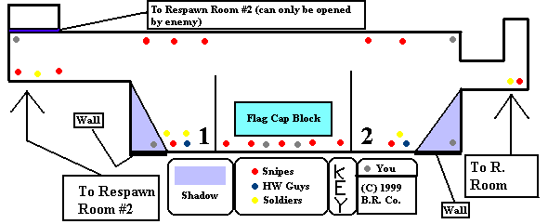
You should be at the locations listed. Both soldiers and HWGuys like to hangout here and fire their big guns (show-off’s). I usually try to blend in rather than trying to take out HWGuys or soldiers, as one shot from the soldiers rocket launcher or the HWGuy’s gun can kill you instantly (especially in Mega-TF). For 100% kills with the knife, wait for a sniper to camp by point 1 or 2 as positioned on the map, then get behind them, and then... “BugerBurger is ass-knifed by BlastRadys”. Also, a fun strategy is to wait for a snipe or other class (except the HWGuy) to position his or herself on the ledge and then knife em in the back. Chances are the won’t die from on hit (it usually takes two, or three with the soldier), but they will be propelled forward so far that they will land in the moat, and then you can toast them (he,he)!

Pretending to be a Soldier or Other Class

When you pretend to be, say a soldier, you have to look busy. Stand on the edge and occasionally lob grenades at the bridge. This makes you look genuine. I don’t like to be a HWGuy in the sniper nest much because if a soldier or other class sees you just standing there and not fireing you big-ass gun, your bloody chunks. When you pretend to be a soldier you can usually get away with being in the nest for long periods of time, just try not to be seen much.

If your discovered, try jumping off the ledge and re-entering he base. That works most of the time.

3.162 - Grenade Fun

This is a short section. When your hiding in the shadows, or are in the either one of the hallways that leads to the sniper nest, it is sometimes effective to prime a grenade (hand grenade, not gas - more on that later), hold it for 1.5 seconds, then release at the snipe. This usually blows em up good, but if by any chance you off by a bit pull out your super shotgun and make his head explode like a cherry bomb (their usually very weak if they caught a little of the grenade blast). Get out of their quickly though, for the snipes are smart and will be looking for you.

3.163 - The “Gas ‘Em Up” Strategy

The only strategy that can be applied to snipers concerning gas grenades is 1) escape, and 2) using it in conjunction with the super shotgun.

Escape

If a sniper sees you, your dead. Not so. If you lob a few gassers by where he’s standing (laying, whatever) he’ll retreat. So if your low on health and need to get out, gas up the sniper nest. An added bonus to this is that it cripples sniper activity for about 30 seconds, allowing you to cross the bridge without fearing snipers.

Using Gas Grenades in Conjunction With the Super Shotgun

First, pull out your super shotgun (preferably when still disguise), and wait for a sniper to camp. Then throw a few gassers near him, and chances are he’ll be zoomed in and it will take him a moment to figure out what’s going on, and by that time he’s already inhaled some of the fumes :-). Now pop him with the super shotgun a few times. A few shots usually does it. They will normally try to retreat to their respawn room, and if so, tranq ‘em, then keep shooting them with the super shotgun (I say super shotgun be cause the nailgun or *Mac10* are not to powerful, and it takes longer to deal the same amount of damage with them in a long stream of bullets than a super shotgun would do with one shot).

3.164 - Stealth, and How to Use It

When your in the sniper nest, try to blend in. Don’t move erratically. If your pretending to be a sniper, mimic the other snipers movements exactly, except in a different position. Also, I should of said this earlier, but if there is only one or two snipers, don’t pretend to be one. They will know one of the snipers is an imposter, and will shoot every one in most cases. Also, don’t be a sniper and walk around the base. What sniper does that? (A very dumb one.) An exception would be if you look like your guarding a door or ramp or something. See below.

3.165 - If the Sniper is Not in the Sniper
Nest

Sometimes, a sniper will guard other areas. Look at the map below:

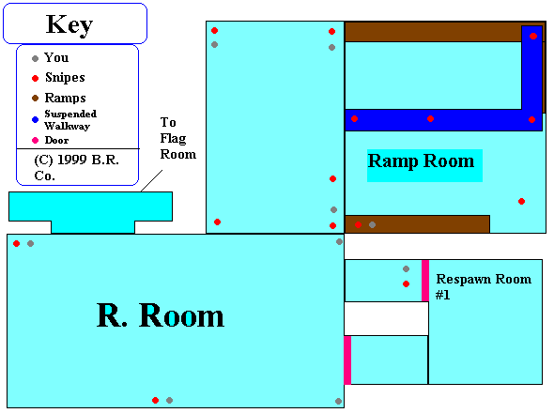

As you can see, snipers favorite spots are by both ramps and on the suspended walkway. Careful, they tend to follow a “if he’s on my team, my shot won’t kill him” policy, so watch it. It’s hard to kill them when their on guard duty, but I like to use hand grenades (gas are no good, as they tend to draw a lot of attention and the sniper can easily escape). Try hanging out in the near the gray spots. If a sniper is in the R. Room (rectangle room), grenade him. Don’t block the respawn room #1 door, because an enemy coming out of it might shoot you if your blocking it to get your attention (so you will move), not knowing your a spy. If they do shoot you, they will know your a spy and start shooting at you - at that point just run, as there is nothing you can do for now.

Snipers always like to hang out on the ceiling grate, compromising any grappling spies who may feel like swinging in, or any other class of your team that wanders in under the grate. Look at the map below, as it points out the most common areas that snipers like to camp at:
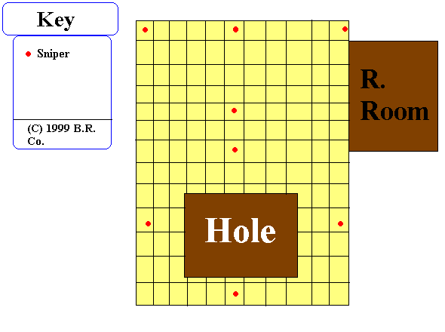
Ceiling Grate

3.17 - “Killing the Sentry Gun and its
Creator” Strategy

This is what makes being a spy worth while. Killing engineers. Engineers are usually guarding the flag with their sentries, in the R. Room, or on top of the ceiling grate.

When There On the Ceiling Grate

When engineers are on the ceiling grate, it’s bad news for inc. spies (if you grapple through the ceiling grate), so don’t go that way. Get to the R. Room any way you can, preferably dressed as an enemy soldier. Then make eye contact with the engineer, but only for a second, then act as if your guarding him. When he starts upgrading/repairing his gun, prime a grenade, hold for 1.5 sec., then release. If it explodes while the engineer is busy with the gun, it will take out the engineer, and the gun will be half dead (doesn’t matter what level). Then just prime and release another grenade (hand, not gas), and you will get an extra two frags.

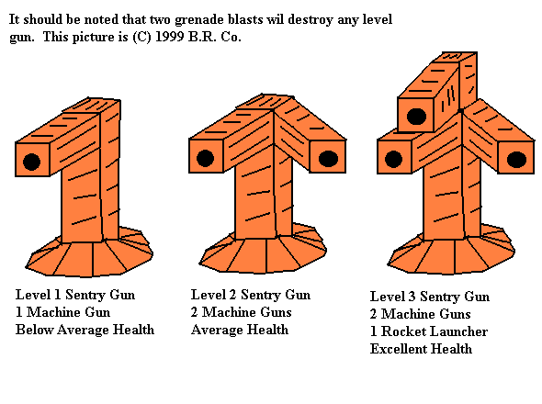
Sentry Gun Levels

Engineers often like to place guns in the R. Room (he,he - they don’t know what’s coming!), and this map below should roughly point out the most commonly used areas:
Engineer/Sentry Locations
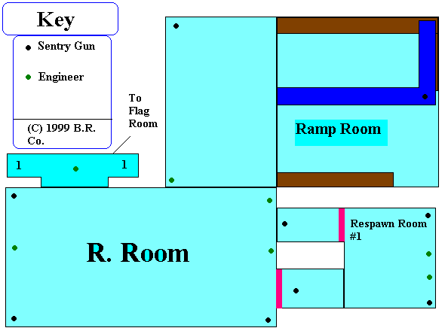
Try to look like a sniper guarding the ramp if you can. When the engineer starts fixing his gun, grenade him, and then finish off the gun - then run to area 1 (either of them) - but be careful, because there might be another engineer hiding around there (as pointed out on the map). Hide there for awhile until the engineer builds another gun, rinse, lather, and repeat. Another strategy is to knife the engineer while he is building, fixing, reloading, or doing whatever to his gun. If the gun is on the suspended stairway, take it out fast, for you are visible to all other players.

Pop en’ Feign

This method is useful if your trying to kill a sentry gun and your out of grenades. What you do is, you get right by a sentry gun and pop it with your super shotgun, then feign. Repeat. You should kill it within 5-7 shots, depending upon the level of the sentry. This really annoys engineers.

Engineers make a habit of guarding the flag with their sentries. Here is a little map that points out the most common positions for engineers and their sentries:
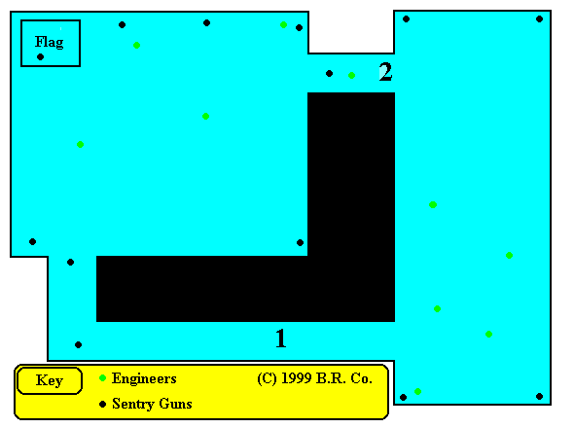
Avoid going through hallway 2! Engineers can see you so easily if you go through this way. Go through hallway 1, as this is the safest route. If the engineer does see you, hopefully you look like the enemy and he won’t suspect a thing. When your at the end of hallway 1, look for sentries by the flag and in the corners of the flag room. Wait for the engineer to leave, then blow up his gun (or blow him up too while he’s tinkering with it, but this is more risky, as there is no escape from the basement, and he will come back down looking for you. You could, however, use the grappling hook - see “Cap the Flag and Daring Escape” strategy). That just about it for the engineer section. Oh! I forgot about the sentry guns that are on some versions of 2Fort5, and how to kill em’. Just use old “Pop en’ Feign” method to kill em. It takes awhile to kill them with the super shotgun, but don’t use grenades cus the blast radius (he, he - blast radius) is too big and you will get liquefied most likely. It takes too long to kill it in one sitting, so every once in awhile your in the R. Room, or tall room, give it a few pops.

3.18 - The “Gas Up a Room” Strategy

When you gas up a room, make sure to do it thoroughly. A half assed gas (he) will result in a dead spy and only slightly hurt enemies. It’s really fun to follow an enemy into a respawn area, then block the exit and start gassing. If it’s a powerful class your dealing with, like the soldier, throw some hand grenades too, if you have them. The cool part about being in an enemy respawn room is that you can refill your supplies wile you kill! I once got 13 frags without losing a life! You can also gas up the sniper deck, as it permits your team’s crossing of the bridge without worrying about the snipes.

3.19 - The “Camper” Strategy

Camping is the act of staying in one spot and picking off targets. Some server admins don’t like it and engaging in such activity tends to get you kicked from servers, even banned in extreme cases of camping. Camping for a spy is normal. Don’t be ashamed. That is how a spy operates; he stays in the shadows. Basically all you have to do is find a nice dark spot, *lay*, and then tranq incoming enemies and then finish them off.

3.191 - The “Tranq Gun” Strategy

When you tranq an enemy, try to do it as many times as you can. If you tranq an enemy two or three times, he’s basically reduced to a crawl, leaving him open to super shotgun shells and nails (*or Mac10 bullets*). Some say not to tranq a HWGuy, as he is already slow. I disagree. When you tranq a HWGuy, he moves even SLOWER and his fireing rate is severely decreased. So my advice is to tranq any and all classes, including HWGuys, as many times as you can.

3.192 - The “Feigning” Strategy

When you feign, don’t do it in front of other people (duh), unless there is a lot of action going on. Don’t feign in the shadows either, as it looks suspicious. I don’t think I have to tell you this, but I will. Do not jump or turn while feigning. It gives you away. Only turn when no one is watching, and only jump to signal other team members.

3.193 - The “Cap the Flag and Daring Escape”
Strategy

HWGuys/Soldier Placement in Basement

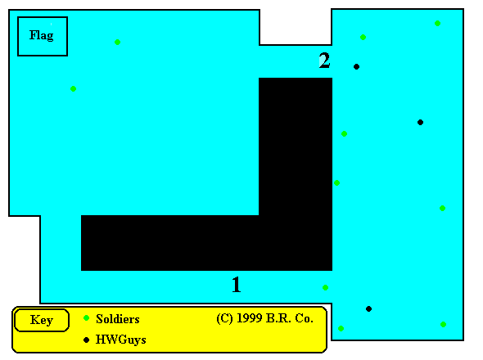
Start out as, as say, an enemy soldier, and then walk casually down the ramps to the basement. If there are enemies down there, immediately take up a guarding position. There are usually HWGuys and soldiers guarding the flag.

The above map points out their relative positions. Also, I’m assuming there are no sentry guns and no engineers. If there are, see “Kill the Sentry Gun and its Creator (Engineer)” Strategy section. When the enemy doesn’t see you, move slowly toward hallway 1, then sneak in and take the flag. *For the daring escape, you need Mega TF. Run to where the elevator is, and then grapple up through the hole and you will be almost in the ramp room. Jump down to the floor of the ramp room, and then walk run through the little hallway that leads to the spiral. Go down the spiral (if you are being chased, detonate some gas grenades). Jump in the water, and come up in your base. Be careful, though, soldiers from the enemy team might be there to say hello.* Also, if you want to guard a flag, you should gas up all the rooms leading to it, or, if it is outside, gas up the bridge and area around the flag. *You could also escape with the flag up the ramp (where you entered the basement) and grapple your way from the enemy sniper nest to your own, with the flag.* Another way of entering the basement is actually the exit you use for your daring escape. Just jump down the elevator shaft. This area is usually not guarded very well, so you be able to integrate seamlessly with your surrounding enemies.

3.196 - Killing Any Other Class

A spy is good for killing pretty much every class. Here are the specifics:

Scout

A scout is a spy’s worst nightmare. Contact with a scout is basically death. They will uncover your disguise if they touch you, so be careful of this fact. Killing one isn’t too hard; you must first tranq him, which is difficult, because he is the fastest class, and then turn him into a cheese grater with your *Mac10* or nailgun, or super shotgun, preferably the super shotgun. They’re the weakest class, so it shouldn’t be too difficult to kill them.

Demoman

Demomen are hard to deal with as a result of their constant piping and det packing, and they usually throw grenades at anything that moves, even their own team. Just try to avoid them, but if you want to kill them, this is what you have to do: when they are lobbing their pipes, tranq em, then run around in circles (avoiding the pipe bombs) pumping them with shotgun shells. Usually if you shoot them early, they will det their pipes out of panic, and kill themselves in the process.

Pyro

Pyros are weak, but have powerful weapons. Tranq em’ and shoot. That’s about the best advice I can give. They also usually stand still a lot, watching their grenades go off. Utilize this weakness to your advantage. Also, try to get them in the water, for most of their weapons are useless when wet.

Snipers

See “Kill the Snipey” strategy.

Engineers

See “Kill the Sentry Gun and its Creator (Engineer)” Strategy.

Heavy Weapons Guy

These are easy. When they turn around, knife em’ in the back. Since they are so heavy, they don’t move forward, and it only takes about 3 swipes to make dog food. Also, if one is chasing you, drop an ammo trap. This will make him lose all his ammo, so now he is just a walking dumpster. Tranq him, then shoot him, or knife him. A HWGuy without ammo is like Kathy Lee Gifford without child labor.

Soldier

Avoid at all costs. They are provoked easily, and are always suspicious. I never really try to kill them, since they are almost perfectly balanced with speed, weapons, and health. You can not kill them with one grenade (unless they are low on health), so be careful. They are always patrolling the base, so the best strategy to use is to look like one and blend in.

Combat Medic

These guys are seriously affected by ludes (tranqs) - shoot em’ with one, then gas em’ then shoot em’. Be careful of their super nailgun, as it isn’t affected that much by ludes.

Spy

Killing another spy is difficult. They usually lude anyone that looks suspicious. So you should lude first, then utilize your super shotgun. *Stupid spies sometimes grapple over to the sniper nest, and there is a bug in Mega TF that can be used to your advantage. If the dumbass spy changes weapons on the way over, he will be stuck until he switches back to the grappling hook. Take this opportunity to lude and shoot him (don’t lude if you think he’s gonna come down soon, as it takes away time).*

3.2 - Spy Advantages

- A spy can walk among enemies without detection.
- A spy can gas up a room, leaving it useless for 30 seconds.
- A spy can keep sniper activity down to almost nothing.
- A spy can befriend an enemy, then stab him or her in the back.
- A spy can guard enemy areas, only to let his friends pass when they come through.
- A spy can kill an enemy in 2 seconds.
- A spy has a nifty suit.

3.2 - Spy Disadvantages

- A spy is weak when going one on one, except when tranqs are used.
- A spy, when moving erratically, can be detected.
- A spy can be flamed for spamming gas.
- A spy can be destroyed by a stray rocket, by accident.
- A spy’s nifty suit can sometimes give you away.

3.3 - Tips In General

- Don’t spam gas.
- Don’t change colors in your own base.
- Don’t change colors on the way to the enemy base.
- Don’t change colors in front of an enemy ‘-)
- Don’t brag about ass-knifing snipers; it can be annoying (unless they’re flaming you)
- *Don’t change weapons when grappling - you will get stuck until you switch back, and that delay can mean death.*
- Don’t stand around doing nothing in the enemy base, it looks suspicious.
- Don’t jump or turn while feigning when an enemy is watching.
- *Unless you have enough power cells to use your grappling hook, don’t jump into the water when a sniper or any other class of enemy is watching, unless you like toasters.*
- Don’t stand in the middle of a fire fight. The enemy may think your genuine, but they might fire a rocket near you because they think it won’t hurt you (unless team kill is on), and end up killing you.

--4--
Misc.

4.0 - Spy Stories

This section is for spy stories. If have them, send them in and I will be sure to post them in the next release. For now, here is one that I wrote. Enjoy :-)

The Streak

It started out like any other game, I was playing as a blue spy and I headed for the water. While in the water, I disguised myself as a red soldier. As I crawled up the enemy’s spiral I saw a soldier looking right at me. “Oh no”, I thought. He would kill me for sure. He walked away. He thought I was on his team, even though I came up through the spiral dressed as a soldier! He was guarding the ceiling grate from another dumbass spy that ran in without disguise and spammed gas. I got up behind him and tranqed him three times. He started shooting a rocket every once in a while, but I blew him away with my shotgun pretty quick. I headed for the ramp room, and it was guarded by no one. So I decided to see what was up with the flag. I went down and to my surprise there was no one guarding the flag. Hmm...a team has 16 players and not one is guarding the flag. Now that’s poor team organization. But wait - here comes an engineer! He thinks I’m on his team and goes into the flag room. I follow him. He starts building a sentry gun, so I go back out and hide in the long hallway that leads to the flag. I wait a couple of minutes and he comes back, builds a dispenser and upgrades his gun. It is now a level 3 sentry. I am about to grenade him when...what!? My team is stealing the flag!!! The engineer chases him, and the sentry gun nips him a little but the rocket it shoots hits the engineer. The engineer is now 4 bloody polygons on the floor. I destroy his sentry and use his dispenser :-). I go back up and head for the sniper deck. There are 6 snipers! I have 2 grenades left. So I ass-knife the first one, the second one I knife, but he is pushed into the water, so I toast him. The four remaining are separated into 2 groups, so I prime two grenades and kill four snipers. My frag count is now at 7 in the first 4 minutes of the game. I have 2 gas grenades left , so I decide to gas the respawn room. Uh-oh! The snipers came back! I am shot and down to 17 health, so I jump of the sniper deck and into the water. Hmm...no toasters. As I swim to my base, I am perforated by a nail. Now I am down to 3 health. I turn around and see 2 combat medics and 1 sniper chasing me! So what I do is, since I didn’t use my grappling hook, I toss a toaster and grapple the underside of the bridge. Add three frags to my score which is now 10 in the first 5 minutes of play. I get up to my base, and run up the spiral, only to see a grinning red sniper waiting for me. Oh well, it was fun while it lasted!!!

By: BlasTRadys Wednesday, June 30, 1999

4.1 - Links

Team Fortress Spy Academy - www.planetfortress.com/spyacademy/

Team Fortress - www.teamfortress.com

Planet Fortress - www.planetfortress.com

Planet Quake - www.planetquake.com

The Factory - www.planetfortress.com/factory/

JMC’s Team Fortress Map Zone - www.planetfortress.com/jmcstfmapzone/

DieHard’s Engineering! - www.planetfortress.com/engineering101/

The TF Maps Sentry - www-iis.unil.ch/~mperreno/sentry.html

Team Fortress Up-To-Date! - www.fortresshq.com/

Ethereal TF - Serving the TF community for over 1/5 of a decade. - www.etherealtf.net/

|The Ladies Team Fortress - www.ladiestf.com/

ATOMICplayer’s Soldier Page!! - www.planetfortress.com/atomicsoldier/

The Demoman Domain - www.planetfortress.com/domain/

Scout Guild - Scout Power! - www.planetfortress.com/scout/

Guild Central Main Page at Planet Fortress - www.planetfortress.com/guildcentral/

4.3 - My Computer

My computer is not very powerful. It is a Compaq Presario P90 ( ! ) w/72 megs of RAM, non-parity, one 820 meg hard drive, and one 1.6 gig hard drive, 56K modem (supposedly), ATI Mach64 video card, 16x CD-ROM drive, a tape drive that is not currently connected (I need a power supply extension), and a crappy 16-bit 16-voice ESS Audiodrive that is embedded on the motherboard. AS you can see, this is not good. My next computer will be a PII 450 (as the PII’s are crap, cus’ the motherboards aren’t configured properly to use them yet, and the cache used on the PIII is actually smaller than that of a PII), DVD-drive (maybe), 17-inch monitor (I now have a 14), 32 megs of RAM (gotta take some out of my old com. to transplant), a 4.7 gig hard drive (I will probably buy a 19 gig), a Voodoo 3 with 3DFX chipset (none of that ATI crap for me, until they get a license to use the 3DFX chipset, I will consider it crap), and a 32-bit 512-voice soundcard. Any suggestions are welcome.

4.3 - Credits

The credits for this document go to me, for writing it, player on the servers I mentioned, for putting up with my spying :-), H.P. Lovecraft for giving me constant inspiration, the makers of Quake, the makers of Team Fortress, and the makers of Mega-TF, the Team Fortress Spy Academy, and all the players of Team Fortress for helping nudge the ball of the digital revolution ‘-). I hope this has proved helpful. Remember, send me all suggestions, comments, threats, and stories! Happy fragging! (I hate to end a document with a cliche, but oh well. bye!)

(C) 1999 B.R. Co. This document, or the contents herein may not be duplicated, copied, or reproduced without the express written consent of BlasTRadys (a.k.a Mac McQuail). All copyrighted material is (C) their respective owners. If I catch you passing this off as your own, I will send your IP address and e-mail address and name if I can to every TF related page on the internet. Thank You.

